

Fauna Impact Assessment Guidelines

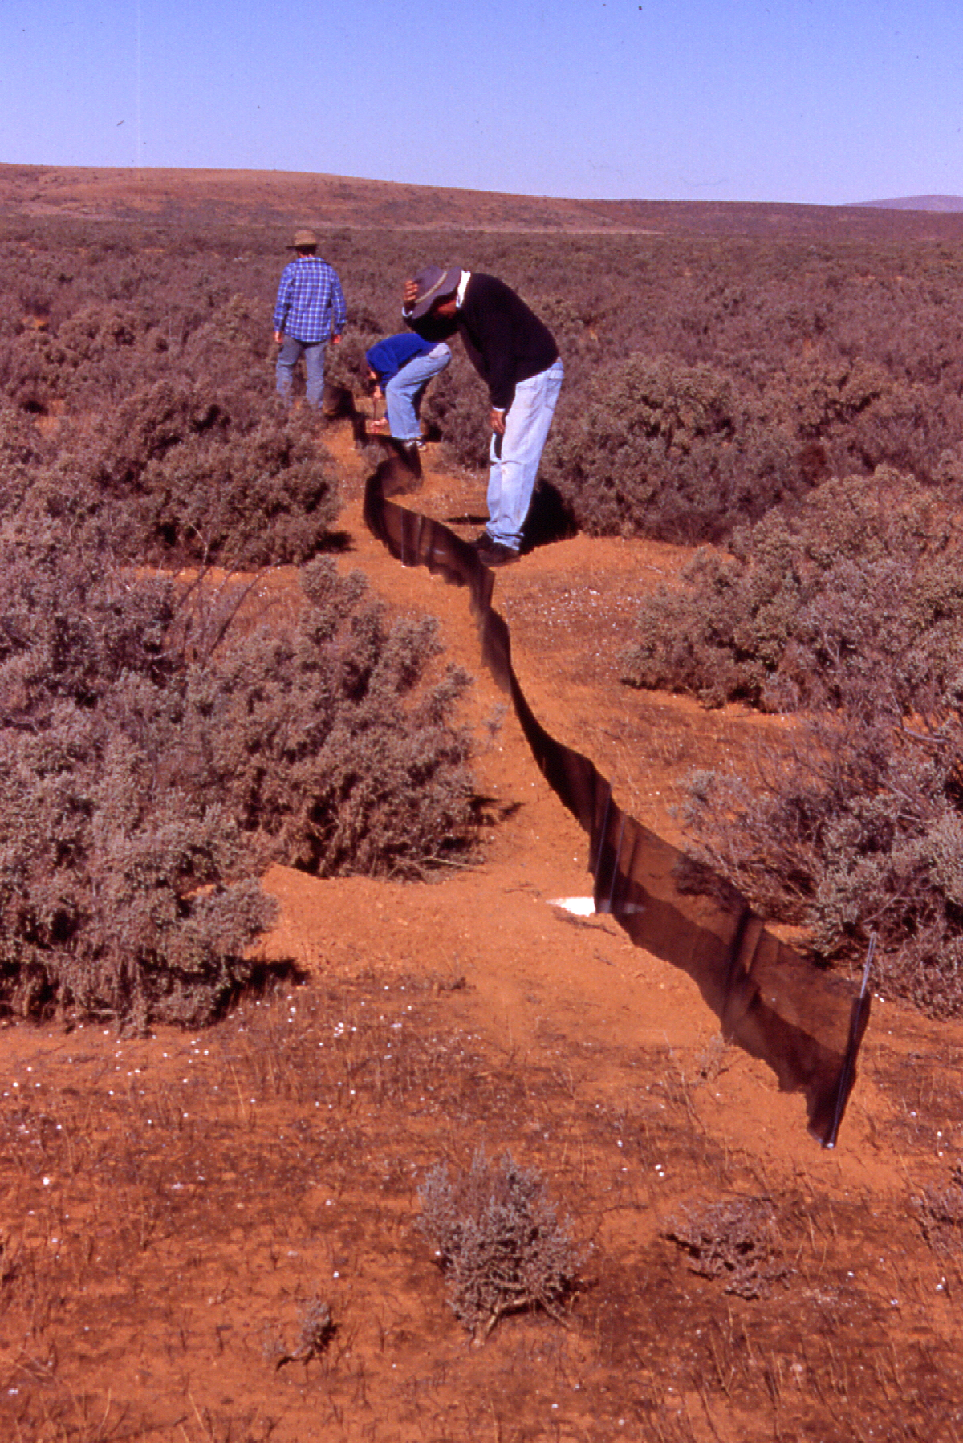
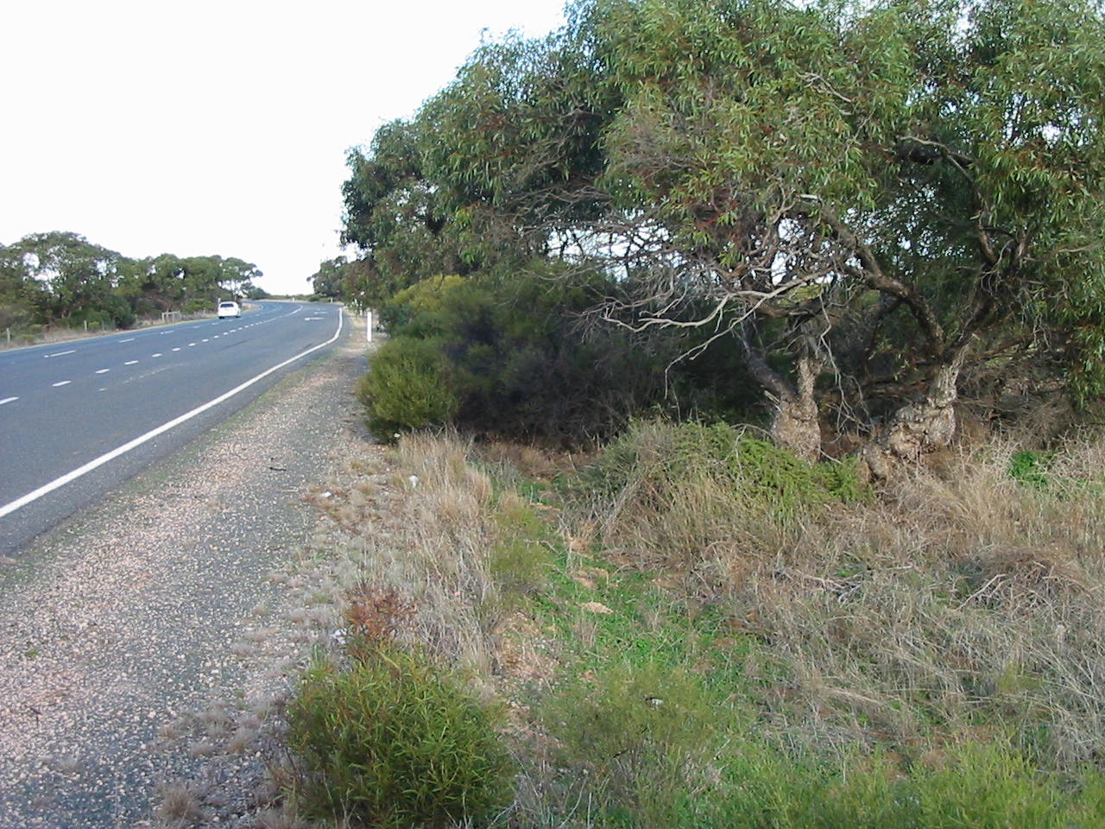

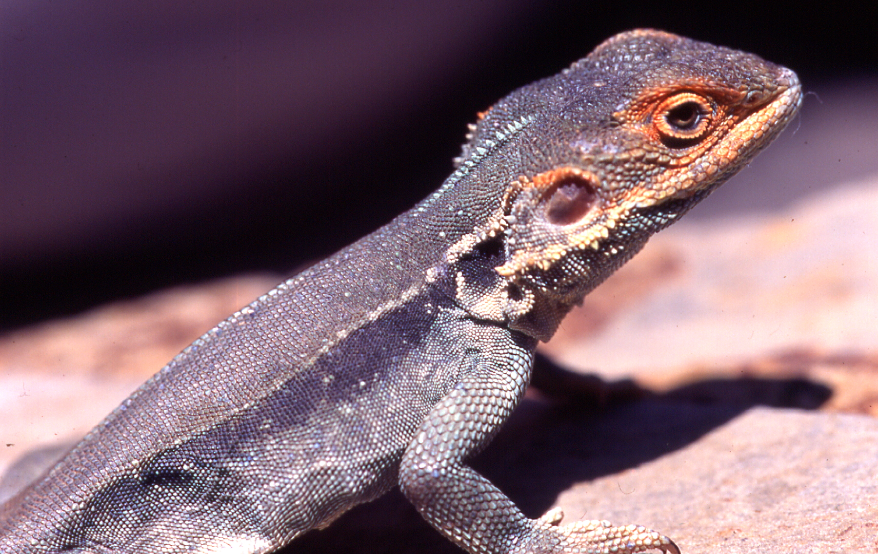

Fauna Impact Assessment Guidelines

© copyright Department of Planning Transport and Infrastructure
77 Grenfell Street
ADELAIDE SA 5000

For further information contact:
Department of Planning Transport and Infrastructure
Environment Group
Contracts and Environment
Telephone (08) 8343 2686

First published December 2002
Revised February 2008
February 2014

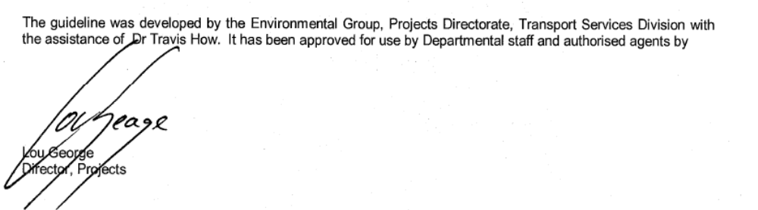

To ensure you have the most up-to-date version of this document refer to http://cms.DPTI.sa.gov.au/enviro_services/standards,_guidelines,_procedures

Cover photos (left to right): Pt Augusta – Pt Wakefield Road, roadside vegetation (photo S Milne); Pitfall trapping, Redbanks Reserve (photo S Milne); Tawny Dragon, male (Ctenophorus decresii) (photo S Milne).

CONTENTS PAGE

1 INTRODUCTION 4
1.1 Purpose of the guidelines 4
1.2 Why do we need to assess fauna? 4
2 LEGISLATION 7
2.1 National Parks and Wildlife Act, 1972 7
2.2 Prevention of Cruelty to Animals Act, 1985 7
2.3 Environment Protection and Biodiversity Conservation Act, 1999 7
3 WHAT IS A FAUNA ASSESSMENT OR FAUNA SURVEY? 8
3.1 Fauna Assessment 8
3.2 Fauna Survey 9
4 WHEN IS A FAUNA ASSESSMENT OR SURVEY REQUIRED? 10
5 FAUNA IMPACT MITIGATION WORKS 11
5.1 Avoiding or minimising impact on fauna 11
5.2 Impact mitigations works 11
6 FAUNA PROTECTION DURING CONSTRUCTION 13
7 MAINTENANCE OF FAUNA MITIGATION MEASURES 13
8 GLOSSARY OF TERMS 14
9 BILBIOGRAPHY 15
Appendix 1 Fauna assessment and fauna survey request form 15

INTRODUCTION

Purpose of the guidelines
These guidelines have been prepared to assist Department of Planning Transport and Infrastructure (DPTI) to undertake Fauna Assessments as part of the environmental impact assessment for infrastructure projects. The guidelines are to be used as a decision making tool to ensure that fauna issues can be identified and managed accordingly. The Fauna Impact Assessment Guidelines should be utilised early in the planning phase of a project. The information gathered from a Fauna Assessment or Survey can then be incorporated into the planning and design phases of a project.

Why do we need to assess fauna?
Native vegetation in road reserves contributes significantly to the conservation of native flora and fauna due to the extensive native vegetation clearance that has occurred within the agricultural districts of the State. A number of Hundreds within South Australia have less than 4% of remnant vegetation remaining (DEP 1987). For example, the Hundred of Maitland on the Yorke Peninsula has <1.0% remaining native vegetation whilst the Hundred of Grey in the State’s South East has approximately 1.1% remaining native vegetation.

A wide range of native fauna species utilise roadside vegetation as it provides shelter, nesting and roosting sites, it is a source of food and it may act as a corridor linking and enabling movement of fauna between larger areas of native vegetation outside of road reserves. In addition to common fauna species, species of conservation significance also utilise road reserves and transport corridors.

Associated with the reduction of native vegetation, is a reduction in the number and abundance of fauna species within South Australia. The original native fauna of this State has thus been substantially diminished by human development. Some 31 of the 953 mammal, reptile, bird and fish species found in South Australia have become extinct within the State since European settlement. A further 230 species are of conservation significance within South Australia with 81 of these being of national conservation significance (Robinson et al 2000).

Transport infrastructure works can adversely affect native fauna species and fauna habitat either directly (i.e. death of individuals) or indirectly (i.e. removal or disturbance of their habitat). Indirect impacts on fauna include creation of a barrier to animal movements; changes to the vegetation quality (eg introduction of weeds); the fragmentation and isolation of habitat; creation of habitat conditions that favour pest species and other habitat impacts (eg loss of food, shelter, roosting and nesting resources).

Habitat disturbance can be detrimental to the long-term survival of a range of fauna species according to their rarity (conservation significance) and the extent and nature of the disturbance. Therefore, potential fauna impacts should be minimised when considering project options.

Pygmy Blue-tongue Lizard (Tiliqua adelaidensis)
(Photo Dr. T. Milne)

Case study
A number of species of conservation significance utilise road reserve areas. An example is the Nationally Endangered Pygmy Blue-tongue Lizard (Tiliqua adelaidensis), which has been found in native grassland within the road reserve along the Burra to Morgan Road in the Mid North Region of the State. This species was directly affected by the re-alignment of this road. During the planning and design phases of the project, the alignment was moved as far as possible away from the location of the Pygmy Blue-tongue habitat and some individuals were relocated prior to earthworks.

Where vegetation is affected by infrastructure projects an assessment of the potential impact on fauna should be undertaken as part of the environmental assessment of the project. The Department’s environmental assessment process is outlined as a flow chart in Figure 1.

Advice on whether a fauna assessment or fauna survey is required for a particular project, and whether a referral is required under the Commonwealth Environment Protection and Biodiversity Conservation Act, should be sought from staff within Environment Group, Projects Directorate.

Determine the need for and level of fauna investigation
Collect data through fauna assessment and/or fauna survey
Evaluate the project options with regard to potential impacts on fauna species
Identify management strategies and mitigation measures
Document impact assessment - EIAR for minor project, Planning report or Environment report for major projects, PEMP if required
Planning Phase
Submit documentation for environmental clearance to the SEMO or Coordinator, Environmental Planning
Incorporate management and mitigation requirements into construction contract
Monitor and audit compliance with fauna management requirements
Ensure fauna issues are incorporated into the hand-over to Regions / Councils where relevant e.g. maintenance of fauna tunnels, maintenance of revegetation works
Implementation Phase
Hand-over Phase

Figure 1. Environmental assessment process for fauna issues
on infrastructure projects.

LEGISLATION

The Department is committed to protecting and enhancing the natural environment as outlined in the 2007 State Strategic Plan –Objective 3: Sustainability, Target 3.1: Lose no species as a result of human activities. (http://www.stateplan.sa.gov.au/)

The Department also has obligations under State and Federal legislation to protect fauna that may be affected by its works and/or present on land under its care and control. Relevant legislation includes the National Parks and Wildlife Act 1972 (State), the Prevention of Cruelty to Animals Act 1985 (State) and the Environment Protection and Biodiversity Conservation Act 1999 (Commonwealth).

National Parks and Wildlife Act, 1972
The National Parks and Wildlife Act 1972 provides for the protection of native animals which includes native animals and migratory species defined by the Act or regulations under the Act. Under section 51 of the Act, it is an offence to take (which includes injuring an animal) or kill protected animals from anywhere in the State unless a permit has been obtained.

Prevention of Cruelty to Animals Act, 1985
The Prevention of Cruelty to Animals Act 1985 prohibits the inhumane treatment of animals. The Royal Society for the Prevention of Cruelty to Animals (RSPCA) have officers authorized under this Act. The Act outlines the powers of the society (RSPCA) including the powers of inspectors, rights of seizure and disposal of animals taken into custody.

Environment Protection and Biodiversity Conservation Act, 1999 (Commonwealth)
The Commonwealth Environment Protection and Biodiversity Conservation Act, 1999 applies to any action with a significant impact on a matter of national environmental significance.

Matters of national environmental significance relating to fauna protection include:
- Wetlands of international importance (Ramsar wetlands)
- Listed threatened species and ecological communities
- Migratory species
- World Heritage properties
- National heritage places
- Commonwealth Marine areas.

If a proposed action is considered likely to have a significant impact on a matter of national environmental significance, it must be referred to the Federal Environment Minister. If the Minister decides that an action is a controlled action, an environmental assessment of the action must be carried out before the Minister decides whether to approve the action.

For information on the Environment Protection and Biodiversity Conservation Act, 1999 refer to the Commonwealth Department of Environment website (http://www.environment.gov.au/) and the DPTI Guide to Matters of National Environmental Significance under the Commonwealth Environment Protection and Biodiversity Conservation Act.

WHAT IS A FAUNA ASSESSMENT OR FAUNA SURVEY?

Fauna Assessment
The purpose of a Fauna Assessment is to determine whether fauna or fauna habitat may be adversely affected by the proposed development and whether more information from a Fauna Survey is required. If the impact is likely to be significant, the Fauna Assessment should also provide advice on the determination of broad project options to avoid or minimise the impacts. During the concept development phase of an infrastructure project, a brief Fauna Assessment should be conducted to ensure significant issues are identified prior to the commencement of detailed planning. A Fauna Assessment should be conducted early in the detailed planning phase of an infrastructure project to enable appropriate project options to be determined.

A Fauna Assessment involves a review of existing information relevant to the project site and areas in close proximity to the project site. It includes a search of fauna records of the databases maintained by Commonwealth Department of Environment, the SA Department of Environment, Water and Natural Resources and the South Australian Museum. A literature review (e.g. Regional Biodiversity Plans, biological surveys) should also be undertaken to gather further information on any species that are of conservation significance in the region and may occur within the project location. Information regarding the habits and habitat requirements of some species may also be required.

Where appropriate liaison should be undertaken with relevant staff from organisations including the Department of Environment, Water and Natural Resources (including Regional Ecologists); Natural Resource Management Boards; SA Museum and local interest groups (e.g. Friends of Parks Groups, Field Naturalist Groups).

Relevant databases can also be used to identify species in a project area. Naturemaps (http://www.naturemaps.sa.gov.au/),
EPBC Act (http://www.environment.gov.au/biodiversity/threatened/index.html)

If a Vegetation Assessment and/or Survey is required for the project site, then this can also assist the assessment of fauna impacts. A Fauna Assessment may be incorporated into a Vegetation Assessment.

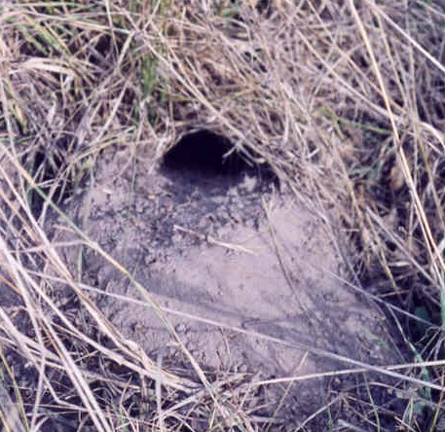
A field inspection including direct and indirect observations of fauna presence of the project site should be undertaken. Observations may include identifying tracks, hair samples, scats and diggings. For a number of species, the indirect signs can easily be distinguished, however, for some species a high level of knowledge of the species’ ecology is required to determine which species are present. The field inspection would not include intensive survey methods such as spotlighting and trapping that may be employed in a Fauna Survey.

Diggings, (above) such as these from a Southern Brown Bandicoot, can help to determine the presence of fauna species in an area (photo Dr. R. Anderson).

Fauna Survey
A Fauna Survey, involving a ground survey, is required when:

- there is a high likelihood of significant fauna or fauna habitat being affected based on the fauna assessment,
- the full impact of the development proposal on fauna needs to be determined or quantified,
- remediation / mitigation measures need to be determined.

Fauna Surveys can be undertaken at different levels, for example, a general survey may be required where all fauna groups (e.g. mammals, reptile, birds, fish, insects) are surveyed. Alternatively, a survey may focus on one particular fauna group (eg birds) or a particular species (e.g. Black-eared Miner), if there is reason to believe that they may be affected.

A general survey would be required when it is unknown what species are likely to occur in the area or a number of significant fauna species are likely to occur in the area. It may also occur when the presence of habitat quality indicators (eg hollows) are present. If it is known that several species from one fauna group occur in the area (eg several reptile species) that are of conservation significance, then a survey that targets that fauna group may be warranted. Alternatively, it may be known (from the fauna assessment or other source) that a species of particular conservation significance occurs within an area. Therefore, a fauna survey designed to detect that particular species may be more appropriate.

A Fauna Survey is preceded by a Fauna Assessment and involves a field survey and compiling fauna records and other relevant information about an area and the fauna species present. The report should also include species that were not found during the field survey but are likely to be present within the area. A field survey may include the use of techniques such as spotlighting, Elliott trapping, pitfall trapping and/or active searching. Data analysis will include evaluating the data from the field work as well as existing fauna records and information obtained from relevant stakeholders/interest groups. The techniques used in a survey should be tailored to species relevant to the project.

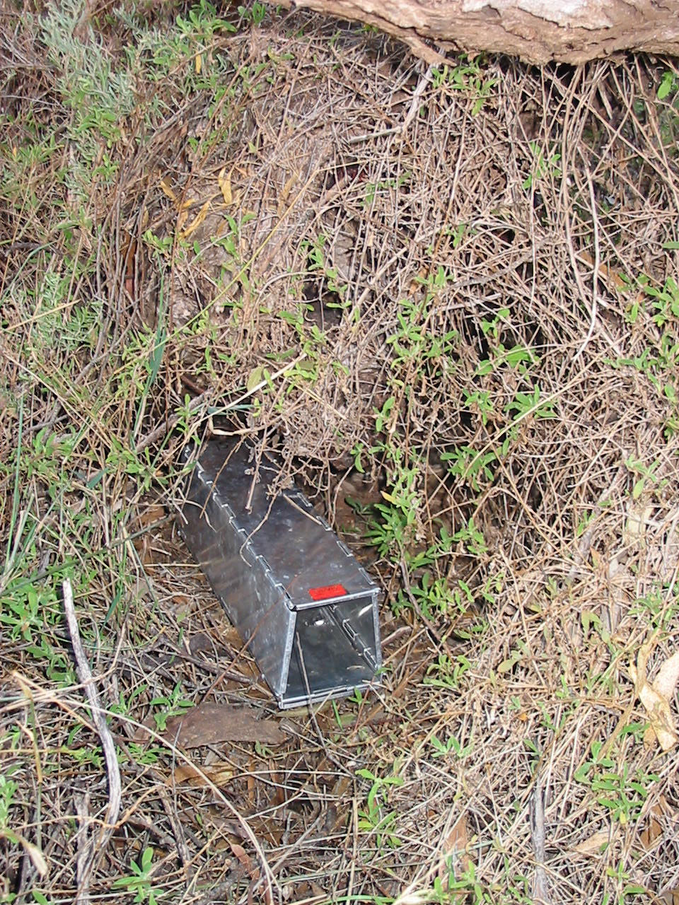

Elliott trapping (left) and pitfall trapping (right) are two common methods used to survey small terrestrial mammals and reptiles (photos S Milne).

WHEN IS A FAUNA ASSESSMENT OR SURVEY REQUIRED?

The decision whether to conduct a Fauna Assessment should be made in consultation with staff from the Environment Group and the Senior Environmental Management Officer.

The need for a Fauna Assessment should be determined as early as possible in the planning phase of a project so that potential fauna impacts can be taken into account. Sufficient time should be allowed for the work to be undertaken and for recommendations/conditions to be incorporated into project planning and design. If the process for determining the need for a Fauna Assessment is undertaken either late in the planning phase or in the design phase, there is a risk that the project could be delayed if significant fauna species are found on site.

The results from the Fauna Assessment should determine if a Fauna Survey is required. A Fauna Survey may be required where an area cannot be avoided and the extent of the impact on a significant species needs to be determined. A Fauna Survey may also be required to determine mitigation measures for an impact on a species or when the Fauna Assessment provides insufficient information to make informed decisions about the management of a species.

The methodology for determining whether a Fauna Assessment is required for a project is based on the predicted area of vegetation to be cleared or disturbed as part of the project and the quality of the fauna habitat.

No Fauna Assessment is required if:

- No vegetation is to be affected by the proposed project, and/or
- No vegetation with potential fauna habitat is to be affected (eg urban exotic street trees, road verge infested with weed species), and/or
- The project is to remove a strip of native vegetation less than 1m in width or less than 500m² and/or
- No impact to natural drainage lines and/or watercourses will occur.

A Fauna Assessment may be required if:
- It is unclear if the area would support significant fauna species, and/or
- The area of vegetation affected is small but is of high fauna habitat quality, and/or
- The area of vegetation affected is large (> 1ha) but is of poor fauna habitat quality and/or
- There may be an impact to natural drainage lines and/or watercourses.

A Fauna Assessment is required if:

- Areas of high quality fauna habitat are to be affected by the proposed project, and/or
- Large areas (>2ha) of vegetation that is of moderate quality is to be affected by the proposed project, and/or
- There are known populations of threatened species within, or in close proximity to, the project site and/or
- There will be an impact on natural drainage lines and/or watercourses that contain areas of fauna habitat.

Advice should be sought from the Senior Environmental Management Officer if it is unclear to which level a project applies or for projects where a Fauna Assessment may be required. A Fauna Assessment or Fauna Survey can be requested on the Form in Appendix 1.

If there is potential to impact on a “matter of national environmental significance” under the Environment Protection and Biodiversity Conservation Act a Referral may be required under the Act.

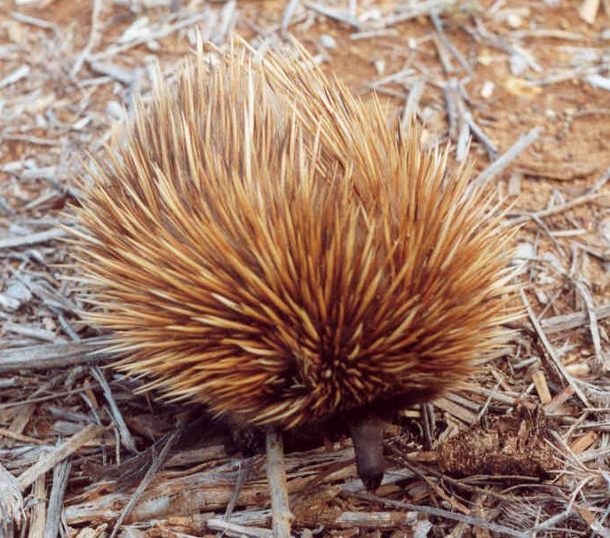
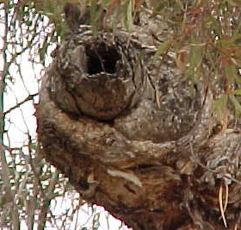

Tree hollows provide habitat for numerous fauna species (left) (photo Dr. T. How). Echidnas are commonly observed within road reserves (right) (photo Dr. T. How).

FAUNA IMPACT MITIGATION WORKS

Avoiding or minimising impact on fauna
Should an area supporting significant fauna be identified as part of the environmental assessment of the project, measures to avoid these impacts should be investigated and adopted, where feasible. Options may include:

- alternative alignments,
- minimising the impact area,
- constructing outside of the breeding season (especially for birds),
- relocation of fauna prior to construction. This is species specific and would require detailed research as a number of species are either territorial or suffer from extreme stress,
- design of waterway crossings to protect fish movement (for further details refer to the DPTI Protecting Waterways Manual).

Impact mitigation works
Where options to avoid the impact on fauna species are not feasible, appropriate mitigation works should be undertaken. The strategies can include:
- installing nest boxes (can be used for birds and arboreal mammals),
- relocating tree hollows,
- undertaking revegetation works and creating compensatory habitat,
- reinstating specific habitats (eg dead wood, rock piles),
- erecting exclusion fencing to separate the fauna from the road,
- constructing fauna tunnels (can be used for mammals (large and small), reptiles and amphibians but need to be specific to the targeted fauna species),
- installing ladders (can be used for species such as koalas).

Most of the mitigation measures will require research into their design and construction so that they will be utilised by the target fauna species. For example, nest boxes can be made to various sizes, however, a small parrot species such as a Red-rumped parrot will use a much smaller nest box compared to a large parrot species such as a Yellow-tailed black cockatoo. Additionally, nest boxes intended for a particular species may be occupied by introduced species such as Common starlings or European honey bees unless appropriate measures are undertaken. Another example of a mitigation measure would be the use of fauna tunnels. Some species will only use tunnels if they contain enough sheltering spots so that they do not feel vulnerable to predators, whereas this may not concern other larger species.

For advice on mitigation measures consult the Environment Group. The mitigation measures should be documented in the Project Environmental Management Plan (PEMP) and incorporated into contract requirements. Where project work may impact on fauna, appropriate legislative approvals should be obtained.

If the project has an significant impact on listed species under the EPBC Act and is considered a “controlled action”, offsets may be required in accordance with the Act. Refer to the Commonwealth Department of Environment Offsets Policy.

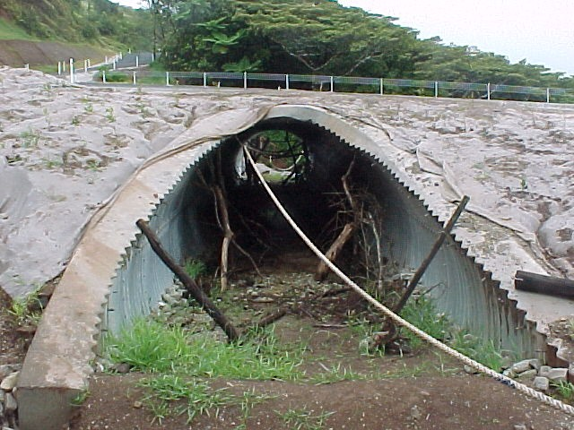
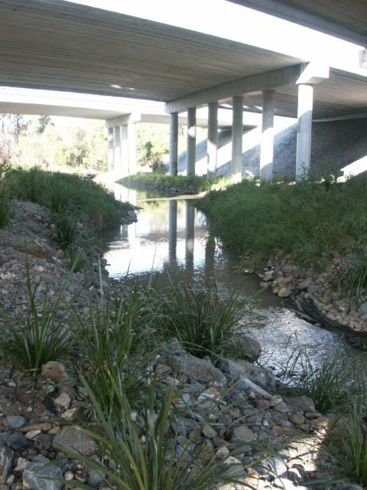

Fauna tunnels can be installed to allow fauna species to move safely from one side of a road to the other. The photo above shows a tunnel in Queensland that was designed specifically as a fauna tunnel for a range of species (Photo N. Scott).

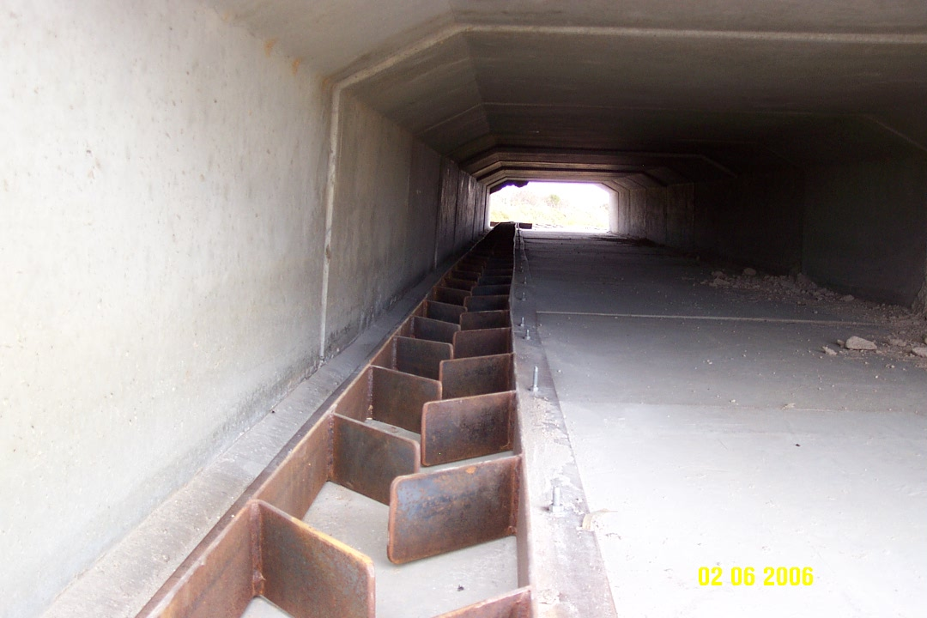
A bridge over a watercourse can be designed to enable fauna movement underneath (above) (Photo N. Scott).

A fish ladder at Margaret Creek on the Oodnadatta track, South Australia. This allows fish to move through the culvert (left) (Photo D.Powell).

FAUNA PROTECTION DURING CONSTRUCTION

Prior to the removal of vegetation during construction of a project, the area to be affected should be checked for fauna species. Where possible the fauna species should be removed or relocated. Appropriately qualified and experienced persons should undertake this work. A permit should be obtained under the National Parks and Wildlife Act 1972.

In addition to the pre-vegetation removal checks for fauna species, daily checks should be undertaken during construction for any fauna that are trapped within the site. These animals should be removed or relocated away from the construction area. Suitably qualified and experienced persons should undertake this work.

If any fauna species are trapped or injured on site, Fauna Rescue of SA (phone (08) 8289 0896) or the RSPCA (phone (08) 8231 6931) can be contacted to provide advice on the relocation of animals or treatment of the injured animals. A local veterinarian may be required to treat injured animals.

MAINTENANCE OF FAUNA MITIGATION MEASURES

At the handover of an infrastructure project any on-going monitoring or maintenance of fauna mitigation works should be identified. They should be documented in the Project Environmental Management Plan and the Project Handover Document. Where appropriate, these management measures should be incorporated into the maintenance contracts.

GLOSSARY OF TERMS

Conservation significance – describes the rarity and risk of extinction of a species, eg. common, uncommon, rare, vulnerable or endangered.

DEWNR – Department of Environment, Water and Natural Resources

Endangered – Rare and in danger of becoming extinct

EPBC Act – Environment Protection and Biodiversity Conservation Act 1999 (Commonwealth)

Fauna – For the purposes of these guidelines, fauna are defined as animals (mammals, reptiles, fish, amphibians and birds) which are indigenous to South Australia

NPW Act – National Parks and Wildlife Act 1972 (State)

NPWSA – National Parks and Wildlife South Australia

NRM – Natural Resource Management (Boards)

Rare – Having a low overall frequency, confined to a restricted range or scattered sparsely over a wider area

SEMO – Senior Environmental Management Officer

Vulnerable – Rare and at risk from potential threats in the long term

BILBIOGRAPHY

Croft, T., House, G., Oppermann, A., Shaw, A. and Zubrinich, T. (1999). ‘Biodiversity Plan for the South East of South Australia’. Department for Environment and Heritage, South Australia.

Department of Planning, Transport and Infrastructure ‘Protecting Waterways Manual’.

Department of Environment and Planning (1987). ‘Remaining Vegetation in the Agricultural Regions of South Australia’. Native Vegetation Management Branch, DEP.

Department of Planning, Transport and Infrastructure. ‘Transport SA Guide to Matters of National Environmental Significance: Commonwealth Environment Protection and Biodiversity Conservation Act, 1999’.

Graham, A. (2001). ‘Biodiversity Plan for the Northern Agricultural Districts of South Australia’. Department for Environment and Heritage, South Australia.

Kahrimanis, M.J. and Carruthers, S. (2001). ‘Biodiversity Plan for the Murray-Darling Basin’. Department for Environment and Heritage, South Australia.

Queensland Department of Main Roads (2000). ‘Fauna Sensitive Road Design. Volume 1 – Past and Existing Practices’. Queensland Department of Main Roads, Technology and Environment Division, Brisbane.

Robinson, A.C., Casperson, K.D. & Hutchinson, M.N. (2000). ‘A List of Vertebrates of South Australia’. Department for Environment and Heritage, South Australia.

VicRoads (2000). ‘Guidelines for the Conduct of Biological Surveys’.

Willoughby, N. and Graham, A. (2001). ‘Biodiversity Plan for Kangaroo Island’. Department for Environment and Heritage, South Australia.

Websites
Department of Environment and Natural Resources (State) http://www.environment.sa.gov.au/

Natural Resource Management Boards (State)

Department of Sustainability, Environment, Water, Population and Communities (Commonwealth) http://www.environment.gov.au/

Databases

Department for Environment Water and Natural Resources (State) Nature maps and Biomaps

Department for Environment Water and Natural Resources. South Australian Aquatic Biota Database

Department of Environment (Commonwealth) EPBC Act 1999
http://www.environment.gov.au/biodiversity/threatened/index.html

South Australian Museum, Fauna Records Database for South Australia.

Appendix 1 Fauna assessment and fauna survey request form

A Fauna assessment or Fauna Survey can be requested using the Projects Directorate work request form.

For the purposes of these guidelines “native fauna” is defined as animals (mammals, reptiles, fish, amphibians and birds) which are indigenous to South Australia.

