Road Surface Texture Measurement
Recommended Investigatory Levels

Tech Note 25

INTRODUCTION
Road surface texture is a measure of the ability of a pavement to drain the road during wet weather (macro-texture). This texture plays a part in road surface friction resistance which assists in the braking of vehicles on roads. This technical note presents an overview regarding the measurement of texture as undertaken by the Technical Services Group of DPTI.

MACRO-TEXTURE
Macro-texture is the visual texture observed when examining the broad stone-binder matrix. It is the characteristic deviation of a pavement surface from the true planar surface within the wavelength of 0.5 and 50mm. This type of texture provides escape paths for water under a tyre and controls how rapidly skid resistance drops off with increase in speed due to lack of water egress.
Initially macro-texture was measured by manual means using the ‘Sand Patch’ method involving the use of a known volume of sand, spread evenly over the road surface and then measuring the size of the patch, finally giving a texture measure, TP346. Texture is now determined using automated laser based systems TP351 & TP352 enabling greater quantities and continuous data to be collected.
Note:
- Determination of Average Texture Depth of a Pavement Surface Using the Sand Patch Method, TP346, DPTI, Adelaide.
- Determination of Road Surface Texture Using a WDM TM2 Device, -TP351, DPTI, Adelaide.
- Determination of Pavement Surface Texture Using the Laser Profiler, -TP352, DPTI, Adelaide.
- Micro texture is the texture found on the surface of the stone forming part of the pavement wearing surface.

SAND PATCH
This method has an extensive history and is the basis by which many engineers have determined the texture of a road surface.
A known volume of sand is poured onto a cleaned road surface and spread out in a circular motion to infill the spaces between the stones. Once the sand has been spread to its limits the diameter of the circle is measured. By using a mathematical formulae the texture, millimetres, can be calculated as used in the pavement evaluation process.
This process has a significant dependence upon the operator. It is also a slow and labour intensive process as well as having safety issues when being undertaken on an operating road. These inefficiencies have been addressed by the automated processes now being used.
For actual details of operation refer to TP346.

LASER PROFILOMETER
This system involves the use of Lasers located at the front of the test vehicle. The laser shines a fine beam of light onto the road and a receptor receives back the reflected signal. The difference between this reading and the calibrated distance is the texture depth. The vehicle operates at speed and so can continually collect a significant amount of data from both wheel paths. Multilaser systems can collect data between pathways.
With the system travelling at speed over the road there is a need to have quality systems to produce accurate results. The sending signal must match the receiver and to achieve this speed limits are applied.
Results from the DPTI Laser Profilometer are reported as mm, sand patch
For actual details of operation refer to TP352
Laser Profilometer
Texture Meter TM2

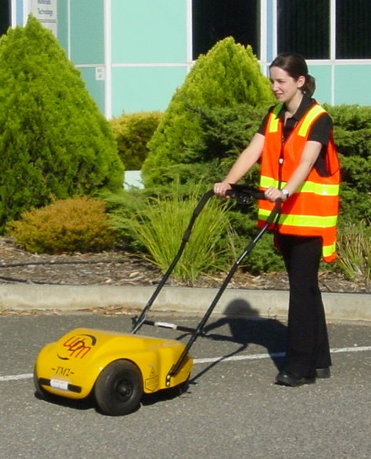
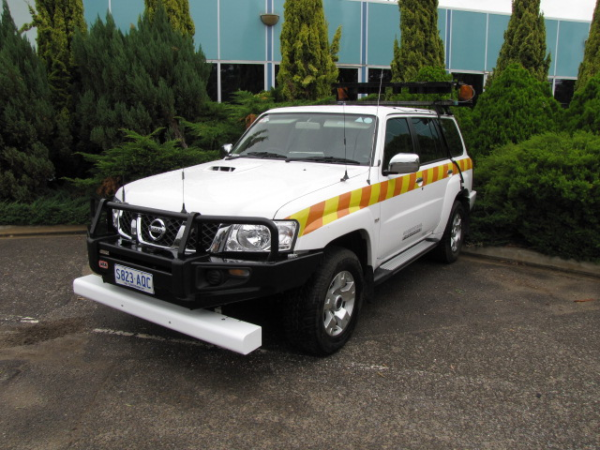

TM2 (Texture Measure Mk 2, WDM)
The TM2 device is an automated system that uses a single Laser. It travels at 5 k/h and produces the most accurate results of the three methods. Reported results are MPD (Mean Particle Depth, mm) and essentially the same as that from a sand patch test. For actual details of operation refer to TP351.

TEXTURE WAVELENGTH & EFFECTS
The following diagram indicates in terms of texture wavelength and spatial frequency the most significant anticipated effects expected over a wide range.
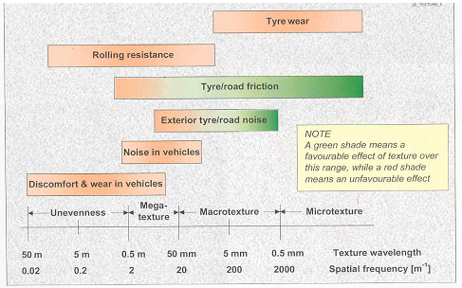
Sandberg U, Ejsmont JA

REPORTING TEST RESULTS
Typical Indicative Investigatory Levels for Surface Texture
Road function | Texture depth  (mm)
Freeways and other high-class facilities with free-flowing traffic conditions | 0.4
Highways (greater than 80km/h)  Other major main roads to stopping and turning (less than 80km/h) | 0.6
Other local roads (sealed) | 0.4
‘Guide to the selection of road surfacings’, (2003), AP-63/03, Austroads, Sydney.

Diagrammatic Representation of Texture:

Microtexture Macrotexture
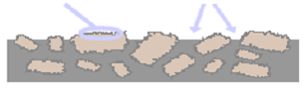

Typical texture depth of new surfacings
Surfacing Type | Texture depth (mm) | Comments
Spray seals, 10mm or larger | >1.5 | Surface textures of 4 to 5mm are common for some new sprayed seals using large aggregates
Spray seals, 7mm | 0.6 – 1.0
Dense graded asphalt, 10 mm or larger | 0.4 – 0.8 | Texture depth can be influenced by grading and mix design more than the nominal mix size
Dense graded asphalt, 7 mm | 0.3 – 0.5
Open graded asphalt (inculding thin open graded asphalt) | > 1.2 | Texture depth measurement can be unreliable due to underlying voids but measurement would only be critical if surface texture had reduced to a level where it was no longer functioning an porous asphalt.
Stone mastic asphalt | > 0.7 | These values are interim only and may be subject to review.
Fine gap graded asphalt | 0.2 – 0.4
Slurry surfacing | 0.4 – 0.8
Tyned concrete | 0.4 – 0.7
Exposed aggregate concrete | > 0.9
Hessian dragged concrete | 0.3 – 0.5
Broomed concrete | 0.2 – 0.4
‘Guide to the selection of road surfacings’, (2003), AP-G 63-03, Austroads, Sydney.
A series of correlation and tests have been undertaken by Technical Services staff to relate all operations.

Correlations
Process | * R²
TM2 and Sand Patch | 0.96
Two Laser and Sand Patch | 0.95
TM2 and Twin Laser | 0.93
* All results are good.
References:
- ‘Guidelines for the Management of Road Surface Skid Resistance’, AP-G 83-05, Austroads Sydney.
- ‘Guide to the Selection of Road Surfacings’, AP-G 63-03, Austroads, Sydney.
- Sandberg U, Ejsmont JA, , Tyre Road Noise Reference Book, Informex, SE-59040 Kuissa, Sweden, www.informex.info
- Determination of Average Texture Depth of a Pavement Surface Using the Sand Patch Method, TP346, DPTI, Adelaide.
- Determination of Road Surface Texture Using a WDM TM2 Device, TP351, DPTI, Adelaide.
- Determination of Pavement Surface Texture Using the Laser Profiler, TP352, DPTI, Adelaide.

Contact:
D Holloway,
Supervising Testing Officer, Field Testing,
Pavements Engineering Unit
Technical Services Group,
(08) 08260 0588

