VE101 - VEGETATION SURVEY GUIDELINE

Purpose
To collect and document data that broadly identifies all characteristics of the existing vegetation and to make recommendations that will minimise detrimental effects on that vegetation; and, where required, to assess and document impacts to inform vegetation removal approval applications.

Goal
To prepare a report which generally describes all critical aspects of the project relating to vegetation. During the field assessment all data, necessary to substantiate the report, is to be collected. The completed report is to be a log of data which quantifies the likely impact of the works and which makes recommendations for mitigation.
This guideline should be read in its entirety to ascertain DPTI’s requirements. Additional requirements may be specified in the work request and/or contract brief.

Documentation
The output of the Survey shall be:
Report | One copy of electronic file.
Data Sheets | One copy of electronic file.
Species Lists | One copy of electronic file.
Photographs | One copy of electronic file.
Plans/Aerials | If required, one electronic copy or one set of paper prints annotated in red.

Contents
A) General | Page 3
B) Report | Page 7
C) Spread Sheets | Page 13
D) Photographs | Page 32
E) Species Lists | Page 34
F) Plans/Aerial Photographs | Page 35
G) References & Information Sources | Page 40
Appendix A | Guidelines for the assessment of “Seriously at Variance”
Appendix B | Development Act & Regulations – Regulated & Significant Trees

Generally information to be collected and presented for each type of vegetation within the survey area shall be as follows. More specific data collection and presentation instructions are contained within Parts B to G.
Related documents for further information and/or reference:
- DPTI – Vegetation Removal Policy – Knet #1965602 (Contractors access DPTI - Department of Planning, Transport and Infrastructure South Australia - Environment)
- http://www.dpti.sa.gov.au/__data/assets/pdf_file/0008/35657/DOCS_AND_FILES-1965602-v28-Environment_-_Technical_Standards_-_Vegetation_-_Vegetation_Removal_Policy.PDF
- Native Vegetation Act, 1991
- Development Act, 1993
- Scattered Tree Clearance Assessment in South Australia
- DPTI’s list of Declared Plants and Environmental Weeds - refer Knet #1072172 (Contractor access http://www.dpti.sa.gov.au/standards/environment?result_40034_result_page=2)

VEGETATION TYPES
The survey may contain one or all of the following vegetation types. Basic information required for each vegetation type is listed. This is not comprehensive and should be read in conjunction with this entire document, associated templates and other related documents.
Native Vegetation (Subject to the Native Vegetation Act, 1991)
Definition - The vegetation is in an area covered by the Native Vegetation Act, 1991 AND the vegetation meets the following criteria:
"native vegetation" (as defined under the Act) means a plant or plants of a species indigenous to South Australia including a plant or plants growing in or under waters of the sea but does not include—
- a plant or part of a plant that is dead unless the plant, or part of the plant, is of a class declared by regulation to be included in this definition; or
- a plant intentionally sown or planted by a person unless the person was acting in compliance with a condition imposed by the Council under this Act or by the Native Vegetation Authority under the repealed Act, or with the order of a court under this Act or the repealed Act (existing SEB areas)

Scattered Tree Assessment Method – individual or group information shall be collected and assessed as per “Scattered Tree Clearance Assessment in South Australia”. The data sheet contained within this document has been incorporated into the DPTI spread sheet “Main”. See Part C below for details.
Basic Information Required:
- Location
- Individual or group photos
- Species
- Numbers
- Height/Spread or ranges if a group
- Butt dia/Butt range

Area Assessment Method
Basic Information Required:
- Location
- Depending on the size of the area, 1 to 2 photos at 50m - 100m intervals along the edges and/or at start/finish will normally be adequate. Additional photos can be taken if required.
- Species – list of main species and plant association
- Area measurement including GPS co-ordinates of each corner
- Condition rating
Native vegetation identification should be to subspecies/var. level.

Native Vegetation (Not Covered by the Native Vegetation Act)
Definition - Naturally occurring, indigenous vegetation, which is located in an area not covered by the Native Vegetation Act, or a dead native tree*.
Individual trees & large shrubs
- Location
- Individual or group photos
- Species
- Numbers
- Condition
- Butt dia at breast height (DBH) or butt dia range if butt dia over >0.15m or multi-stemmed >0.10m.
- Note there may be instances where the butt diameter immediately above the buttress will also be required
Areas and/or low shrubs, ground covers, and grasses
- Location
- Depending on the size of the area, 1 to 2 photos will normally be adequate e.g. start/finish. Additional photos can be taken if required.
- Species – list of main species or plant association
- Approximate numbers or area measurement
- Condition
Native Vegetation (Not Covered by the Native Vegetation Act) identification, where known or easily identified, should be to species, else genus.

*Any dead native tree (not covered by the Act), which has a trunk diameter 150mm or greater, or 100mm for multi-stemmed, measured at 1m above natural ground level. Excludes dead trees subject to the Native Vegetation Act.

Regulated & Significant Trees (Subject to the Development Act, 1993)
Definition – a tree(s) located in an area covered by the Development Act, 1993 AND which meets the requirements of the Act (refer Appendix B).
Basic information required:
- Location
- Individual photograph
- An actual measurement in metres (not estimated or converted from the butt dia except where access is hazardous or unavailable). Measurement of circumference of the trunk at 1m above natural surface; at the point just above the taper; and at 1.4m above natural surface. Where the tree is multi-stemmed, the number of stems, the measured circumference in metres of each stem, and the average stem size, is required.
- Note if tree is considered ‘exempt’ state the reasons on the data sheet and in report.
Regulated & Significant Tree identification should be to species.

Amenity Vegetation
Definition - All planted vegetation. Self-seeded vegetation (excluding vegetation covered by the Native Vegetation Act), which has been assessed as having high amenity value, can be included as amenity (e.g. large, self sown oak tree).
Basic information required; Individual Trees & Large Shrubs:
- Location
- Individual or group photos
- Species
- Numbers
- If required height/spread sizes or ranges
- If required butt dia at breast height (DBH) or butt dia range if butt dia over >0.15m or multi-stemmed >0.10m.
- Note there may be instances where the butt diameter immediately above the buttress will also be required

Basic information required; Areas and/or low shrubs, ground covers, and grasses, including lawn areas:
- Location
- Depending on the size of the area, 1 to 2 photos will normally be adequate e.g. start/finish. Additional photos can be taken if required.
- Species – list of main species
- Approximate numbers of plants or area measurement
Amenity vegetation identification, where known or easily identified, should be to species, else genus.

Declared & Environmental Weeds. (Including self-seeded plants)
Definition – a “Declared” plant under the Natural Resources Management Act 2004; or listed as an environmental weed under DPTI’s Environmental Weed List (refer Knet #1072172); or is self seeded (does not included indigenous vegetation) and is not of high amenity value.
Basic information required; Individual trees & large shrubs
- Location
- If required individual or group photos
- Species
- Numbers – if butt dia or butt dia range is >0.15m or multi-stemmed >0.10m

Basic information required; Areas and/or low shrubs, ground covers, and grasses
- Location
- Species – list of main species
- Approximate numbers or area measurement
Declared weeds identification should be to species.
Environmental weeds and other self seeded plants identification should be to species, else genus.

The surveyor shall prepare a report that reflects the findings of the site investigation. The report need only contain information from the categories below which are relevant to the specific survey.
One copy of the electronic file is required.

Report Template
The general formatting of the report template (Microsoft Word document), including main headings, headers and footers is to remain as originally provided by DPTI (additional footnotes can be added in the normal way and should appear above the footer information). Comments/notes contained within the report format have been précised from the following guidelines and serve as reminders only. These comments/notes are visible ‘on screen only’ when the mouse is passed over yellow highlighted areas.
Other information, text and tables under the main headings are examples which may be used, changed, deleted and/or altered to suit. Provide reference(s) within the main report text; and/or as a footnote and/or in a reference listed at the end of the report after the signature block.
The guideline below sequentially follows the headings and numbering within the report template.
As required insert file number; vegetation survey number; project description including road number, name and specific location e.g.
2014/096

PROJECT:
RN3160
MAIN NORTH ROAD
EASTERN SIDE OF THE ROAD BETWEEN MM 204.35 & MM 206.45

- GENERAL
General introductory statement. Normally left as written on the template, but can include any additional requirements of the survey.

- GENERAL SITE & PROJECT INFORMATION
Discuss and describe the following:

- Location and extent of proposed works.
- General description of surrounding land use (eg cropping, grazing, forestry, residential, parkland etc).
- IBRA Region/Subregion (for native vegetation only).
- List any DPTI RSSD (Roadside Significant Site Database) sites listed within and/or in close proximity to the works. (DPTI to provide RSSD information to external contractors). Discuss implications of works to the RSSD site(s).
- Structural formation descriptions (for native vegetation only) and general description of each plant association (including exotic associations), its location(s) and extent [eg side of the road, start and finish point (MM, GPS and/or chainage)]. Any major changes in the condition of the plant association(s) should also be similarly documented. State the condition class (as per ‘Guide to Roadside Vegetation Survey Methodology for South Australia’, Stokes et al,1998; and Vegetation Removal Policy) and conservation status of each plant association (Neagle, pages 12 & 13). Include main weed species present and other evident physical impacts (e.g. tracks, borrow pits, grazing, fire). Describe and assess the ecological and landscape values. Example as below:
Plant Association 1
Eucalyptus baxteri, E. cosmophylla, and/or E. diversifolia, +/- E. lansdowneana ssp. albopurpurea, open shrubland located in two small areas on the northern side of the road between MM 203.340 – MM 203.560 and MM 203.900 – MM 204.120. The understorey is relatively undisturbed with the main species being Hakea rostrata, Banksia marginata, Allocasuarina sp., Leptospermum myrsinoides, (+/- Melaleuca uncinata), Xanthorrhoea semiplana ssp. tateana, Platylobium obtusangulum, Acacia myrtifolia and Astroloma conostephioides (for complete list see attached species list). Few weed species were noted (see species list for details) although an area of Buffel Grass (Cenchrus ciliaris) is located on northern side of the road at MM 203.450. Scattered occurrences of Onion weed (Asphodelus fistulosus) and Salvation Jane (Echium plantagineum) were also observed along the edge of shoulder on the northern side of the road between MM 203.400 and MM 203.510.
No substantial loss of plant richness was noted with only a slight weed invasion at the periphery of the association where it meets the road. The condition class of this plant association is therefore considered to be 1:4 (Vegetation Removal Policy) and as such is a good example of the plant association Eucalyptus baxteri, E. cosmophylla, and/or E. diversifolia, +/- E. lansdowneana ssp. albopurpurea, open shrubland.
The association’s conservation status is R (Neagle), being conserved reasonably in several national/conservation parks and heritage agreements across the state although none are located within 50 kms of this site. The site is also likely to provide food and shelter for a number of fauna species and is of a size to be self-sustaining; therefore its overall ecological value to the local area is rated as high.
Due to the vegetation clearance within much of the adjacent private property and the general lack of trees along the rest of the road reserve this plant association is also considered to have a high landscape value.

- DEVELOPMENT ACT, 1993
State and discuss current Development Act 1993 requirements in regard to ‘Regulated’ and ‘Regulated Significant Trees’ for the local council in which the site is located. Amend the following as required.

Current Development Act 1993 requirements in regard to ‘Regulated/Regulated Significant Trees’ for this council area are as follows:
  - *Regulated Tree - Any tree with a trunk circumference of 2.0m or more – or, in the case of trees with multiple trunks, that have trunks with a total circumference of 2.0m or more and an average circumference of 625mm or more – measured at a point 1.0m above natural ground level; or
  - *Regulated Significant Tree - Any tree with a trunk circumference of 3.0m or more – or, in the case of trees with multiple trunks, that have trunks with a total circumference of 3.0m or more and an average circumference of 625mm or more – measured at a point 1.0m above natural ground level; or
  - Any tree identified as a significant tree in a Development Plan.
sa.gov.au - Development plans
*Excludes species which are exempt under the Development Act
(Refer to Appendix B for further information and a list of excluded species).
Give total number of trees surveyed covered by the Act and then the number of trees affected by the proposed works (eg 40 covered, 23 impacted). If relevant generally discuss the removal, pruning and/or disturbance impacts associated with the project on DAC trees. Note if the pruning and/or disturbance impacts are judged to affect less than 30% of the total crown then development approval is normally not required.
Suggested text insertions are supplied in the report template if the site is located outside the designated area covered by the Act or does not contain any vegetation meeting the requirements of the Act.
In the situation where the vegetation is covered by both the Development Act, 1993 and Native Vegetation Act, 1991, the requirements of the Native Vegetation Act normally take precedence, but not in all cases – Refer Appendix B.

- NATIVE VEGETATION
Discuss and describe any vegetation surveyed which is covered by the Native Vegetation Act, 1991.
If no native vegetation is described, then delete the contents of this section and insert under this heading ‘No vegetation as described under the Native Vegetation Act, 1991 was found (or ‘was impacted’) within the survey area.’
If very little native vegetation is present and/or impacts will not be seriously at variance with any of the principles, then a short discussion of impacts and conclusions can replace the detailed contents under this heading. Delete those principles not at variance. Include summary comment e.g.“ the works were considered not at variance with Principles a), c) d) and f)”.

Principles of Clearance
Where native vegetation impacts are likely to be reasonably significant then each Principle of Clearance (see below) is to be addressed and comment made as to whether proposed works will be at serious variance with that Principle.
- it comprises a high level of diversity of plant species;
Discuss each plant association separately as species diversity representation levels will vary between associations. Consider the number of species usually present in an association that is the same/similar and in good condition and judge whether your association diversity is high, moderate or low in comparison. Make an overall comment as to the level of variance from the Principle the estimated amount of vegetation clearance will have on ongoing species diversity of the remaining vegetation.
- it has significance as a habitat for wildlife;
Discuss the size, density, floristic combination and proximity to other vegetation links/corridors and the potential to provide a suitable habitat environment for wildlife. Consult the EPBC ‘Protected Matters’ and DEWNR ‘Naturemaps’ or ‘Envmaps’ databases for listed species recorded and a specified distance (usually 10km radius) of the project site. Determine whether the wildlife species are likely to use the remnant and to be adversely impacted by works (ref.Birds in Backyards website; Morcombe, Pizzey & Knight, etc).
Do not include in list:
- any species which, for obvious reasons will not be found within the survey area eg whales, albatross etc
- Migratory species unless the area is a significant/critical part of their habitat/lifecycle eg nesting site.
- it includes plants of a rare, vulnerable or endangered species;
Number of species surveyed (or are highly likely to occur in the area eg orchids) having a rating of rare, vulnerable or endangered including species as listed under the Commonwealth Environment Protection & Biodiversity Conservation Act 1999. Note any species identified under this Act should be confirmed with the Botanical Gardens. Consult the EPBC ‘Protected Matters’ and DEWNR ‘Naturemaps’ or ‘Envmaps’ databases for listed species recorded and a specified distance (usually 10km radius) of the project site.
If possible, for any species mentioned, give approximate numbers and locations. Make an overall comment as to the level of variance from the Principle the estimated amount of vegetation clearance will have on any rare, vulnerable or endangered species.
- the vegetation comprises the whole, or part, of a plant community that is rare, vulnerable or endangered;
Give the conservation ratings for each plant association and make comment on its condition paying particular attention to those associations with a rare, vulnerable or endangered rating (refer, Provisional List of Threatened Ecosystems of South Australia (DEH 2001, unpublished and provisional list). Repeat the conservation ratings and condition class from item 3.6 for those plant associations with rare, vulnerable or endangered rating. Discuss removal impacts on each of these associations and make an overall comment as to the level of variance from the Principle this clearance will have on a plant community that is rare, vulnerable or endangered.

- it is significant as a remnant of vegetation in an area which has been extensively cleared;
Discuss clearance causes eg grazing, cropping, urban expansion etc. Quote relevant remnancy figures for the Hundred(s) and the Environmental Association(s). Note local clearance situation may differ from the remnancy values requiring further discussion as to the significance of the vegetation in both the local and regional context. Summary from “Scattered tree Clearance Assessment in South Australia” ‘the more extensively cleared an area is, the more significant the remaining trees become; and the closer the trees resemble their original density, the more likely they are to be considered significant remnants’. Because the agricultural regions of SA have been largely cleared, most blocks of intact vegetation are relatively rare and therefore very important. For further information see “Scattered tree Clearance Assessment in South Australia”
- it is growing in, or in association with, a wetland environment;
Generally discuss the site’s relevance/relationship to/with the wetland environment. Is this wetland a declared Ramsar Wetland as listed under EPBC Act 1999? Consult the EPBC ‘Protected Matters’ and DEWNR ‘Naturemaps’ or ‘Envmaps’ databases for wetlands occurring near the project site (how far). Consider whether proposed works will impact the wetland directly or indirectly.
- it contributes significantly to the amenity of the area in which it is growing or is situated;
Generally discuss the amenity/landscape value of the vegetation. Issues to be considered may include visual dominance; delineation of the road; shade; shelter (eg wind break); historical both pre and post European settlement (If an aboriginal canoe/scar tree refer to Aboriginal Heritage Act, 1988) etc.

- OTHER INFORMATION
- Declared and/or Environmental Weeds
List and discuss the dominant declared and/or environmental weeds found within the survey site. Note in particular Weeds of National Significance (WoNS). Give an indication of the extent and location of major occurrences and assess the overall threat of these occurrences to existing native vegetation and other unaffected areas. Emphasise any special eradication and/or dispersal minimisation (during construction) techniques.

- Phytophthora
DPTI Operational Instruction 21.3 [Phytophthora (Dieback) Control] [Internet Link Technical Standards and Guidelines (Road & Marine)] contains a map of the Phytophthora (Dieback) Threat Areas in the State and outlines the requirements regarding assessment and management of Phytophthora sites. Using this map and the information contained within the operational instruction, state the threat risk and assess the Phytophthora risk of the survey site.
This assessment can discuss the likelihood of Phytophthora being present within the site and make comment on the condition of any indicator species present. Also indicate whether hygiene procedures outlined in the Operational instruction will be required and the need for specific testing within the site.
Text in the report template is an example only and may be adjusted accordingly.

- IMPACT OF WORKS
  - Direct Impacts
Details of direct impacts will be shown on the Datasheet; Impacts Table and Summary.

  - Indirect Impacts
Discuss indirect impacts of works which may include (but not limited to) the following examples:
- reduction in the size of vegetation area such that long term viability is compromised for the vegetation as a whole and/or for a particular species (flora and fauna) within the area. Removals may affect the long term health, condition and sustainability of the remaining vegetation and any associated fauna.
- potential spread of declared (NRM Act, 2004) and/or other environmental weeds (DPTI Environmental Weeds List)
- effects of level changes (cut and fill activities, diversion of and/or changes to drainage patterns or water flows) on remaining vegetation particularly when associated with a wetland.
- clearance likely to contribute to soil erosion, salinity or the spread of soil-borne pathogens (eg Phytophthora)
- clearance likely to cause deterioration in the quality of surface or underground water
- clearance likely to cause, or exacerbate, the incidence or intensity of flooding
- long term effects of pruning (both canopy and root); potential damage to remaining vegetation during construction

- APPROVALS, SET ASIDES & RECOMMENDATIONS & COMMENTS
A standard recommendation to help mitigate impacts is embodied within the report template, however others, such as the following, can be inserted and expanded, where relevant:
- pest and/or weed control, in particular declared weeds eg controlling the spread of weeds within and/or off the construction site.
- protective fencing (temporary or longer term eg areas of significant vegetation which are not directly affected by works can be temporarily fenced off during construction to prevent accidental damage)
- plant rescue and relocation.
- tree hollow relocation
- the need for any additional survey(s) to confirm rare plant existence or fauna
- on-going monitoring of vegetation (mainly trees) for safety
- disposal of vegetative material
- possible on-going maintenance requirements
- erosion control
Any of the above dot points can be expanded to be more descriptive. Standard recommendations should be deleted or expanded as required.

The surveyor shall prepare a spreadsheet that records relevant information and which facilitates a summary of the findings of the site investigation to inform vegetation removal approval applications. A suite of spread sheets in Microsoft Excel format (i.e. the “Datasheet”) contained in a single template file (Knet #872217) [Internet Link Technical Standards and Guidelines (Road & Marine)] has been developed to:
- record and display the vegetation survey data
- provide vegetation impact information
- provide approval information
- provide set-aside information
- provide GIS information
Also included are the Vegetation Removal Form and a list and summary for submission, as part of the approval process, to the Native Vegetation Group, Department of Environment, Water & Natural Resources (DEWNR).
The contractor may use the spreadsheet provided, or provide an alternative (subject to negotiation and approval by the Principal).

A description of each DPTI spread sheet and its use is below.
SPREAD SHEET TAB 1 – “Guide”
This Spread Sheet briefly describes each of the other spread sheets and their uses. It also contains link “buttons” to each sheet.
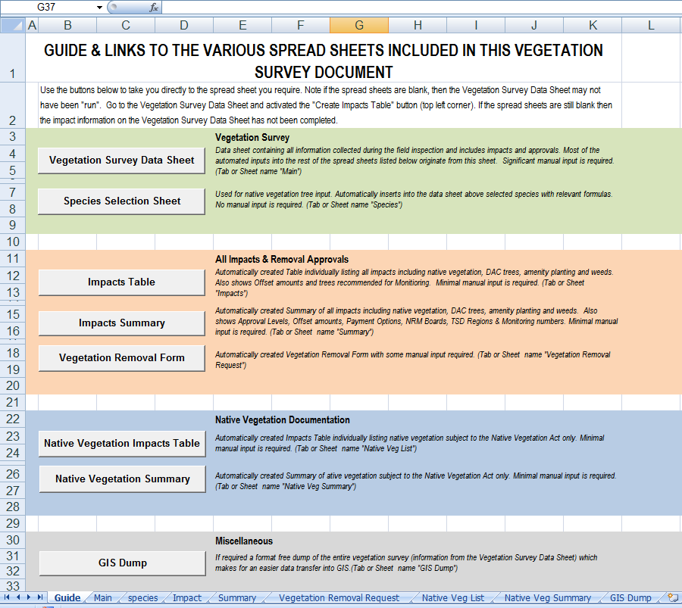
Spread Sheet Descriptions
Short-cut Buttons to various Spread Sheets
Spread Sheet Tabs

SPREAD SHEET TAB 2 – “Main”
This Spread Sheet is the primary input sheet and is generally known as the “Datasheet”. When completed it will contain all data collected during the field inspection, including assessed impact and approval information for individual entries and other information based on a variety of sources. Most of the automated inputs on the other spread sheets originate from this sheet. Significant manual input is required.

Beware! - There are many “hidden” columns and rows, which are an integral part of the “running” of this and the other spread sheets. Care should be taken not to inadvertently delete any of these columns or rows.
Cells which show a small green triangle in the top left corner contain formulas. Do not over-write. If inadvertently over-written copy/paste formula from another cell in the same column (Not to be used for columns “BY” and “CL” as they contain different formulas for different species).
Always try to use the “Insert Row” button at the top left of the sheet to insert rows onto the bottom of the sheet. Rows can be inserted well ahead of your input. If a row(s) needs to be inserted elsewhere, use the normal Excel “insert row” then copy/paste an entire row which is known to contain the formulas.
Some “on screen” comments are available (indicated by a small red triangle in the top right corner) and can be accessed by passing the mouse over the relevant cell. See following example.

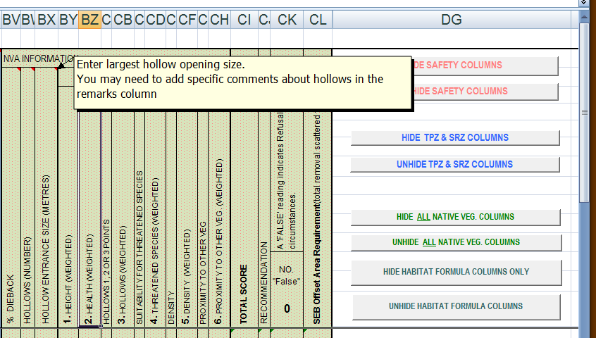

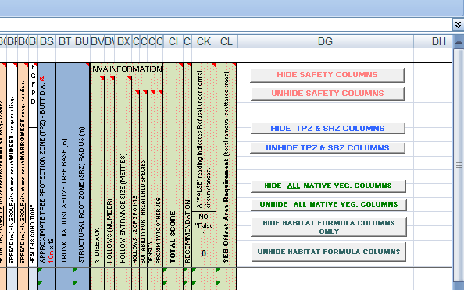
Various Buttons to “Hide” or “Unhide Columns as required
Button 1
Button 3
Button 5
Button 6
Button 7
Button 8
Button 4
Button 2

Buttons are also provided in the top right of the sheet which allows certain columns to be “hidden/unhidden”. Use these buttons to modify the data sheet to suit the information being provided for a particular survey. A description of each button is as follows:
Button | Button Description
1 | Hide Safety Columns  Refers to columns “G” to “L” inclusive. Use this button to “hide” the safety columns if you are not undertaking a safety type survey.
2 | Unhide Safety Columns  Refers to columns “G” to “L”inclusive. Use this button to “unhide” the safety columns if hidden and required.
3 | Hide TPZ & SRZ Columns  Refers to columns “BS” to “BU” inclusive. Use this button to “hide” these columns if not relevant to the survey.
4 | Unhide TPZ & SRZ Columns  Refers to columns “BS” to “BU” inclusive. Use this button to “unhide” the TPZ & SRZ columns if hidden and required.
5 | Hide All Native Veg. Columns  Refers to columns “BV” to “CL” inclusive. Use this button to “hide” the Native Vegetation columns if survey area is outside the area covered by the Native Vegetation Act or no native vegetation (subject to the Act) was recorded.
6 | Unhide All Native Veg. Columns  Refers to columns “BV” to “CL” inclusive. Use this button to “unhide” the Native Vegetation columns if hidden and required.
7 | Hide Habitat Formula Columns  Refers to columns “BY, BZ, CB, CD, CF, CH”. Use this button to “hide” the Habitat Formula columns. These columns are automatically inputted and are normally hidden unless being viewed as part of checking.
8 | Unhide Habitat Formula Columns  Refers to columns “BY, BZ, CB, CD, CF, CH”. Use this button to “unhide” the Habitat Formula columns if required for checking purposes.
General – Inputs Required
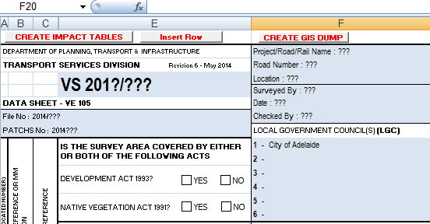
Allocate a Local Government Area(s) to each number. May be more than one Council Note not all numbers need to be used. If outside council areas write “Out of Council” next to number “1”.
Insert Vegetation Survey Number
“Check” relevant boxes
Insert information provided
Insert DPTI file & PATCHS numbers if provided
Excel column ID

Add information to the following columns if relevant to the survey. Note the completion of some columns is compulsory for the successful “running” of the spread sheets. The table below lists each column by Excel column ID (refer above) and a description of the information required to be inputted.
Column | Column Input Description
A | LGA (Allocated Number) – Compulsory Input Column - If outside council areas, insert “1”.  Insert the “allocated” Local Government number.
B | Plan Reference or MM Location - Compulsory Input Column  Insert either the Maintenance Marker Location (MM) or Plan Reference (either photo number or chainage). Maintenance Marker Locations are generally used when plans are not available. The Plan Reference is normally the same as the photographic reference number. The number of decimal points may need to be adjusted depending on the reference used. The default is “no decimal point” which is suitable for Plan references; at least 2 decimal points should be provided for a MM reference.
C | Photo Reference - Compulsory Input Column  Refers to the numbers allocated to photographs. This should also correspond with the numbers shown on any plans (see above). This unique number is used for specific identification and location on site, and for identifying impacted vegetation for approvals. Numbers should be allocated in a logical manner; sequential and with minimal subservient numbering/lettering. Note - if, for whatever reason, the field work was undertaken more “randomly” (i.e. return visits) then the numbering for data entry, photos and plans may need to be redone.
D | A Hidden Column created for the successful “running” of the various spread sheets.
E | Species or Group/Area Description - Compulsory Input Column  Describe one of the following:  - if a general photo – give a general vegetation description; photo direction etc  - if information pertains to an individual tree/shrub or group of trees/shrubs – give species using correct botanical nomenclature:  - Native vegetation (subject to NVA) species identification should be to sub species  - Amenity vegetation, where known or easily identified, should be to species, else genus  - DAC trees should be to species  - Weeds and others, where known or easily identified, should be to sub species, else species  - Native vegetation (not subject to NVA), where known or easily identified, should be to species, else genus  If a group photo is taken and a mix of vegetation is being reported then a separate line will be required for each vegetation type/species  For further information see attached “Main” sample.
F | Remarks/Notes  Can be used to;  - expand the species list (i.e. include understorey species, or general comments on weed species)  - make comment on the condition of individual trees and/or areas of vegetation/plant associations etc  - provide required information for multi-stemmed DAC trees  - any other relevant information
G | Clearance Envelope  A validated cell with a drop-down selection of either “S” for Standard or “R” for Restricted. Clearance envelope information for only Metro & Eastern Regions can be found in the Vegetation Removal Policy
H | Side of Road – for ARB, clearance envelope and safety surveys  A validated cell with a drop-down selection of either “L” for Left or “R” for Right. The side of the road/rail is left or right according to increasing maintenance markers. Note not always required if not on a roadside
I | Width of the Travelled way – for ARB, clearance envelope and safety surveys  Width (m) of the pavement edgeline to edgeline or edge of seal if no edgeline is present.
J | Distance – Centreline to Edgeline/Edge of Seal – for ARB, clearance envelope and safety surveys  Distance (m) to edgeline or edge of seal if no edgeline is present
K | Distance of Tree from the Edgeline/Edge of Seal – for ARB, clearance envelope and safety surveys?  Distance (m) from the closest point to the road of the tree trunk to edgeline or edge of seal if no edgeline is present.  Highlight cell if tree trunk is located behind guard railing
L | Clearance @ Edgeline OR Edge of Envelope for ARB, clearance envelope and safety surveys?  Vertical measurement at edgeline or Edge of Clearance Envelope
M-P | Impact or Recommended Action  To be completed when project impacts are known – To enter a “tick” enter a capital “P”
Q | Off-set is Negated - DEAD vegetation with no habitat value - Compulsory Input Column once impacts are known  A validated cell with a drop-down selection of either “Y for Yes or “N” for No. Usual input “N” – for exceptions refer to Vegetation Removal Policy.
R | Veg is structurally unsound/within the Clearance Envelope etc - Compulsory Input Column once impacts are known  A validated cell with a drop-down selection of either “Y for Yes or “N” for No. Refer to Vegetation Removal Policy.
S | REGULATION 5(1)(lb) APPLIES - Compulsory Input Column once impacts are known  A validated cell with a drop-down selection of either “Y for Yes or “N” for No. The DPTI Environmental Planner will indicate whether or not clearance will be under Regulation 5(1)(lb). Refer to Vegetation Removal Policy
T | Area reporting selected in lieu of individual reporting - Compulsory Input Column once impacts are known  A validated cell with a drop-down selection of either “Y for Yes or “N” for No. Annotate “Y” if an ‘area’ assessment method is used. For further information see attached “Main” sample.
U | AREA OF VEGETATION TO BE REMOVED (m²)  Complete if reporting an area of vegetation and Y is ticked in column T
V | AREA TO BE REMOVED SUBJECT TO THE NVA (m²)  Complete if reporting an area of vegetation which is subject to the Native Vegetation Act. This should be the same number as in the previous column “U”.
W | NVA SEB Multiplication Factor (Condition) Compulsory Input Column when Native Veg area assessed  Complete if reporting an area of vegetation which is subject to the Native Vegetation Act. Refer to the Vegetation Removal Policy for condition assessment
X | NVA SEB for AREA (HA)  Automatic Input Column – Do not over write
Y | Easting  Insert GPS reading. GPS (Geographical Positioning System) to be used is WGS84
Z | Northing  Insert GPS reading. GPS (Geographical Positioning System) to be used is WGS84
AA | NUMBER IN GROUP  Is the number of specimens being reported on within a particular photo. Often this number is ‘1’, but will vary when a group photo is used. As an example, a group photo of 5 trees is taken. The number in this column will be 5. Specific numbers are not necessary for specimens (excluding native vegetation subject to the NVA) with a butt dia less than 0.15m; or multi stemmed specimens with stems less than 0.10m butt dia, but some indication of amount e.g. ‘many, some, few’ should be noted in this column. (For a definition of single-stemmed and multi-stemmed specimens see page 22, figures 1 & 2)
AB-BB | Are Hidden Columns containing automatic formulas and are required for the successful “running” of the various spread sheets.
BC | WEED SPECIES & OTHERS (N; D; E; O) - Compulsory Input Column  A validated cell with a drop-down selection of the following :  - N – NO – None of the following  - D - Declared Plant  - E - Environmental weed - refer TSD list  - O – Other - Self seeded plants (excluding indigenous vegetation)  - M - (Mixed - A range of above)]
BD | Amenity Planting or has Amenity Value - Compulsory Input Column  A validated cell with a drop-down selection of either “Y for Yes or “N” for No.  Definition - All planted vegetation. Self seeded vegetation (excluding indigenous vegetation) which has high amenity value can be included here (eg large self seeded oak tree). Note: if included here select "N" for previous column (BC).
BE | NATIVE VEGETATION - Compulsory Input Column  A validated cell with a drop-down selection of either “Y for Yes or “N” for No  Definition - Naturally occurring, indigenous vegetation.
BF | SUBJECT TO NATIVE VEGETATION ACT - Compulsory Input Column  A validated cell with a drop-down selection of either “Y for Yes or “N” for No. Note - If this is ticked, so should BE be ticked.
BG | SUBJECT TO DEVELOPMENT ACT- Compulsory Input Column  A validated cell with a drop-down selection of either “Y for Yes or “N” for No.  For definition see Appendix B
BH | REGULATED (R) OR REGULATED SIGNIFICANT TREES (S)  Only complete if tree is subject to the Development Act and meets Regulated/Significant criteria A validated cell with a drop-down selection of either “R” for Regulated or “S” for Significant.
BI | NO IN GROUP WITH BUTT DIA. 0.15+ OR MS 0.10+  Is the number of specimens being reported on within a particular photo. Often this number is ‘1’, but will vary when a group photo is used. As an example, a group photo of 5 trees is taken. 3 of those trees have a butt dia less than 0.15m; or are multi stemmed specimens with stems less than 0.10m butt dia. The input into this column is "3".
BJ | SINGLE-STEMMED(S) OR MULTI-STEMMED(M) SPECIMEN - (See figures 1 & 2 below for definitions)  A validated cell with a drop-down selection of “S” for Single-stemmed; “M” for Multi-stemmed; “S/M” for a mixed group of single and multi-stemmed specimens.
BK | BUTT DIA (M) - (IN GROUP AND/OR MS SITUATIONS INSERT HIGHEST RANGE READING)  Diameter to be measured at 1m above natural ground level. Insert butt diameter in metres. In group or multi-stemmed (MS) situations insert largest butt dia (eg if the range of butt diameters in a group and/or for a multi-stemmed specimen is between 0.05m and 0.20m insert the number '0.20')
BL | BUTT DIA (M) - (IN GROUP AND/OR MS SITUATIONS INSERT LOWEST RANGE READING)  Diameter to be measured at 1m above natural ground level. Insert butt diameter in metres. Only use this column in a group or multi-stemmed (MS) situation insert smallest butt dia
BM | CIRCUMFERENCE (M) DEVELOPMENT ACT REQUIREMENT ONLY  This column is specifically related to trees covered by the Development Act. Insert the trunk circumference measurement (metres).  A physical measurement (not estimated or converted from the butt dia. measurement) of circumference of the trunk at 1m above natural surface is required. Where the tree is multi-stemmed the number of stems, the measured circumference of each stem and the average stem size is to be provided in the Remarks Column (Column F). The total of stems circumferences should be recorded in Column BM
BN | HEIGHT (m) - In GROUP situations insert HIGHEST range reading  Height of the specimen can be measured by various means but the accuracy shall be + 10%. In group situations insert maximum height range (eg if the height range of a group is between 3m and 9m insert the number '9')
BO | HEIGHT (m) - In GROUP situations insert LOWEST range reading  Height of the specimen can be measured by various means but the accuracy shall be + 10%. In group situations insert maximum height range (eg if the height range of a group is between 3m and 9m insert the number '3')
BP | SPREAD (m) - In GROUP situations insert WIDEST range reading  Spread of the specimen can be measured by various means but the accuracy shall be + 10%. In group situations insert maximum spread range (eg if the spread range is between 2m and 7m then insert the number '7').
BQ | SPREAD (m) - In GROUP situations insert NARROWEST range reading  Spread of the specimen can be measured by various means but the accuracy shall be + 10%. In group situations insert maximum spread range (eg if the spread range is between 2m and 7m then insert the number '2').
BR | HEALTH & CONDITION  Insert one or a combination of the following:  E – Excellent  G – Good  F – Fair  P – Poor  D - Dead  Some of the things to considered when assessing health and condition :  * Structural stability, hollow trunks/limbs  * Form and structure  * Growth patterns not typical  * Nutrient problems  * Suppressed by other vegetation  * Disease and/or insect attack eg. signs of termite/borers  * Heavy scarring and/or damage  * Arboriculture work required.  * Vigour, age and future potential  * Any other observations
BS | APPROXIMATE TREE PROTECTION ZONE (TPZ) - BUTT DIA. @ 1.0m x 12  Automatic Input Column – Do not over write  Approximate measurement is based on 1m instead of 1.4m (breast height- standard). This is done to reduce data collection requirements on site. Consequently the approximate TPZ shown here will normally be slight larger than the standard.
BT | TRUNK DIA. JUST ABOVE TREE BASE (m)  Insert measurement
BU | APPROXIMATE STRUCTURAL ROOT ZONE (SRZ  Automatic Input Column – Do not over write
BV | NVA Information - % DIEBACK Compulsory Input Column for NATIVE VEG covered by the Act only  Insert % dieback eg 30 for 30 %. 'Dieback refers to the proportion of the possible tree volume that is missing or is 'dead' due to ill health/senescence. For further information see 'Scattered tree clearance assessment in South Australia' Appendix 3, page 98.
BW | NVA Information - HOLLOWS (NUMBER) Compulsory Input Column for NATIVE VEG covered by the Act only  Insert the number of visible hollows
BX | NVA Information - HOLLOW ENTRANCE SIZE (METRES)  Insert hollow entrance size
BY | NVA Information - 1. HEIGHT (WEIGHTED)  Automatic Input Column – Do not over write  Relevant to species listed on 'species' sheet. If an unlisted species is entered and considered to be a tree or large shrub, then the HEIGHT formula will need to be changed.  A height category will need to be established and formula adjusted as per "Scattered Tree clearance Assessment in South Australia" Appendix 3, page 105
BZ | NVA Information - 2. HEALTH (WEIGHTED)  Automatic Input Column – Do not over write  Based on 'dieback' input.
CA | NVA Information - HOLLOWS 1, 2 OR 3 POINTS Compulsory Input Column for NATIVE VEG covered by the Act only  Enter score of 1, 2 or 3.  1=No hollows visible  2=1-4 small (<100mm) or 1 medium (100mm to 150mm) visible  3=5+small or 2+ medium or 1+ large (>150mm) or 1-4 small and 1 medium visible
CB | NVA Information - 3. HOLLOWS (WEIGHTED)  Automatic Input Column – Do not over write  Based on 'Hollows 1, 2 or 3 points'.
CC | NVA Information - SUITABILITY FOR THREATENED SPECIES Compulsory Input Column for NATIVE VEG covered by the Act only  Suitability for threatened species for feeding, roosting, nesting, shelter etc  1=None (Common only)  2=One uncommon species (at regional, state or national level)  3=At least 2 uncommon or 1 or more rare species (at regional, state or national level)
CD | NVA Information - 4. THREATENED SPECIES (WEIGHTED)  Automatic Input Column – Do not over write  Based on 'Suitability for Threatened species' input.
CE | NVA Information – DENSITY Compulsory Input Column for NATIVE VEG covered by the Act only  Distance to nearest neighbours measured from canopy edge to nearest tree  1=Widely spaced. More than 50m or two tree less than 50m apart but more than 50m away from other trees  2=Mid-densely separated. 3 or more trees each within at least 5 to 50m of at least 1 other tree in the group or 2 trees less than 5m apart, with at least one being within 5 to 50m of another tree  3=Close. 3 or more trees each within 5m of at least 1 other tree in the group
CF | NVA Information - 5. DENSITY (WEIGHTED)  Automatic Input Column – Do not over write  Based on 'Density' input
CG | NVA Information - PROXIMITY TO OTHER VEG Compulsory Input Column for NATIVE VEG covered by the Act only  Distance from tree to block of native vegetation (bushland)  1=200m or more  2=between 50 & 200m  3=within 50m  What constitutes bushland as opposed to clumps of scattered trees? If area of native vegetation is:  - greater than 1 hectare in size and  - contains a good complement of understorey and overstorey species similar to the original vegetation association and  - it possesses an overstorey resembling the original density.  For further information see 'Scattered tree clearance assessment in South Australia' Appendix 3, page 106t
CH | NVA Information - 6. PROXIMITY TO OTHER VEG. (WEIGHTED)  Automatic Input Column – Do not over write  Based on 'Proximity to other vegetation' input
CI | NVA Information - TOTAL SCORE  Automatic Input Column – Do not over write  Total Tree Score
CJ | NVA Information - RECOMMENDATION  Automatic Input Column – Do not over write  Automatic insertion based on 'Total Score’ input  1= Refusal  0=Conditional Consent  For further information see 'Scattered tree clearance assessment in South Australia' Appendix 3, page 106
CK | NVA Information - A 'FALSE' reading indicates Native Vegetation Removal Refusal under normal circumstances.  Automatic Input Column – Do not over write  Automatic insertion based on 'Total Score’ input. If ‘Recommendation’ column reading is ‘1’ then ‘FALSE’ (refusal) will be inserted here.
CL | NVA Information - SEB Offset Area Requirement (total removal scattered trees)  Automatic Input Column – Do not over write  Set aside area requirement (SEB). This column should contain the same number as the previous column “CK” unless “CK” = “FALSE”
CM-DE | Are Hidden Columns containing automatic formulas and are required for the successful “running” of the various spread sheets.

Definitions
MULTI STEMMED
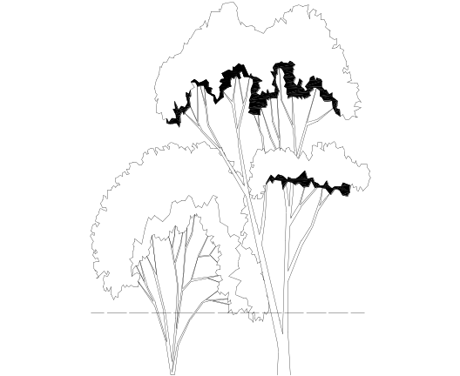
Figure 1
SINGLE STEMMED
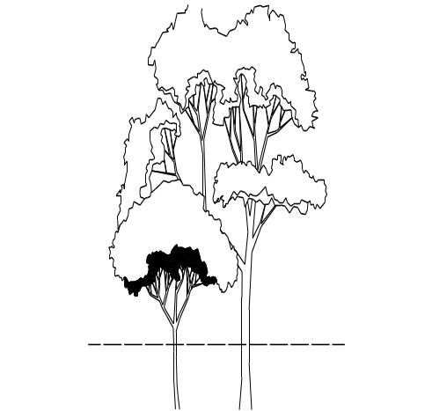
Figure 2
1.0m above natural surface
1.0m above natural surface

SPREAD SHEET TAB 3 – “species”
Used for native vegetation, subject to the Native Vegetation Act, tree formula input. Automatically inserts into Tab 2 - Main data sheet (above) selected species with species-specific height formulas. No manual input is required. (Tab or Sheet name "Species").
The species are listed alphabetically. Find the required species; press “insert” button to the left – the species and related formulas will be inserted on “Main” at the bottom of the sheet. Copy and paste – special – formulas – if inserting above the last completed line.
Height Column – contains the formulas which will vary for each species. All other formulas remain the same.
Species list
Notes and/or descriptions
Insert buttons
Instruction to add a new species to list
Hyperlink to National Parks & Wildlife Regulations

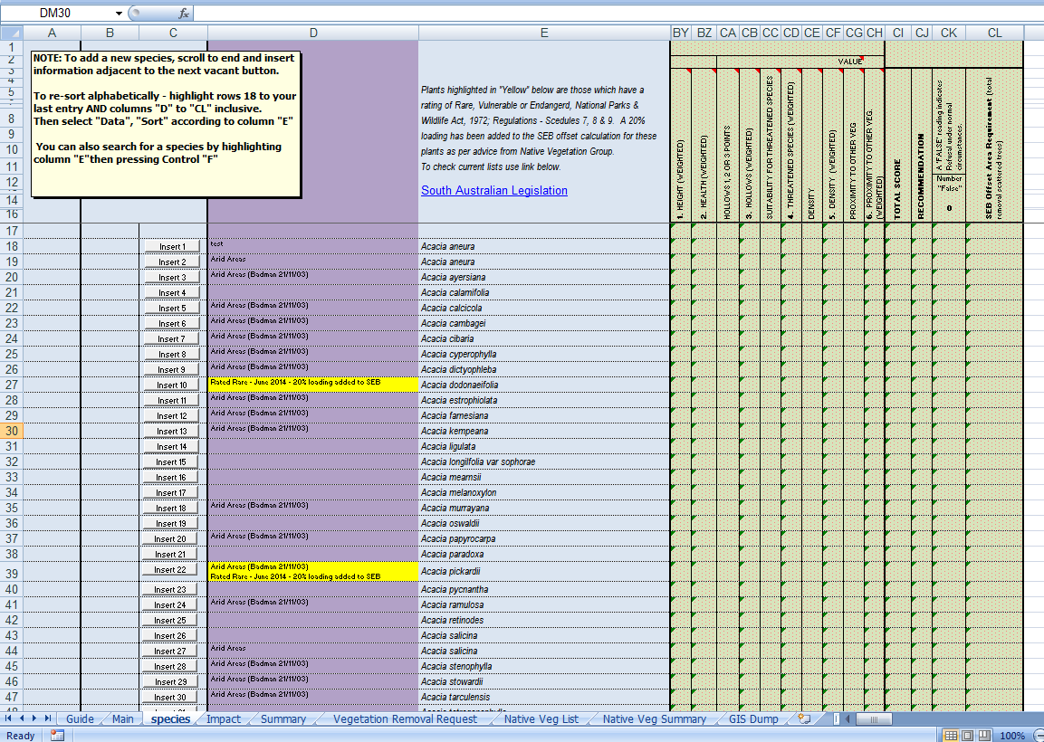

SPREAD SHEET TAB 4 – “Impact”
Automatically created table individually listing all impacts, including native vegetation, DAC trees, amenity planting and weeds. This table is populated when the impacts are completed on “Main” and the “Create Impacts Table” button is activated (top left corner of “Main”). Also shows approvals, SEB/offset amounts and trees recommended for Monitoring. Minimal manual input is required (Tab or Sheet "Impact").
Only the cells highlighted in yellow, are manual input to be completed (if required).
Where NV subject to the ACT, insert each Local Government Council Land Value (See Appendix C). Note: Land values must correspond to the number allocated to the relevant Council on “Main”.
Date of Table Creation

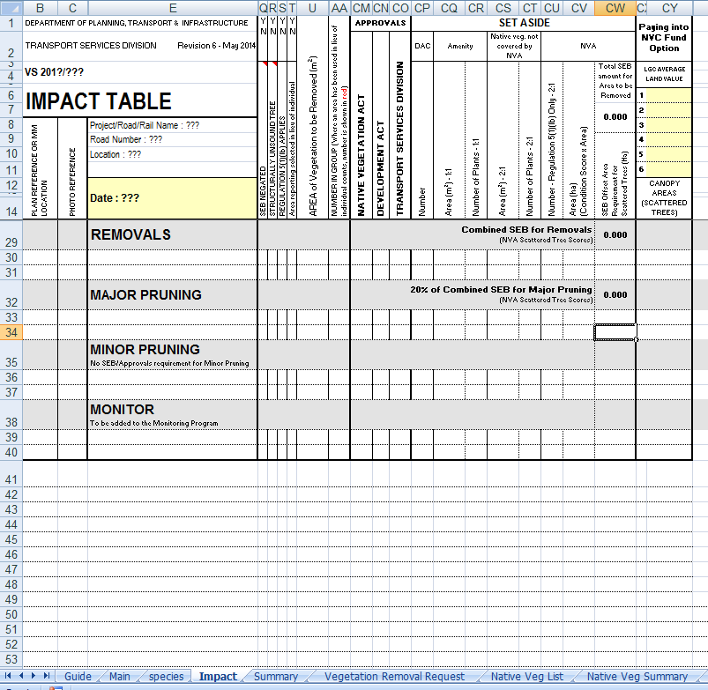

SPREAD SHEET TAB 5 – “Summary”
Automatically created 2 page summary of all impacts, including native vegetation, DAC trees, amenity planting and weeds. Also shows Approval Levels, Offset amounts, Payment Options, NRM Boards, TSD Regions & Monitoring numbers. Minimal manual input is required. (Tab or Sheet name "Summary"). This table is populated when the impacts are completed on “Main” and the “Create Impacts Table” button is activated (top left corner of “Main”).

Summary Page 1

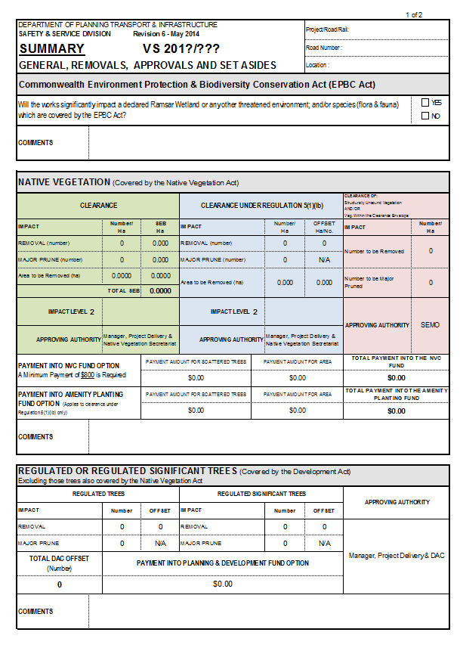
Check appropriate box
Change Approving Authority if required. If not relevant to the current survey input “N/A”
Comments as required
Comments as required
Comments as required
If not relevant to the current survey input “N/A”
Complete level and approving authority. If not relevant to the current survey input “N/A”
Complete level and approving authority. (See Veg Rem Policy for this) If not relevant to the current survey input “N/A”
Summary Page 2

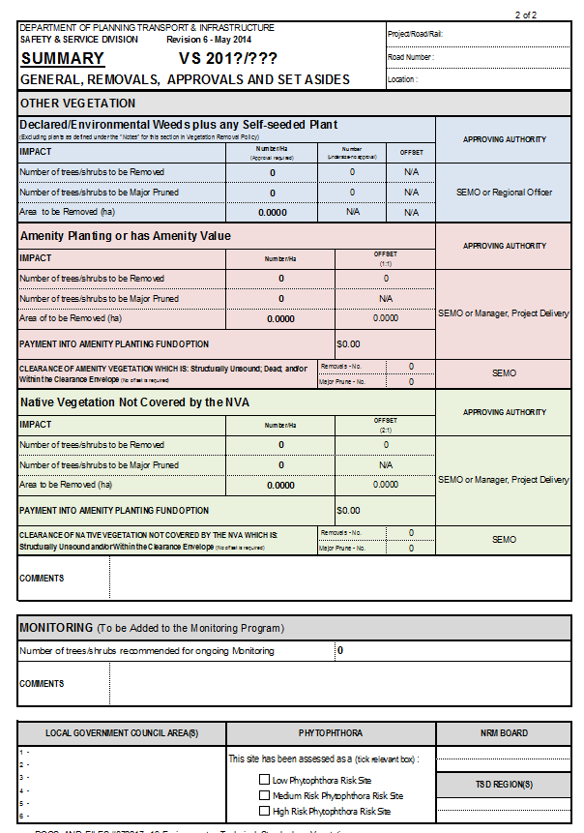
Change Approving Authority if required. If not relevant to the current survey input “N/A”
Change Approving Authority if required. If not relevant to the current survey input “N/A”
Change Approving Authority if required. If not relevant to the current survey input “N/A”
Comments as required
Comments as required
If not relevant to the current survey input “N/A”
If not relevant to the current survey input “N/A”
Select from drop-down list
No longer applies; ignore
Check relevant box

SPREAD SHEET TAB 6 – “Vegetation Removal Request”
Automatically created 2 page “Vegetation Removal Request” form. This form is generally completed by the DPTI Environmental Planner, however may be required of a Contractor. Areas where manual input is/may be required are highlighted in blue.

Vegetation removal Request Page 1
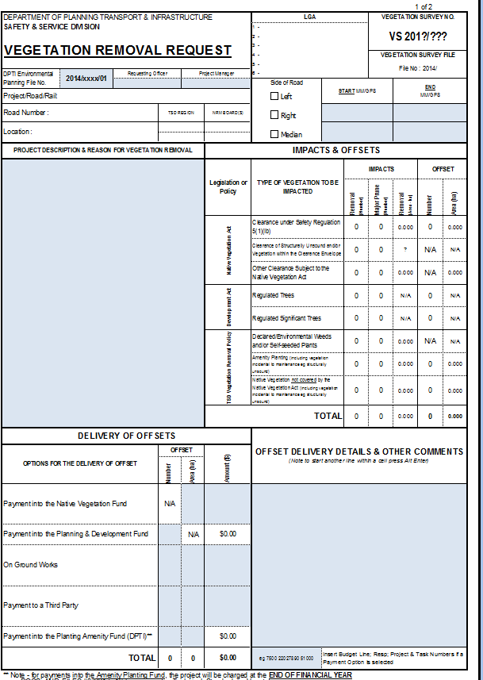

Vegetation removal Request Page 2

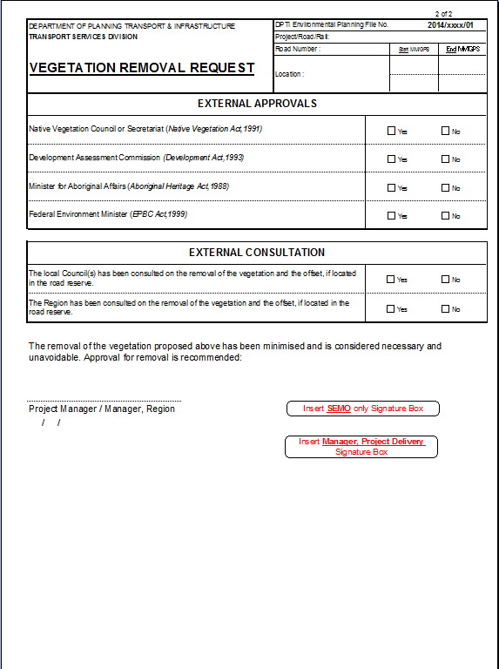
Check either “Yes” or “No” for each approval type
Check either “Yes” or “No” for each consultation type
Activate relevant signature box by selecting appropriate button. This button can be used to toggle between the 2 signature boxes if required

SPREAD SHEET TAB 7 – “Native Veg List”
Automatically created list specifically developed to be included in submissions for native vegetation clearance. It contains a list of impacted native vegetation (subject to the Native Vegetation Act only), including SEB amounts. Only the creation date is required as a manual input. Removal and major pruning information will be automatically populated once the data sheet (Create Impact Tables button) has been “run”.

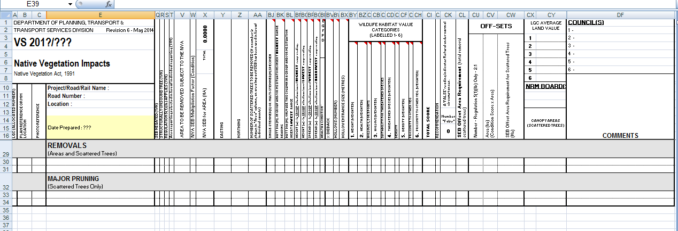
Comments as required

SPREAD SHEET TAB 8 – “Native Veg Summary”
Automatically created summary of native vegetation subject to the Native Vegetation Act only. Comments box is the only manual input required, if relevant.

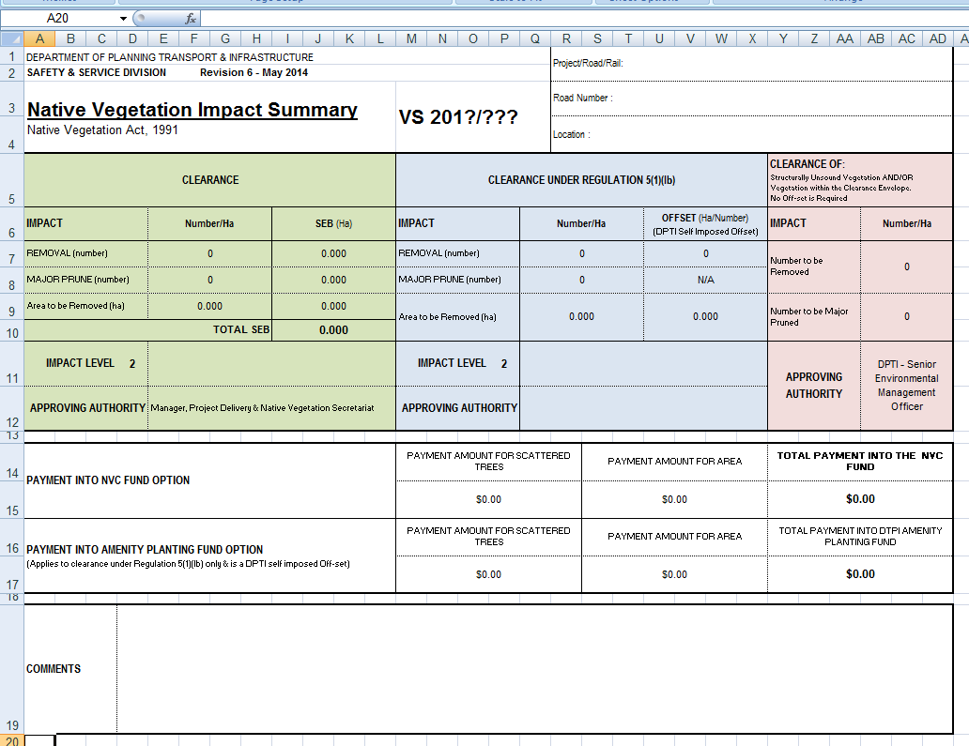
Comments as required

SPREAD SHEET TAB 9 – “GIS Dump”
If required an automatically created format free dump of the entire vegetation survey (information from the Vegetation Survey Data Sheet) which makes for an easier data transfer into GIS. This dump is initiated by activating the “Create GIS Dump” button located in the top left corner of Spread Sheet 2 “Main”. No manual input is required.

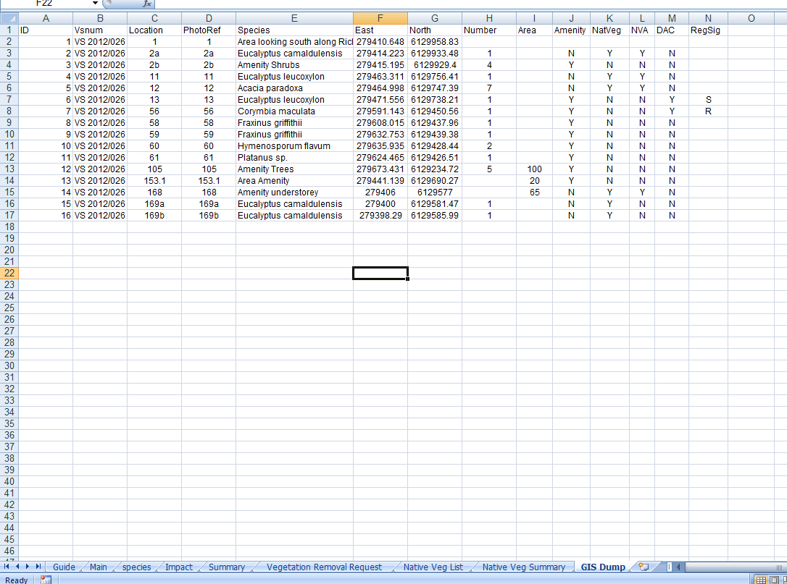

Photographs are taken to communicate the data and to provide a visual record of the vegetation. Photos should:
- be presented in electronic “Word” files using the DPTI Photo Template (Knet #9366130) [Internet Link Technical Standards and Guidelines (Road & Marine)]. Photos are to be inserted “In Line with Text” (see below) to avoid formatting difficulties if photos are removed or additional photos inserted. The Template shows examples of annotation and photo size. These example photos are to be removed and information relevant to the project inserted, however similar annotation and SAME photograph sizing should be incorporated.
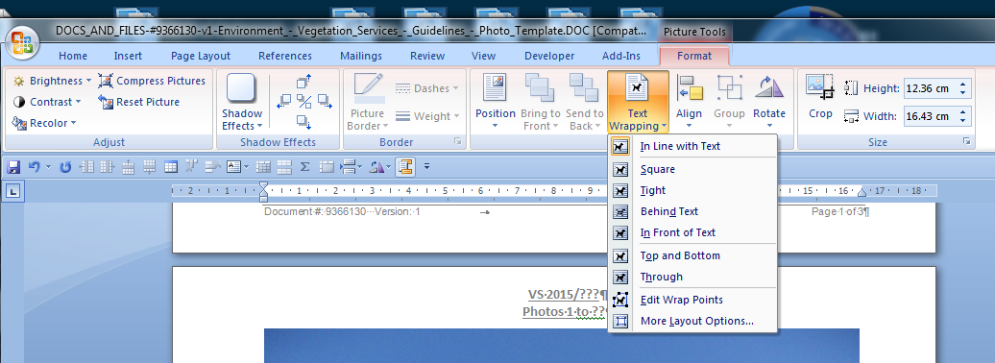
Ensure “In Line with Text” is selected

- be numbered sequentially and relate directly to those numbers shown on the data sheet and plans.
- clearly indicate the tree, group of trees or area being recorded on the data sheet, via arrows/annotated callouts on photograph, as per example.
- Show the whole tree or group of trees/shrubs – photos of trunks showing little or no canopy are not acceptable.
- Fit as much of the tree to the photo area as possible. Large areas of ground/sky are not useful.

Photographic requirements for each vegetation type are as follows:
Native Vegetation (Subject to the Native Vegetation Act)
Vegetation Assessed as Scattered Trees (As described under the Act including both trees and large shrub species)
- Individual or group photos
Vegetation Assessed as Areas
- Depending on the size of the area, 1 to 2 photos will normally be adequate (usually group or area start/finish). Additional photos can be taken if required, eg major changes in plant associations, including changes in condition. Where long linear areas are being assessed, photographs at the road edge, every 50 to 100m, or where the plant association changes, are acceptable. Additional photos looking back over each site/plant association change are useful but not essential. All photo locations and directions should be noted in the remarks column of the datasheet.
Regulated & Significant Trees (Subject to the Development Act)
- Individual photos

Amenity Vegetation
Trees & Large Shrubs
- Individual or group photos
Areas and/or low shrubs, ground covers, and grasses, including lawn areas
- Depending on the size of the area, 1 to 2 photos will normally be adequate (usually group/area start/finish. Additional photos can be taken if required.
Native Vegetation (Not Covered by the Native Vegetation Act)
Trees/Shrubs with 0.15m butt dia or greater (measured at 1.0m above the ground); or multi stemmed trees/shrubs with one or more stems 0.10m butt dia or greater (measured at 1.0m above the ground).
- Individual or group photos
Areas and/or low shrubs, ground covers, and grasses
- Depending on the size of the area, 1 to 2 photos will normally be adequate (usually group/area start/finish. Additional photos can be taken if required.
Declared & Environmental Weeds. (Including self-seeded plants)
Trees/Shrubs with 0.15m butt dia or greater (measured at 1.0m above the ground); or multi stemmed trees/shrubs with one or more stems 0.10m butt dia or greater (measured at 1.0m above the ground).
- Photos generally only required if the plants have amenity value. Group photos are acceptable.

The Species List (Microsoft Excel) forms part of the report and is a list of plant species found during the survey. As with the data sheet, instructions/comments/notes are contained within the Template (Knet #974798) [Internet Link Technical Standards and Guidelines (Road & Marine)]. These instructions/comments/notes are visible ‘on screen only’ when the mouse is passed over the cell highlighted with a small red triangle in the top right corner.
A semi-automated option to insert listings directly from ‘Florlist’ (R.E.Taplin, January 2014) is available.
Information to be provided includes:
- Family
- Genus
- Species
- Common Name (one only)
- Conservation Status (Lang & Kraehenbuehl, NPW/EPBC Acts).
- Plant Association(s) number in which it was found
- Differentiate between indigenous, exotic, declared weeds (Natural Resources Management Act 2004) and environmental weed species (DPTI list)
One electronic copy of report is required.

Most surveys will require plans and/or aerials showing numbering which is directly related to that on the data sheet and photos, identifying the location of vegetation surveyed. As a minimum, scanned, neatly annotated (hand or otherwise) copies of plans will be sufficient. The information presented on plans is to be similar to that shown on the following examples. Additional information can be provided if pertinent to the recording of the vegetation e.g. extent of plant associations; areas of high risk weeds etc.
Any plant shown individually on the original plan provided by DPTI, but which does not exist on site, is to be marked on the vegetation survey plan as ‘NF’ (not found). Any trees on site but not marked on the plan provided, should be marked on, to scale wherever possible.
Where design plans are not available, aerial imagery (sourced from Google Earth or alternative) is acceptable to show the area of proposed works and/or to annotate with photo numbers etc.
If requested, DAC and/or native vegetation (subject to NVA), are to be annotated differently on plans.
Where electronic plans are submitted, they must be editable and in “Word”, Autocad, Arcmap or similar (agreed) format. If the plan development work is sub-contracted out, the brief shall indicate the type of plans to be provided.

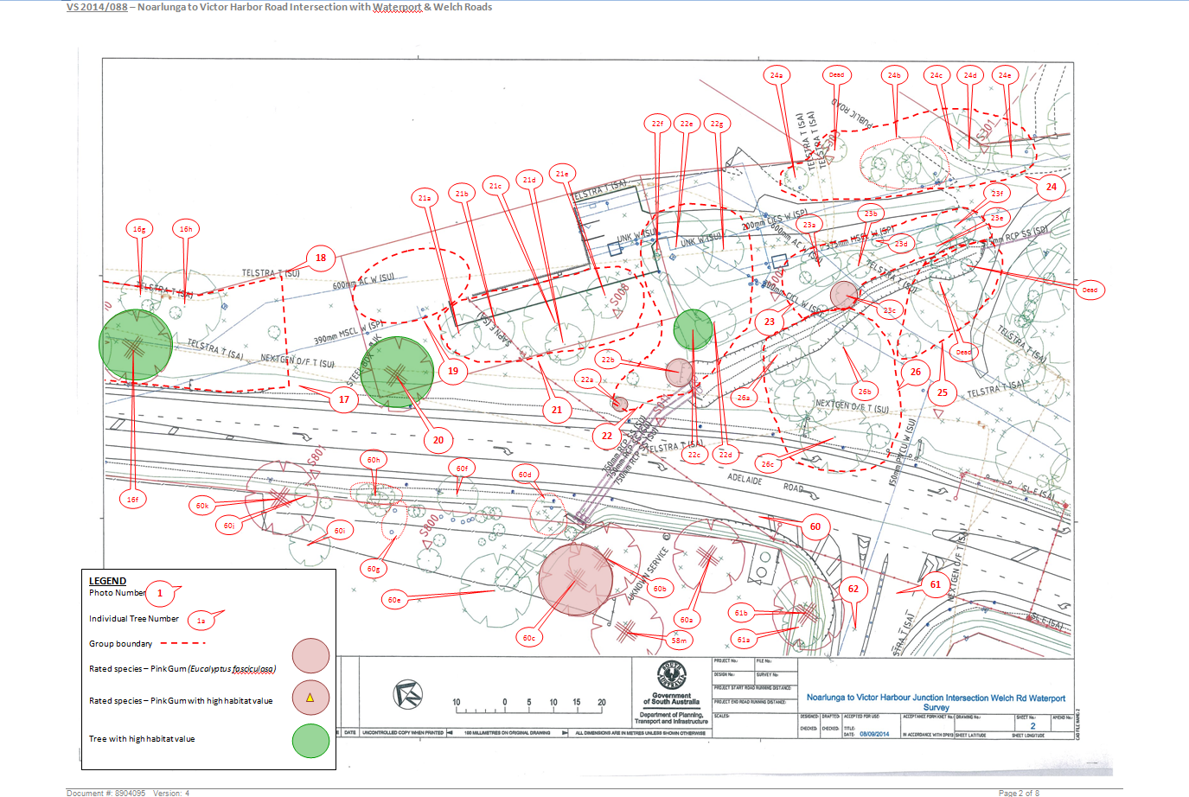
Example 1 – Scanned base drawing into ‘Word’ with annotation added in the Word document plus various highlighted vegetation

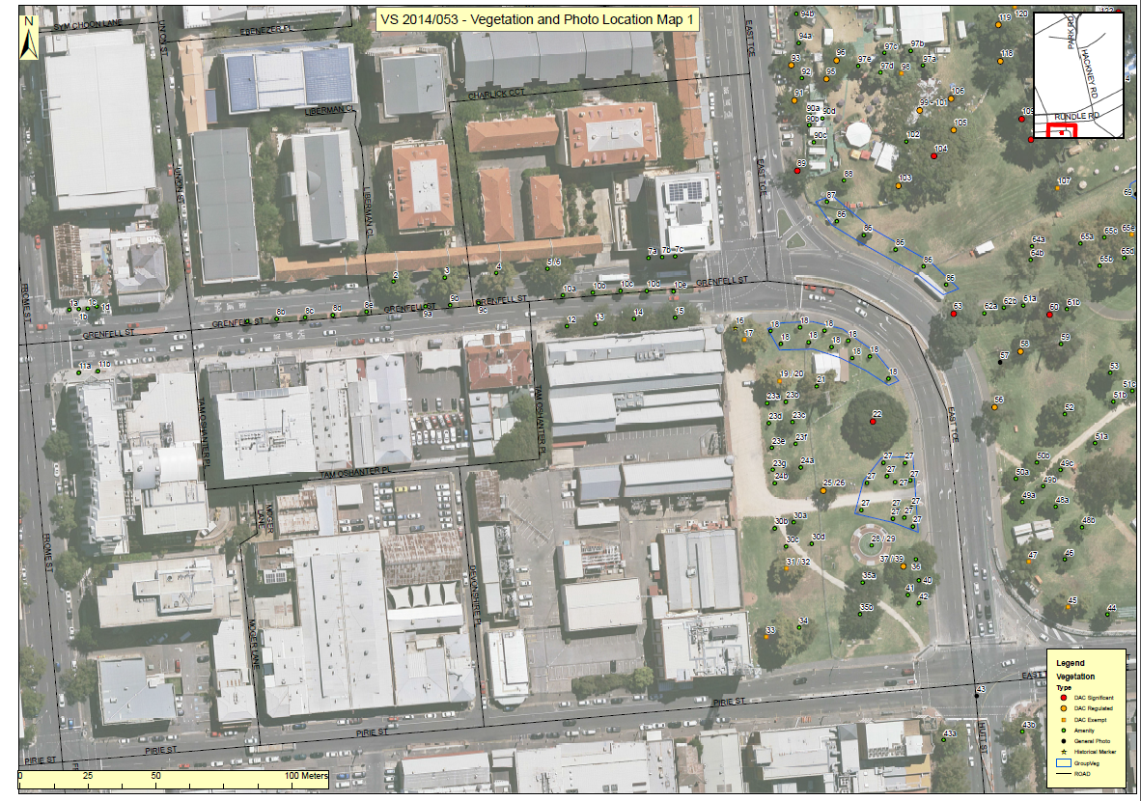
Example 2 – ArcMap generated plan

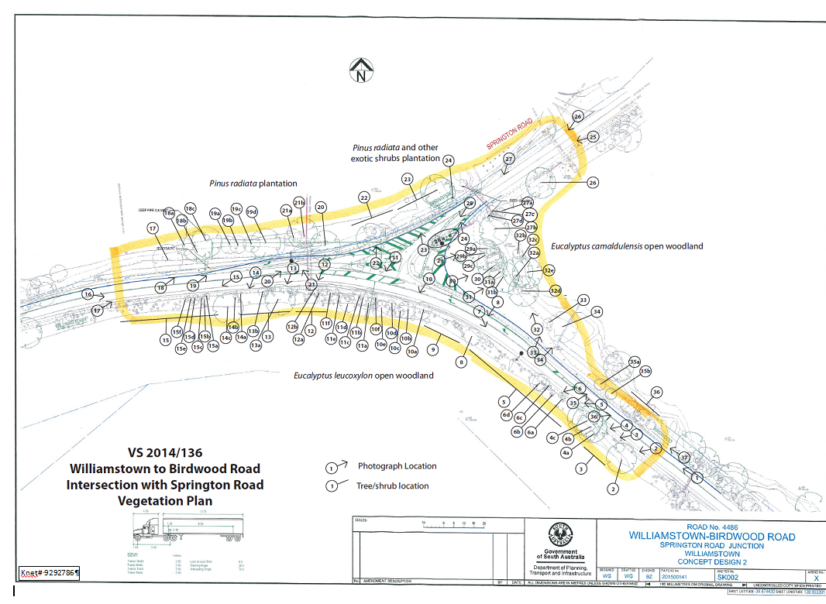
Example 3 - Scanned base drawing into ‘Word’ with annotation added in the Word document

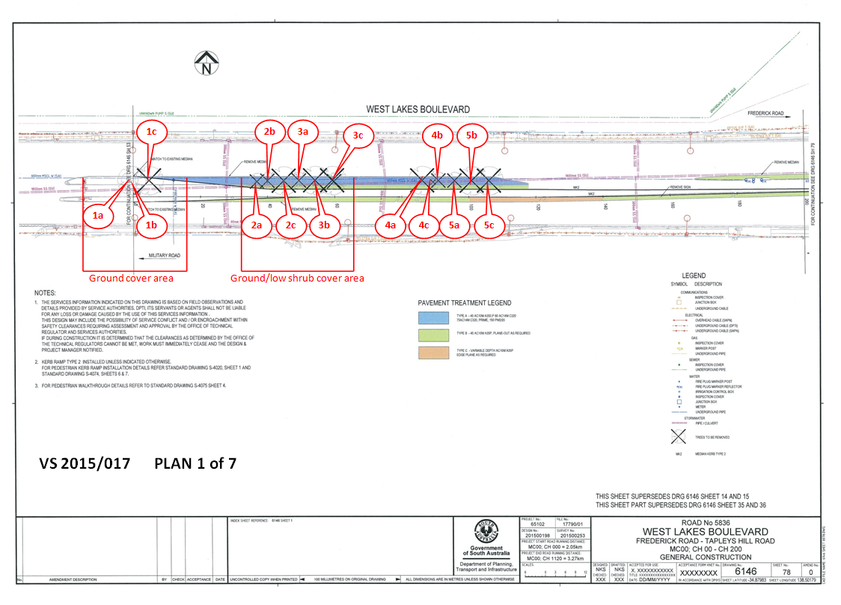
Example 4 – Small job - Scanned base drawing into ‘Word’ with annotation added in the Word document.

Provide reference(s), either within the main report text; as a footnote and/or in a reference listed at the end of the report.
- Development Act, 1993
- Council Development Plans via Planning SA website
- Environments of South Australia, Laut et al. 1977, CSIRO, Canberra
- DPTI RSSD (Roadside Significant Site Database)
- An Update of the Conservation Status of Major Plant Associations of South Australia, Neagle 1995
- Lang & Kraehenbuehl, Florlist, latest version based on National Parks & Wildlife Act, 1972, PART 2, Schedules 7, 8 & 9
- Commonwealth Environment Protection & Biodiversity Act, 1999
- Native Vegetation Act, 1991
- National Parks & Wildlife Act, 1972
- Scattered Tree Clearance Assessment in South Australia, DWLBC (Dept of Water, Land Biodiversity Conservation)
- Natural Resources Management Act 2004
- DPTI Environmental Weeds List
- Quarantined Area for Branched Broomrape [Map information available from PIRSA (Primary Industries & Resources SA)]
- DPTI Operational Instruction 21.3 [Phytophthora (Dieback) Control]
- Department of Environment and Natural Resources, SA, Updated December 2002

1 Introduction
As described in Section 3 of this Policy, DPTI will raise the level of approval for vegetation clearance to the next level if the clearance is “seriously at variance” with the Principles of Clearance. This Appendix outlines the procedures for assessing “seriously at variance”.
Under the Native Vegetation Act 1991 the Native Vegetation Council must not allow clearance of native vegetation that is “seriously at variance” with the Principles of Clearance below unless it complies with an exemption under the Regulations. A range of exemptions apply to The Department’s activities but in particular Regulation 5(1)(d) which states that “native vegetation may… be cleared if the clearance is incidental to the construction of a building or infrastructure and the Council is satisfied that the clearance is in the public interest”.
Principles of Clearance of Native Vegetation
Native Vegetation should not be cleared if in the opinion of the Council:-
  - it comprises a high level of diversity of plant species;
  - it has significance as habitat for wildlife:
  - it includes plants of a rare, vulnerable or endangered species;
  - the vegetation comprises the whole, or a part, of a plant community that is rare, vulnerable or endangered;
  - it is significant as a remnant of vegetation in an area which has been extensively cleared;
  - it is growing in or in association with, a wetland environment;
  - it contributes significantly to the amenity of the area in which it is growing or is situated; and
  - (i), (j) and (k) cover land management issues (addressed by relevant Natural Resources Management Board)
- the clearance of the vegetation would cause significant harm to the River Murray within the meaning of the River Murray Act 2003; (unlikely to be applicable to DPTI activities, addressed by referral to the Minister for the River Murray in accordance with any guidelines developed to guide the referral process and where impacts could be considered ‘major’ eg Level 3
- the clearance of vegetation would cause significant harm to the Adelaide Dolphin Sanctuary (unlikely to be applicable to DPTI activities)
Criteria are set out below to assist in determining whether vegetation clearance for work assessed by The Department under the Standard Operating Procedure is “seriously at variance” and therefore if the approval authority should be raised (refer Table 1 of the Vegetation Removal Policy). These criteria are to be used as a guide, as each project must be assessed individually and on its own merits.
In applying these guidelines, only the part of the site affected by the clearance proposal is to be considered when addressing the primary indicator and moderating factors.
In order to be as objective and consistent as possible a clearance scenario is judged to be “at variance” with a Principle with respect to a PRIMARY INDICATOR and then may be moderated to “not at variance” or “seriously at variance” after consideration of a number of other criteria.
If the vegetation removal is seriously at variance with any principle, the vegetation removal should be raised to ie. a joint sign off by the Director, Major and the staff of the secretariat to the Native Vegetation Council. If it is not seriously at variance, the approval can be undertaken by the Director, Projects.
(a) it comprises a high level of diversity of plant species
Primary indicator – total species count
The number of species expected in various associations based on structural formation (ie. Mallee, Woodlands, Shrubland, Grasslands etc) for each Floristic Region needs to be determined first as a baseline “pristine condition”. The DEH Biomaps can be used to access species lists for various associations from National Parks, Conservation Parks, Reserves and Heritage Agreements. Previous TSA Vegetation Surveys in the vicinity may also be useful. If projects are not near a reserve, local experts should be consulted. Vegetation is often relatively intact in these areas and can therefore be used to determine what would be considered a high level of species diversity for that association. High level species diversity for an association would be considered to be an association which is “intact” or vegetation close to “pristine” or pre-European settlement condition.
The species count at the project site should be compared with the total number of species in the baseline “pristine” area identified above.
Clearance of a remnant with a total species count greater than 70% of that of a nearby intact remnant would be “seriously at variance”.
Clearance of a remnant with a total species count of 50 - 70% of that of a nearby intact remnant would be “at variance”.
Clearance of a remnant with a total species count of less than 50% of the intact remnant would be “not at variance”.
Moderators
Season of survey
Spring time is when the total species observable and identifiable will be at its maximum. At other times, the perennial species will be observable, but the short-lived annual component is expected to be less. If a survey is not undertaken in spring a certain number of annuals should be added to the total to enable comparison with the baseline. This may elevate a clearance scenario to become “seriously at variance”.
Amount of clearance relative to area of remnant
Where clearance involves an area where both understorey and overstorey will be removed, the smaller the fragment, the higher impact a smaller clearance % will have. This should be viewed in the context of the diversity of the part to be cleared, not necessarily the diversity of the whole fragment. The following table can be used as a guide.
 | < 1 ha | 1-10 ha | > 10 ha
<10% clearance | at variance | at variance | at variance
10-25% clearance | seriously at variance | at variance | at variance
25-75% clearance | seriously at variance | seriously at variance | seriously at variance
>75% clearance | seriously at variance | seriously at variance | seriously at variance

Ease of replacement
Consideration should be given to which species are affected by the clearance and their:
- ease of propagation or regeneration
- time required to replace what has been removed
If this is “easy” and “short” respectively (ie in the order of up to 3 years to establish an equivalent offset), then the degree of variance may be tempered to “not at variance”. If this is “difficult” and “long” respectively, then degree of variance may be raised to “seriously at variance”.
(b) it has significance as a habitat for wildlife
Primary indicator –habitat for wildlife including threatened species
Assess the value of the vegetation for its habitat value particularly for threatened species. Threatened species are any species listed as “Rare”, “Vulnerable”, “Endangered” or “Critically Endangered” or “Conservation Dependant” under the National Parks and Wildlife Act, 1972 (South Australia) or the Environment Protection and Biodiversity Conservation Act, 1999 (Commonwealth).
Any threatened species likely to use the vegetation should be documented. Reference to standard texts on native fauna and their habitat requirements, relevant scientific reports and journals, Bird Atlas, Biological maps http://maps.deh.sa.gov.au/website/BioMaps/viewer.htm, EPBC online database http://www.deh.gov.au/erin/ert/epbc/imap/map.html, regional biodiversity plans, and relevant biological survey reports can provide information on threatened species’ distribution and habitat requirements. Advice can also be sought from the following sources regarding habitat values of areas of certain types of vegetation in different regions.
Use the following criteria as a guide to determine whether a clearance action will have a significant impact on a threatened fauna species and therefore, will be “at variance” with Principle (b).
A clearance action may have a significant impact on threatened fauna species if it does, will, or is likely to:
- lead to a long-term decrease in the size of a population, or
- reduce the area of occupancy of the species or an important population, or
- fragment an existing population into two or more populations, or
- adversely affect habitat critical to the survival of a species, or
- disrupt the breeding cycle of a population, or
- modify, destroy, remove, isolate or decrease the availability or quality of habitat to the extent that the species is likely to decline, or
- result in invasive species that are harmful to a threatened species becoming established in the threatened species´ habitat, or
- interfere with the recovery of the species.
An important population is one that is necessary for a species' long-term survival and recovery. This may include populations that are:
- key source populations either for breeding or dispersal,
- populations that are necessary for maintaining genetic diversity, and/or
- populations that are near the limit of the species range.
Moderators
Scattered Trees
The Biological Assessment Section (BAS) have developed and adopted a standard procedure for assessing the wildlife habitat of scattered trees called the Point Scoring System. The “cut off level” of 30 points represents the point score where BAS considers that clearance becomes “seriously at variance” with Principle b). Trees scoring below the cut-off are nevertheless valuable and their clearance may still be considered to be “at variance” but not “seriously at variance” with Principle b). However, if trees below the cut off score provide habitat for listed threatened species they may be considered to be “seriously at variance”.
Area of “significant habitat” to be cleared.
If the proposed impact on the habitat by the threatened species is limited to a small number of trees, shrubs, herbs, grasses or small area, the severity of impact may be reduced to “not at variance”. The set-aside area can sometimes provide better habitat and a net biodiversity gain than the vegetation being removed. The area of vegetation to be cleared may also provide linkages between other good quality habitat areas. This may increase the potential impact to “seriously at variance”.
Impact on “Migratory” species
For areas of vegetation, take into account if the vegetation to be cleared is likely to be habitat for migratory species. ”Migratory” species are listed in the Commonwealth Environment Protection and Biodiversity Conservation Act, 1999.
Use the following criteria as a guide to determine whether a clearance action will have a significant impact on a migratory fauna species.
A clearance action may have a significant impact on a migratory species if it does, will, or is likely to:
- substantially modify (including by fragmenting, altering fire regimes, altering nutrient cycles or altering hydrological cycles), destroy or isolate an area of important habitat of the migratory species, or
- result in invasive species that is harmful to the migratory species becoming established in an area of important habitat of the migratory species, or
- seriously disrupt the lifecycle (breeding, feeding, migration or resting behaviour) of an ecologically significant proportion of the population of the species.
An area of important habitat is:
- habitat used by a migratory species occasionally or periodically in a region that supports an ecologically significant proportion of the population of the species, or
- habitat used by a migratory species which is at the limit of the species’ range, or
- habitat in an area where the species is declining.
Listed migratory species cover a broad range of species with different life cycles and population sizes. Therefore, what is an ecologically significant proportion of the population varies with the species (each circumstance will need to be evaluated).
Definitions of Terms
Some of the criteria above refer to the concept of 'habitat critical to the survival of a species’. This habitat includes the critical habitat for many species identified in recovery plans for those species and the critical habitat on the Register maintained by the Minister for the Environment under the EPBC Act. However, there may not be recovery plans in place for all listed species, as plans take some time to prepare. Similarly, the Register may not be comprehensive. The absence of a recovery plan or the fact that an area may not be listed on the Register of Critical Habitat does not mean that there is no habitat critical to the survival of the species.
Habitat “critical to the survival of a species” may include areas that are necessary:
- for activities such as foraging, breeding, roosting, or dispersal,
- for succession,
- to maintain genetic diversity and long term evolutionary development, or
- for the reintroduction of populations or recovery of the species.
Habitat critical to the survival of a species will depend largely on the particular requirements of the species in question. For example, areas only incidentally used by a vulnerable species, and which the species is unlikely to be dependent upon for its survival or recovery, are not areas of habitat critical to the survival of a species.
Some of the criteria above refer to actions likely to lead to a "long-term decrease" in the size of a population or a "long-term adverse affect" on a community. Depending on the level of endangerment and the nature of the action, not all actions which create an immediate decrease in the population of a threatened species will have long-term consequences. For example, an action which causes injury or death to only one or a very small number of a species will not, except in the case of the most endangered of species, generally lead to a long-term or irreversible decrease in the population that normal processes, rates of mortality and recruitment could not buffer.
Ease of replacement
Consideration of which (plant association supporting the particular fauna)? species are affected by the clearance andits their:
- ease of propagation or regeneration
- time required to replace what has been removed
If this is “easy” and “short” respectively (ie in the order of up to 3 years to establish an equivalent offset), then the degree of variance may remain “at variance” or moderated to “not at variance” accordingly. If this is “difficult” and “long” respectively, then the degree of variance may be raised to “seriously at variance”.
(c) it includes plants of a rare, vulnerable or endangered species
Primary indicator – presence of listed plant(s)
For clearance to be “at variance” with this principle plant species being impacted upon must fit one of the following categories:
- At least one ‘Rare species’ as listed in the National Parks and Wildlife Act 1972 - Part 2, Schedule 9;
- At least one ‘Vulnerable species’ as listed in the National Parks and Wildlife Act 1972 - Part 2, Schedule 8;
- At least one ‘Endangered species’ as listed in the National Parks and Wildlife Ac, 1972 - Part 2, Schedule 7;
- Any plant species listed (Extinct in the Wild, Critically Endangered, Endangered or Vulnerable) under the Environmental Protection and Biodiversity Conservation Act 1999.
- Any plant species listed as “Endangered” or “Vulnerable” in a region by Lang and Kraehenbuehl (current Florlist update).
Moderators
Impact Significance
The following criteria can be used as a guide to determine whether an action will have a significant impact on listed threatened plant species and therefore, will be “seriously at variance”.
A clearance action will have, or is likely to have a significant impact on a threatened species if it may:
- lead to a long-term decrease in the size of a population, or
- reduce the area of occupancy of the species, or
- fragment an existing population into two or more populations, or
- adversely affect habitat critical to the survival of a species, or
- modify, destroy, remove, isolate or decrease the availability or quality of habitat to the extent that the species is likely to decline, or
- result in invasive species that are harmful to a threatened species becoming established in the threatened species´ habitat, or
- interfere with the recovery of the species.
Number of plants to be cleared
The number of individuals of the species (rare, vulnerable or endangered) that are proposed for removalas a percentage of what exists on the site) should be considered, plus the number of other sites where the same species are located.

Ease of replacement
Consideration of which species are affected by the clearance and their:
- ease of propagation or regeneration
- time required to replace what has been removed
If less than 10% are affected, or the affected individuals can be transplanted or replaced easily, the proposed clearance may be tempered to “not at variance”.
(d) the vegetation comprises the whole, or a part, of a plant community that is rare, vulnerable or endangered
Primary indicator – presence of listed plant community
For clearance to be “at variance” with this principle, plant communities being affected must be:
- Considered “Rare”, “Vulnerable” or “Endangered” according to Croft & Carpenter (2001), or
- “Poorly conserved (P)” or “Not Conserved (N)” according to Neagle (1995), or
- listed “Critically Endangered” or “Endangered” under the Environmental Protection and Biodiversity Conservation Act, 1999.
- Considered “Rare”, “Vulnerable” or “Endangered” according to IBRA rating.
Moderators
Impact Significance
The following criteria should be used as a guide to determine whether a clearance proposal will have a significant impact on a listed threatened plant community and therefore, will be “seriously at variance” with this principle.
An action has, will have, or is likely to have a significant impact on a threatened plant community if it does, will, or is likely to:
- lead to a long-term adverse affect on a plant community, or
- reduce the extent of a community, or
- fragment an occurrence of the community, or
- adversely affect habitat critical to the survival of a plant community, or
- modify or destroy abiotic (non-living) factors (such as water, nutrients, or soil) necessary for the community's survival, or
- result in invasive species that are harmful to the threatened plant community becoming established in an occurrence of the community, or
- interfere with the recovery of a plant community.
In addition, nationally adopted Recovery Plans may also provide further guidance on whether a clearance action is likely to be significant.
(e ) it is significant as a remnant of vegetation in an area which has been extensively cleared
Primary indicator – regional remnancy
Most blocks of intact native vegetation in the agricultural areas are considered “significant” because the agricultural regions of South Australia have been so extensively cleared, so any intact blocks of native vegetation, regardless of their condition are relatively rare and therefore very important. The value of scattered trees as remnants generally depends on the extent of clearance in the local vicinity, and the extent to which the trees retain their original density. The more extensively cleared the surrounding area is, the smaller (or less dense) the vegetation needs to be to be considered ‘significant’ (from DLWBC Scattered Tree Assessment Guidelines).
If a remnant exists in a Hundred or an Environmental Association (Laut et al. 1977) where 10-30% remains, it can be considered “at variance” with Principle 1(e). If more than 30% remains can be considered “not at variance”.
Moderators
Quality of remnant
Consider the quality of the vegetation in the remnant:
- Does it have a high complement of species reflective of the original community? (higher quality)
- Is it a good representative of the vegetation community (in good overall condition)? (higher quality)
- Is it degraded and weed infested? (lower quality)
- Does its shape or size make it prone to long term decline (edge effects)? (lower quality)
Ease of replacement
Consideration of which species are affected by the clearance and their:
- ease of propagation or regeneration
- time required to replace what has been removed
If this is “easy” and “short” respectively (ie in the order of up to 3 years to establish an equivalent offset), then degree of variance may be tempered to “not at variance”. If this is “difficult” and “long” respectively, then degree of variance may be raised to “seriously at variance”.
(f) it is growing in, or in association with, a wetland environment
Primary indicator – associated with a wetland environment
If a clearance action is proposed in or in association with, a wetland environment, it is “at variance” with this Principle. The definition of wetland includes a wetland of international importance (Ramsar) or a creek, stream, swamp or river of national importance (http://www.deh.gov.au/water/wetlands/database/index.html). A wetland is considered to be “land permanently or temporarily under water or waterlogged…”, that “…must have surface water or waterlogging of sufficient frequency and/or duration to affect the biota…” (Paijmans et al, 1985)
Moderators
Impact Significance
Consider the presence of plant species which may support wetland wildlife although not physically form part of the wetland (eg. hollow trees with potential to be used by waterfowl, bats; breeding or hibernating sites for aquatic fauna (frogs, aquatic insects etc.). The presence of these factors may constitute clearance “at variance” with principle 1(f).
The following criteria can be used as a guide to determine whether a clearance action will have a significant impact on a wetland, and therefore be “seriously at variance” with Principle 1(f).
A clearance action may have a significant impact on the ecological character of a wetland if it does, will, or is likely to result in:
- areas of the wetland being destroyed or substantially modified, or
- a substantial and measurable change in the hydrological regime of the wetland, for example, a substantial change to the volume, timing, duration and frequency of ground and surface water flows to and within the wetland, or
- the habitat or lifecycle of native species dependant upon the wetland being seriously affected, or
- a substantial and measurable change in the physico-chemical status of the wetland, for example, a substantial change in the level of salinity, pollutants, or nutrients in the wetland, or water temperature which may adversely impact on biodiversity, ecological integrity, social amenity or human health, or
- an invasive species that is harmful to the ecological character of the wetland being established in the wetland.
Ease of replacement
Consideration of which species are affected by the clearance and their:
- ease of propagation or regeneration
- time required to replace what has been removed
If this is “easy” and “short” respectively (ie in the order of up to 3 years to establish an equivalent offset), then degree of variance may be tempered to “not at variance”. If this is “difficult” and “long” respectively, then degree of variance may be raised to “seriously at variance”.
(g) it contributes significantly to the amenity of the area in which it is growing or is situated
Primary indicator – substantial alteration to landscape character
If a clearance action is proposed that alters the landscape character, it can be considered “at variance” with Principle 1(g). Application of the guidelines for this principle is quite subjective.
Moderators
Amenity value
Assess the amenity value of trees based on:
- Location of trees (screens, shading, corridor planting, marker tree)
- Size and species
- Cultural or historical values and local community views (comments from Local Council)
- Condition and shape
- Shade provision - parking in summer; respite from the monotony of hot open countryside for drivers (and wildlife); reduced use of air-conditioning; reduced glare for drivers
- Windbreak value.
Outcomes which may constitute “seriously at variance” could be:
- alteration to a landscape that has been an important factor in attracting development to the area. Although alteration may be incremental, consider the long term impact of change – not only on remaining wildlife but on current and future residents and commuters – desirability as a place to live, as a recreational route etc; It is very difficult to recreate the natural landscape character once lost, especially in urban or semi-urban areas
- clearance of an avenue of mature trees defining a road corridor (eg. some Fleurieu Peninsula roads) or a stand of trees framing a landmark or geographical feature (eg. Lower North East Road eucalypts framing city views)
- clearance of high profile or landmark trees (any number) (eg. Glynburn Road)
- clearance of vegetation on a roadside that provides the only visual relief in the surrounding landscape. In this case it’s not relevant whether “woodland” or “shrubland”. The quality of the vegetation (biologically) may have no influence on the amenity value. Many studies show a vegetated landscape is more attractive.
Ease of replacement
Consideration of which species are affected by the clearance and their:
- ease of propagation or regeneration
- time required to replace what has been removed
If this is “easy” and “short” respectively (ie in the order of up to 3 years to establish an equivalent offset), then degree of variance may be tempered to “not at variance”. If this is “difficult” and “long” respectively, then degree of variance may be raised to “seriously at variance”.
(h), (i), (j) and (k) cover land management issues
These issues should be addressed by consulting with Natural Resources Management Boards. It is unlikely that Agency project would be at variance with these Principles.
(l) the clearance of the vegetation would cause significant harm to the River Murray within the meaning of the River Murray Act 2003
It is unlikely that Agency projects would be a variance with this Principle as they are unlikely to cause ‘significant’ harm to the River or its related ecosystems. The scale and nature of clearance together with consideration of the previous principles of seriously at variance, as described by this procedure, will inform whether the clearance is considered to be a minor/moderate/major impact under the terms of this Standard Operating Procedure. Where clearances are categorised as major (Level 3) and require Native Vegetation Council Approval, DFW/NVC can refer applications to Minister for the River Murray for a determination of this principle in accordance with the referral mechanism and any guidelines established under the River Murray Act.
(m) clearance of vegetation would cause significant harm to the Adelaide Dolphin Sanctuary
It is unlikely that Agency projects would be a variance with this Principle, however if clearance of marine vegetation is proposed in the vicinity of the Adelaide Dolphin Sanctuary this criteria will be considered the context of the scale and nature of the activity, its potential impacts and its location in relationship to the Adelaide Dolphin Sanctuary.

Table I.1. Summary table (checklist)
Principle | Primary Indicator – At Variance | Moderators  ▼ may modify decision from “at variance” to “not at variance”  ► may confirm decision “at variance”  ▲may modify decision from “at variance” to “seriously at variance”
1(a) High level of diversity of plant species | Total no. of spp. 50-70% of number expected in pristine situation | Extent of proposed clearance▼▲►  Total no. of spp. >70% of expected in pristine situation▲  Total no. of spp. <50% of expected in pristine situation▼  Amount of clearance/area▼▲►  Season of survey►▲  Ease of replacement▼▲►
1(b) Significance as a habitat for wildlife | Available habitat for listed threatened wildlife species | Area of “significant habitat” affected ▼▲►  Impact on migratory spp. ▲  Ease of replacement▼▲
1(c) Includes plants of a rare, vulnerable or endangered species | >=1 endangered sp.  >=1 vulnerable sp.  >=1 rare sp.  >=1 EPBC listed sp. | Extent of proposed clearance▼▲►  Impact significance▼  Long term decrease in population  Reduce area of occupancy  Fragment population  Threaten population survival  Introduce invasive spp.  Interfere with recovery  No. of plants to be cleared▼▲►  Health/ condition ▼▲►  Ease of replacement▼▲
1(d) Whole, or a part, of a plant community that is rare, vulnerable or endangered | R,V,E from Croft & Carpenter  P,N from Neagle  R,V,E from IBRA | Extent of proposed clearance▼▲►  Impact significance▲►  Long term adverse effect  Reduce extent  Fragment community  Threaten community survival  Introduce invasive spp.  Interfere with recovery
1(e) Significant as a remnant of vegetation in an area which has been extensively cleared | 10-30% left in Hundred  10-30% left in Environmental Assoc. | Extent of proposed clearance▼▲►  <10% left in Hundred▲  >30% left in Hundred▼  <10% left in Environmental Assoc.▲  >30% left in Environmental Assoc.▼  Quality of remnant▼▲►  Ease of replacement▼▲►
1(f) Growing in or in association with, a wetland environment | In or associated with a wetland | Extent of proposed clearance▼▲►  Impact significance▼▲►  Substantial modification or destruction  Substantial hydrological change  Substantial physico-chemical change  Habitat/life cycle change  Introduce invasive spp.  Ease of replacement▼▲►
1(g) Contributes significantly to the amenity of the area | alteration of landscape character | Road corridor definition▼▲►  High profile landmark▼▲►  Visual relief or interest▼▲►  Shade value▼▲►  Windbreak value▼▲►
1(h) Contribute to soil erosion or salinisation | Usually not applicable to DPTI projects
1(i) Cause deterioration of surfacer or ground water | Usually not applicable to DPTI projects
1(j) Cause or exacerbate flooding | Usually not applicable to DPTI projects
1(k) Change land use | Usually not applicable to DPTI projects
1(l) Significant harm to the River Murray | Usually not applicable to DPTI projects
1(m) Significant harm to the Adelaide Dolphin Sanctuary | Usually not applicable to DPTI projects

Definition of Regulated and Significant Trees
(Reference Part 2, 6A ‘Regulated & significant Trees’ – Development Regulations 2008)
Regulated Tree
Trees within the designated area (see below) that have a trunk with a circumference* of 2 metres or more or, in the case of trees with multiple trunks, that have trunks with a total circumference of 2 metres or more and an average circumference of 625 millimetres or more, measured at a point 1 metre above natural ground level
OR
Significant Tree
Trees within the designated area (see below) that have a trunk with a circumference* of 3 metres or more or, in the case of trees with multiple trunks, that have trunks with a total circumference of 3 metres or more and an average circumference of 625 millimetres or more, measured at a point 1 metre above natural ground level.
OR
A tree declared to be a significant tree by a Development Plan (whether or not the tree is also declared to be a regulated tree, or also falls within a class of trees declared to be regulated trees, by the regulations).
*the measurement of the circumference of the trunks of a tree with multiple trunks is to be undertaken on the basis of the actual circumference of each trunk and without taking into account any space between the trunks.

Designated Area
The designated area will be constituted by—
(a) the whole of Metropolitan Adelaide, other than—
(i) those parts of the area of the Adelaide Hills Council within the Extractive Industry Zone, the Public Purpose Zone or the Watershed (Primary Production) Zone in the Development Plan that relates to that area; and
(ii) those parts of the area of the City of Playford within the Watershed Zone or the Mount Lofty Ranges Rural Zone on the eastern side of the Hills Face Zone in the Development Plan that relates to that area; and
(b) any part of the area of the Adelaide Hills Council outside Metropolitan Adelaide that is within a Country Township Zone in the Development Plan that relates to that area; and
(c) the whole of The District Council of Mount Barker other than those parts of the area of The District Council of Mount Barker within the Industry (Kanmantoo) Zone, the Rural Watershed Protection Zone, the Rural (Mount Barker) Zone, the Rural (Kanmantoo) Zone or the Rural (Kondoparinga) Zone in the Development Plan that relates to that area.

Tree Damaging Activities
Removal and pruning (including root pruning) are considered to be “tree damaging activities”.
Pruning is not considered a ‘tree damaging activity’ (and does not need DAC approval) only in the following circumstances:
(a) it does not remove more than 30% of the crown of the tree; and
(b) it is required to remove—
(i) dead or diseased wood; or
(ii) branches that pose a material risk to a building; or
(iii) branches to a tree that is located in an area frequently used by people and the branches pose a material risk to such people
Exclusions
- the tree located within 10 metres** of an existing dwelling or an existing in-ground swimming pool, other than one of the following:
- Agonis flexuosa (Willow Myrtle)
- Eucalyptus (any tree of the species); or
**the distance between a dwelling or swimming pool and a tree will be measured from the base of the trunk of the tree (or the nearest trunk of the tree to the dwelling or swimming pool) to the nearest part of the dwelling or swimming pool at natural ground level.

- the tree is one of the following species:
- Acer negundo (Box Elder)
- Acer saccharinum (Silver Maple)
- Ailanthus altissima (Tree of heaven)
- Alnus acuminate subsp. Glabrata (Evergreen Alder)
- Celtis australis (European Nettle Tree)
- Celtis sinensis (Chinese Nettle Tree)
- Cinnamomum camphora (Camphor Laurel)
- Cupressus macrocarpa (Monterey Cypress)
- Ficus spp. (Figs), other than Ficus macrophylla (Morton Bay fig) located more than 15 metres from a dwelling
- Fraxinus angustifolia (Narrow-leaved Ash)
- Fraxinus angustifolia ssp. Oxycarpa (desert ash)
- Pinus Radiata (Radiata Pine / Monterey Pine)
- Platanus x acerifolia (London Plane)
- Populus alba (White poplar)
- Populus nigra var. italica (Lombardy Poplar)
- Robinia pseudoacacia (Black Locust)
- Salix babylonica (Weeping Willow)
- Salix chilensis 'Fastigiata' (Chilean Willow, Evergreen Willow, Pencil Willow)
- Salix fragilis (Crack Willow)
- Salix X rubens (White Crack Willow, Basket Willow)
- Salix X sepulcralis var. chrysocoma (Golden Weeping Willow)
- Schinus areira (Peppercorn Tree); or
- the tree belongs to a class of plants to which a declaration by the Minister under Chapter 8 Part 1 of the Natural Resources Management Act 2004 applies; or
- the tree that may not be cleared without the consent of the Native Vegetation Council under the Native Vegetation Act 1991; or
- the tree is planted as part of a woodlot, orchard or other form of plantation created for the purpose of growing and then harvesting trees or any produce; or
- the tree is one of the following species:
- Melaleuca styphelioides (Prickly-leaved Paperback)
- Lagunaria patersonia (Norfolk Island Hibiscus); or
- the tree is within 20 metres of a dwelling in a Bushfire Protection Area identified as Medium Bushfire Risk or High Bushfire Risk in the relevant Development Plan (measured from the base of the nearest trunk of the tree to the dwelling to the nearest part of the dwelling at natural ground level); or
- the tree is on land under the care and control of the Minister who has primary responsibility for the environment and conservation in the State; or
- the tree is on land under the care and control of the Board of the Botanic Gardens and State Herbarium; or
- the tree is dead.

Note: Exclusions 1 to 5 (inclusive), do not apply to a tree declared to be a significant tree by a Development Plan.

Trees covered by both the Development & Native Vegetation Act
The general definition of a Regulated Tree excludes Native Vegetation covered by the Native Vegetation Act. But if a Council declares a tree which is also covered by the Native Vegetation Act to be significant, there may be cases where both Acts apply. S54B of the Development Act says that DAC approval is still needed to impact a Regulated Tree (and that includes Significant Trees), even if the activity is permitted under the Native Vegetation Act.

Miscellaneous
- An application does not require expert* arboricultural advice, unless the relevant authority (typically DAC and/or the Local Government Council) considers that special circumstances apply.
*Development Regulations classes ‘expert’ advice as advice from a person with a Certificate V in Horticulture (Arboriculture), or a comparable or higher qualification.
- Any approval to remove a Regulated or Significant Tree must be subject to a requirement to plant and maintain 2 trees (in the case of a Regulated Tree) or 3 trees (in the case of a Significant Tree).
- The cost of the replacement planting will be borne by the applicant, while the cost of maintenance will be borne by the owner of the land.
- DAC can specify what kind of replacement trees are to be planted, but they cannot be any of the species listed under exclusions; nor can the replacement trees be planted within 10m of an existing house or in-ground pool.
- DAC can allow a payment in lieu of planting a replacement tree (or trees). A payment of $82 per replacement tree is specified in the Regulations, with the money going to the relevant fund**. Does this negate clause 2 aobve?
**Payments in lieu of replacement plantings are to be paid into the relevant authority’s fund. In the majority of cases, DAC is the relevant authority for DPTI’s projects, so we pay the money into the Planning and Development Fund. However, if Council is the relevant authority for some reason, it will be paid into the Council’s Urban Trees Fund
- If urgent work needs to be done on a Regulated Tree (and that includes Significant Trees), eg to protect people or buildings, then that work can be done without seeking approval first. However, DAC must be notified within 4 weeks of the work.
- If a person has impacted a Regulated Tree (and that includes Significant Trees) without approval, the Environment, Resources & Development (ERD) Court has the power to require that person to:
- establish a tree/trees in a specified place/places;
- remove anything that has subsequently been built on or near the place where the Regulated Tree used to be;
- maintain any tree/tree until fully established or for a period specified by the Court (or make a payment in lieu)
- Pay a fine

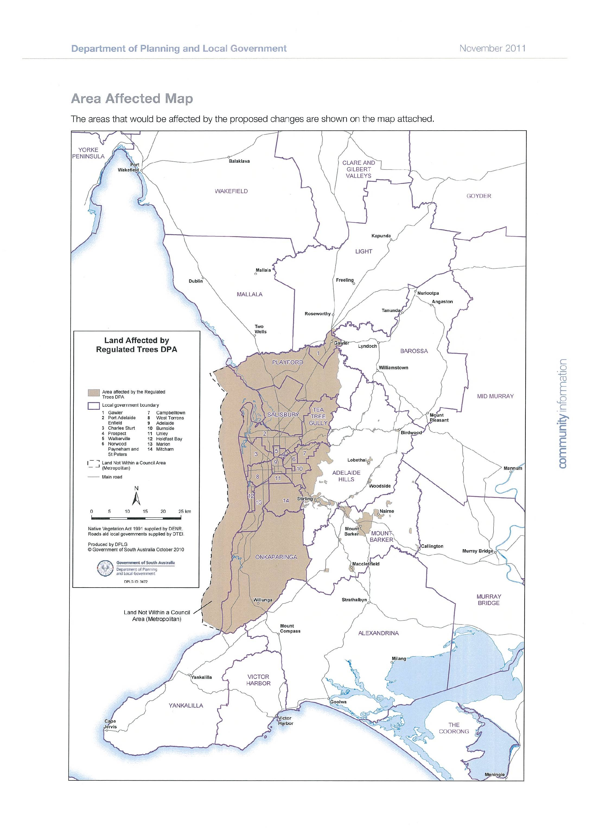

Site values as at 2009.
LGA | Land value/ha | LGA | Land value/ha
Adelaide Hills | $11,519 | Mt Barker | $8,401
Alexandrina | $7,289 | Mt Gambier C | $5,148
Barossa | $9,049 | Mt Remarkable | $577
Barunga West | $4,928 | Murray Bridge (RC) | $1,551
Berri and Barmera | $10,095 | Naracoorte Lucindale | $2,543
Burnside | $11,519 | Northern Areas | $2,626
Ceduna | $301 | Onkaparinga | $29,409
Clare & Gilbert Valleys | $7,384 | Orroroo Carrieton, Peterborough | $223
Cleve, Wudinna | $565 | Playford | $16,894
Coober Pedy | $3,588 | Pt Adelaide | $16,894
Coorong | $630 | Pt Augusta | $386
Copper Coast | $15,439 | Pt Lincoln | $1,676
Elliston | $1,174 | Pt Pirie | $1,351
Flinders Ranges | $155 | Renmark Paringa | $5,693
Franklin Harbor | $1,710 | Robe | $6,325
Gawler (T) | $4,635 | Roxby Downs | $2,454
Goyder | $758 | Salisbury | $16,894
Grant | $5,148 | Southern Mallee | $445
Kangaroo Island | $803 | Streaky Bay | $261
Karoonda East Murray | $243 | Tatiara | $1,356
Kimba | $232 | Tea Tree Gully | $11,519
Kingston | $1,055 | Tumby Bay | $2,095
Light, Mallala | $4,635 | Victor Harbor | $24,050
Lower Eyre Peninsula | $1,676 | Wakefield | $2,957
Loxton Waikerie | $943 | Wattle Range | $3,101
Mallala, Light | $4,635 | Whyalla | $339
Marion | $29,409 | Wudinna, Cleve | $565
Mid Murray | $625 | Yankalilla | $4,390
Mitcham | $11,519 | Yorke Peninsula | $3,292

NOTE: For unincorporated areas, use land value of $20 per hectare, as per DENR advice received 21/12/11 (knet 6017076)

J. Cutten and M. Hodder, DWLBC, 2002
An Update of the Conservation Status of the Major Plant Associations of South Australia, Neagle 1995
Lang & Kraehenbuehl, Florlist, latest version based on National parks & Wildlife Act, 1972, PART 2, Schedules 7, 8 & 9
Department of Environment and Natural Resources, SA, Updated December 2002
Scattered Tree Clearance Assessment in South Australia, DWLBC (Dept of Water, Land Biodiversity Conservation), Appendix 3, Page 93
Scattered Tree Clearance Assessment in South Australia, DWLBC (Dept of Water, Land Biodiversity Conservation), Appendix 3, Page 93
Natural Resources Management Act, 2004
TSD Environmental Weeds List

