LOCATING SEQUENTIAL STRINGS – Sequential Strings

CODE | AB
DESCRIPTION | Bridge Abutment
MODEL | SURVEY MODEL
TINNABLE | YES
DIRECTIONAL | NO
LOCATION INFORMATION
COMMENTS
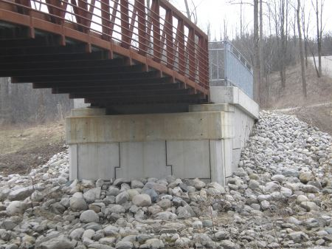

CODE | B
DESCRIPTION | Building ***
MODEL | SURVEY MODEL
TINNABLE | YES
DIRECTIONAL | NO
LOCATION INFORMATION
COMMENTS | Locate with building to the right
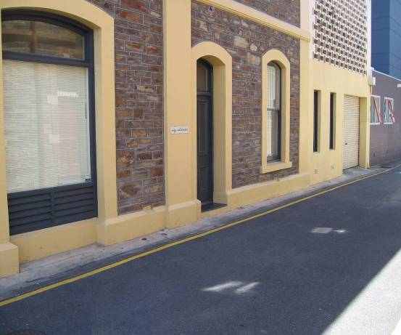
1

2

CODE | BB
DESCRIPTION | Bank Bottom
MODEL | SURVEY MODEL
TINNABLE | YES
DIRECTIONAL | NO
LOCATION INFORMATION
COMMENTS
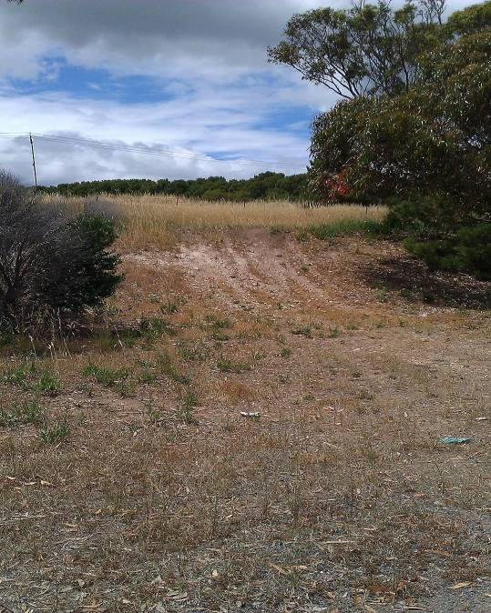

CODE | BC
DESCRIPTION | Concrete Border ***
MODEL | SURVEY MODEL
TINNABLE | YES
DIRECTIONAL | YES
LOCATION INFORMATION | Locate with feature to the right
COMMENTS
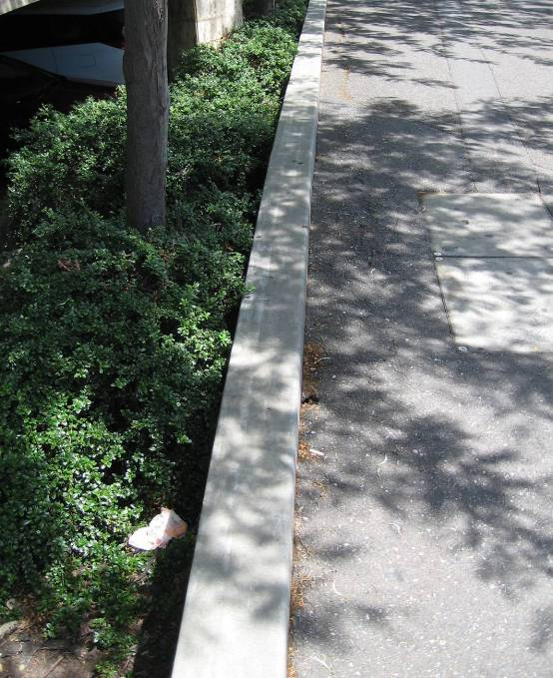
2

1

CODE | BE
DESCRIPTION | Concrete Barrier Edge
MODEL | SURVEY MODEL
TINNABLE | NO
DIRECTIONAL | NO
LOCATION INFORMATION
COMMENTS | Used to show the outside edges of the concrete barrier.
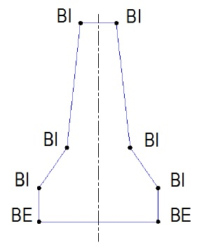

CODE | BI
DESCRIPTION | Concrete Barrier Intermediate
MODEL | SURVEY MODEL
TINNABLE | NO
DIRECTIONAL | NO
LOCATION INFORMATION
COMMENTS | Used to show the shape of the concrete barrier.

CODE | BP
DESCRIPTION | Telephone Box
MODEL | SERVICES ASSET
TINNABLE | YES
DIRECTIONAL | NO
LOCATION INFORMATION | 4 point closed string
COMMENTS
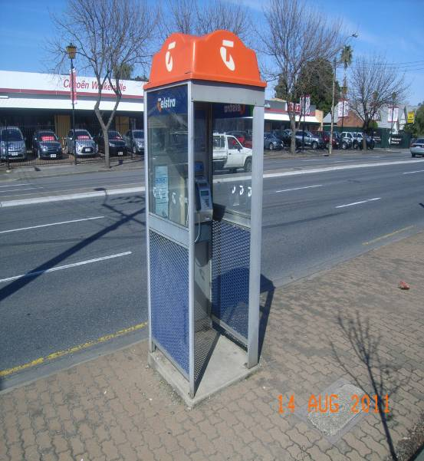

CODE | BR
DESCRIPTION | Bridge Deck
MODEL | BRIDGE MODEL
TINNABLE | NO
DIRECTIONAL | NO
LOCATION INFORMATION | Edge of bridge, From deck join to deck join
COMMENTS | Break strings that cross BR string
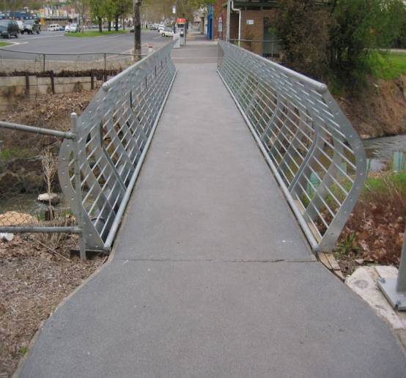

CODE | BRP
DESCRIPTION | Bridge Piers
MODEL | XSURVEY
TINNABLE | NO
DIRECTIONAL | NO
LOCATION INFORMATION | Locate at base of pier
COMMENTS | Closed string
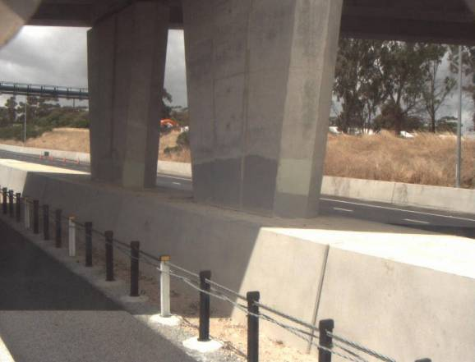

CODE | BS
DESCRIPTION | Bus Stop Shelter
MODEL | SURVEY MODEL
TINNABLE | YES
DIRECTIONAL | NO
LOCATION INFORMATION | 4 point closed string
COMMENTS | Also locate verandah in this case
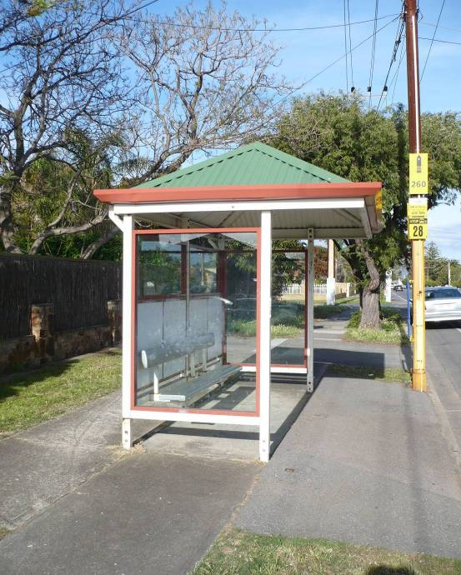

CODE | BSE
DESCRIPTION | Bench Seat
MODEL | SURVEY MODEL
TINNABLE | YES
DIRECTIONAL | NO
LOCATION INFORMATION | 4 point closed string
COMMENTS
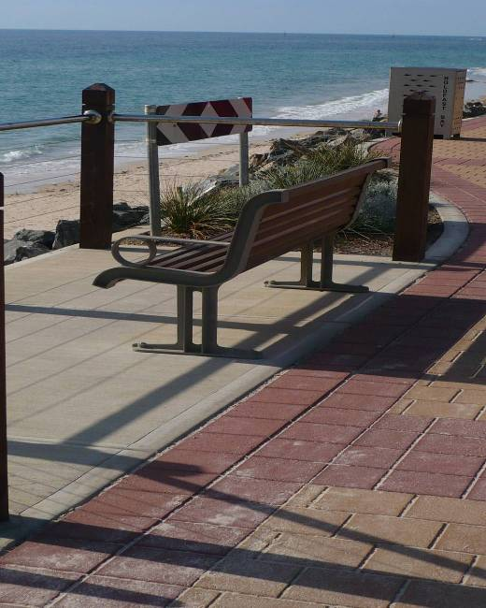

CODE | BT
DESCRIPTION | Bank Top ***
MODEL | SURVEY MODEL
TINNABLE | YES
DIRECTIONAL | YES
LOCATION INFORMATION
COMMENTS | Locate with bank to the right
1

2

CODE | CC
DESCRIPTION | Centre of Creek
MODEL | SURVEY MODEL
TINNABLE | YES
DIRECTIONAL | NO
LOCATION INFORMATION
COMMENTS
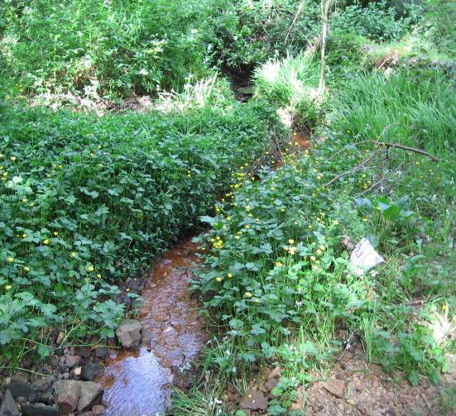

CODE | CD
DESCRIPTION | Centre of Drain
MODEL | SURVEY MODEL
TINNABLE | YES
DIRECTIONAL | NO
LOCATION INFORMATION
COMMENTS
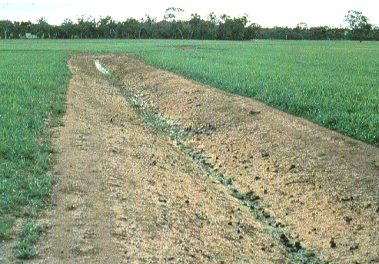

CODE | CR
DESCRIPTION | RailTrack (CentreLine)
MODEL | SURVEY MODEL
TINNABLE | NO
DIRECTIONAL | NO
LOCATION INFORMATION
COMMENTS
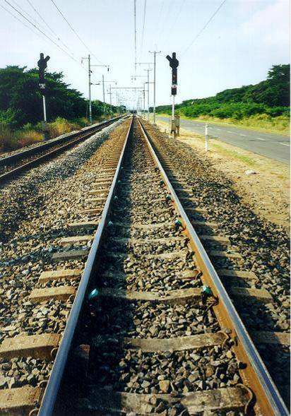

CODE | CT
DESCRIPTION | Centre of Track
MODEL | SURVEY MODEL
TINNABLE | YES
DIRECTIONAL | NO
LOCATION INFORMATION
COMMENTS
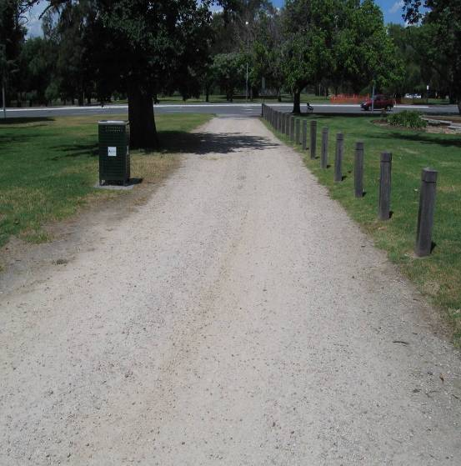

CODE | DR
DESCRIPTION | Driveway
MODEL | SURVEY MODEL
TINNABLE | YES
DIRECTIONAL | NO
LOCATION INFORMATION
COMMENTS
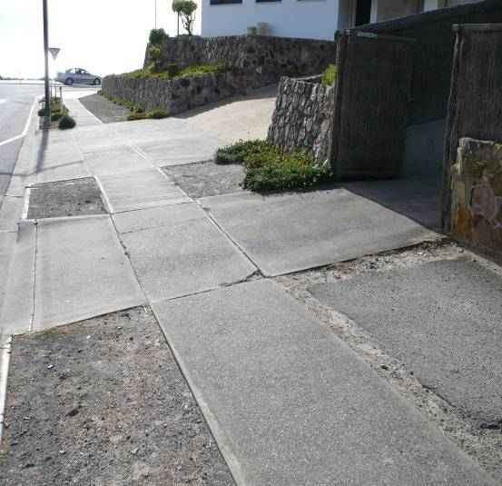

CODE | DW
DESCRIPTION | Doorway
MODEL | XSURVEY
TINNABLE | NO
DIRECTIONAL | NO
LOCATION INFORMATION | Locate at floor level
COMMENTS
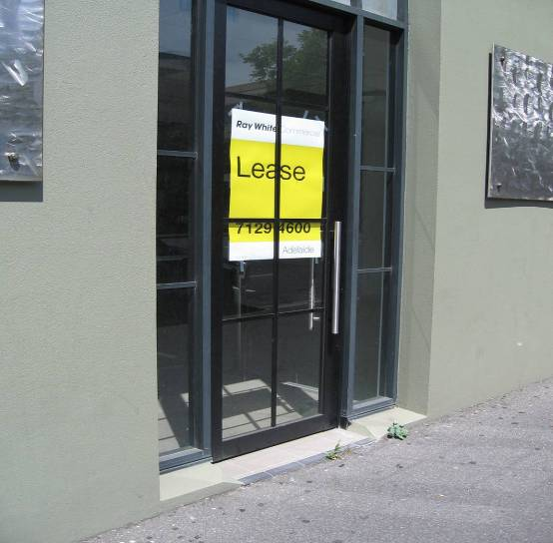

CODE | EA
DESCRIPTION | Eath Cables (RAIL)
MODEL | SERVICES ASSET
TINNABLE | NO
DIRECTIONAL | NO
LOCATION INFORMATION | String from box to earth stake
COMMENTS
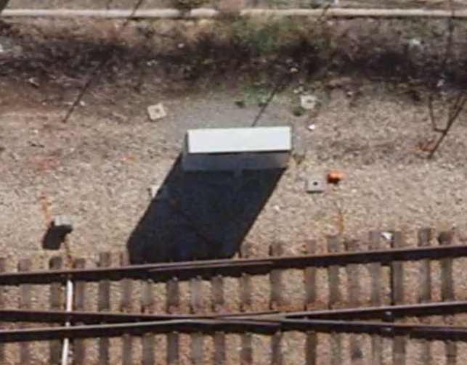

CODE | EB
DESCRIPTION | Edge of Bitumen
MODEL | SURVEY MODEL
TINNABLE | YES
DIRECTIONAL | NO
LOCATION INFORMATION | Locate as near as possible to lip of kerb
COMMENTS | Used to extend crossfall in designs
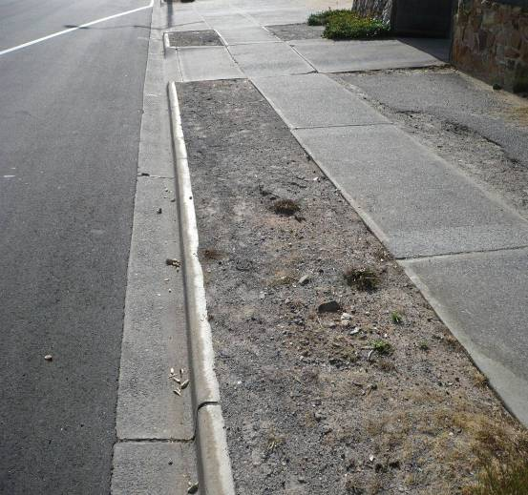

CODE | EC
DESCRIPTION | Edge of Concrete
MODEL | SURVEY MODEL
TINNABLE | YES
DIRECTIONAL | NO
LOCATION INFORMATION
COMMENTS | Tactile pad as EC or EU
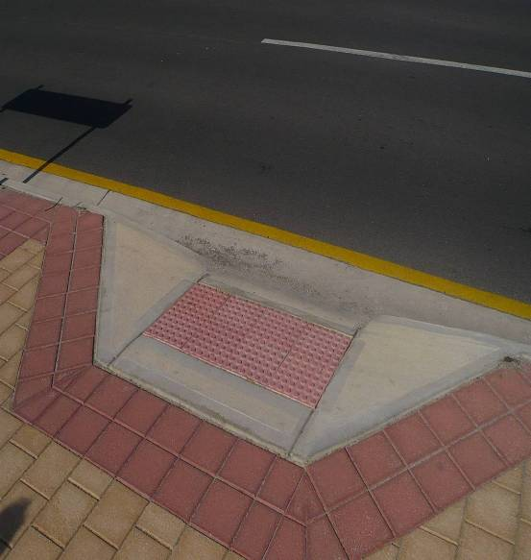

CODE | ED
DESCRIPTION | Edge of Drain
MODEL | SURVEY MODEL
TINNABLE | YES
DIRECTIONAL | NO
LOCATION INFORMATION
COMMENTS
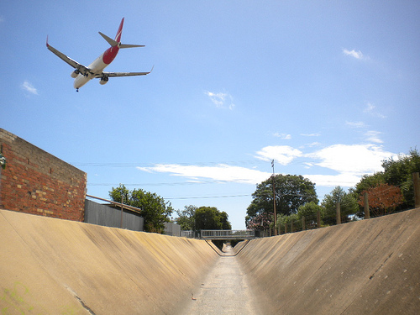

CODE | EF
DESCRIPTION | Edge of Footpath
MODEL | SURVEY MODEL
TINNABLE | YES
DIRECTIONAL | NO
LOCATION INFORMATION
COMMENTS
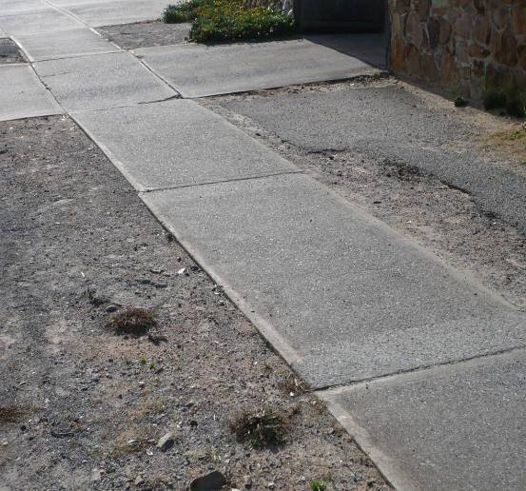

CODE | EP
DESCRIPTION | ETSA Pylon
MODEL | SERVICES ASSET
TINNABLE | YES
DIRECTIONAL | NO
LOCATION INFORMATION | 4 point closed string
COMMENTS | Locate at base
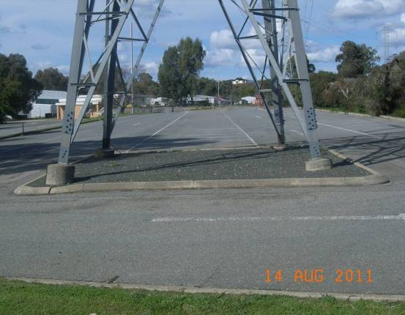
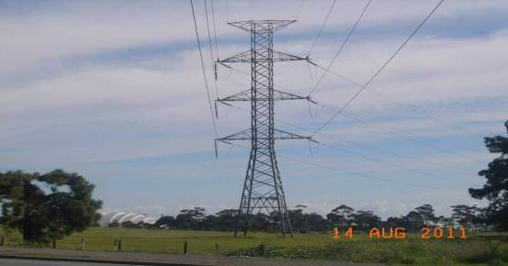

CODE | ER
DESCRIPTION | Edge of Road
MODEL | SURVEY MODEL
TINNABLE | YES
DIRECTIONAL | NO
LOCATION INFORMATION
COMMENTS
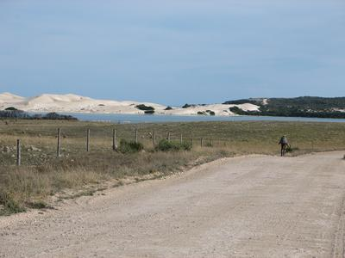

CODE | ES
DESCRIPTION | Edge of Shoulder
MODEL | SURVEY MODEL
TINNABLE | YES
DIRECTIONAL | NO
LOCATION INFORMATION
COMMENTS
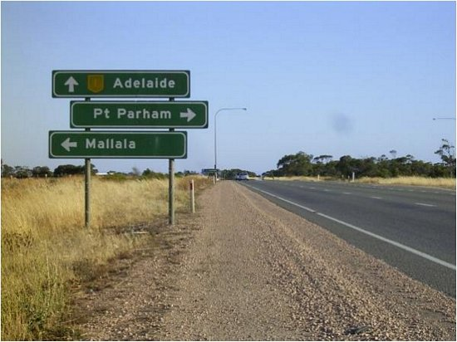

CODE | ET
DESCRIPTION | Edge of Track
MODEL | SURVEY MODEL
TINNABLE | YES
DIRECTIONAL | NO
LOCATION INFORMATION
COMMENTS
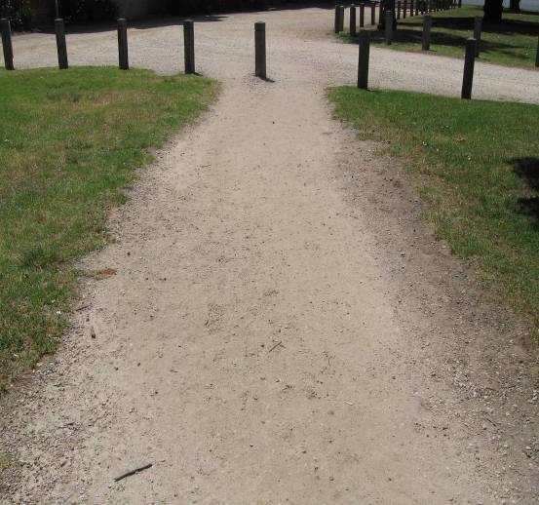

CODE | EU
DESCRIPTION | Edge of Brick Pavers
MODEL | SURVEY MODEL
TINNABLE | YES
DIRECTIONAL | NO
LOCATION INFORMATION
COMMENTS | Tactile pad as EC or EU
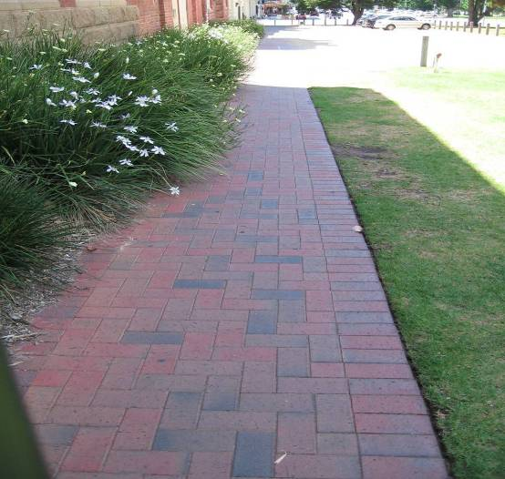

CODE | EW
DESCRIPTION | Edge of Water
MODEL | SURVEY MODEL
TINNABLE | YES
DIRECTIONAL | NO
LOCATION INFORMATION
COMMENTS
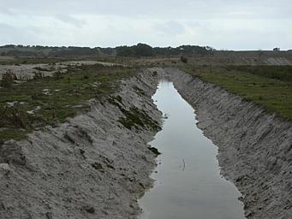

CODE | F
DESCRIPTION | Fence
MODEL | SURVEY MODEL
TINNABLE | YES
DIRECTIONAL | NO
LOCATION INFORMATION
COMMENTS
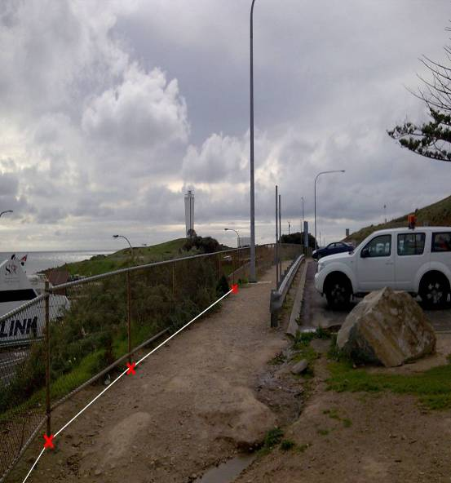

CODE | FL
DESCRIPTION | Flood Level
MODEL | XSURVEY
TINNABLE | NO
DIRECTIONAL | NO
LOCATION INFORMATION | Locate edge of water
COMMENTS
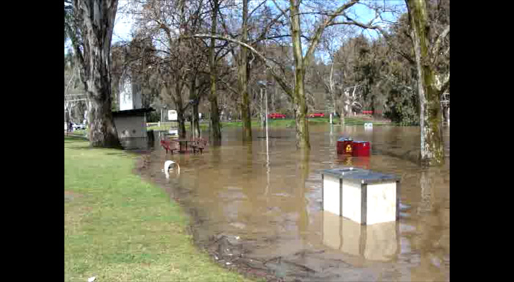

CODE | FP
DESCRIPTION | Fuel Pipe (Above Ground)
MODEL | XSURVEY
TINNABLE | NO
DIRECTIONAL | NO
LOCATION INFORMATION | Locate on top of pipe
COMMENTS
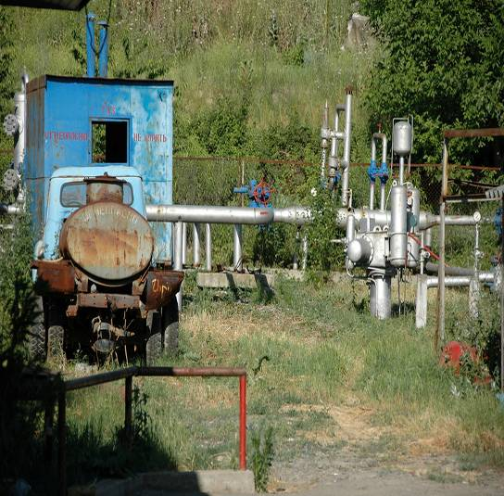

CODE | G
DESCRIPTION | Gate
MODEL | SURVEY MODEL
TINNABLE | YES
DIRECTIONAL | NO
LOCATION INFORMATION | Inside post to inside post
COMMENTS
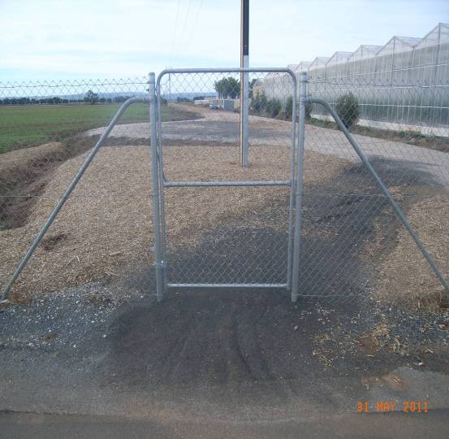

CODE | GB
DESCRIPTION | Wire Rope Safety Fence
MODEL | SURVEY MODEL
TINNABLE | YES
DIRECTIONAL | NO
LOCATION INFORMATION | Along fenceline
COMMENTS
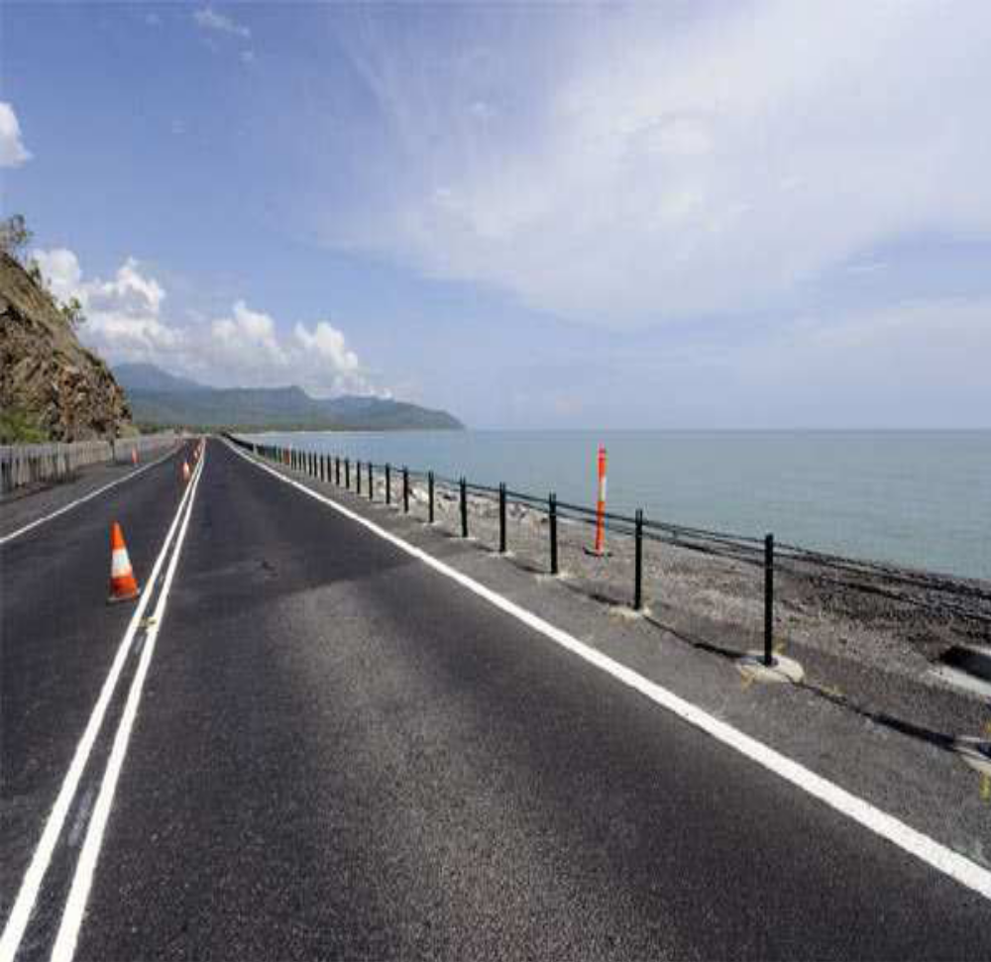

CODE | GD
DESCRIPTION | Grid
MODEL | SURVEY MODEL
TINNABLE | YES
DIRECTIONAL | NO
LOCATION INFORMATION | Closed string
COMMENTS | Locate extra points if not flat
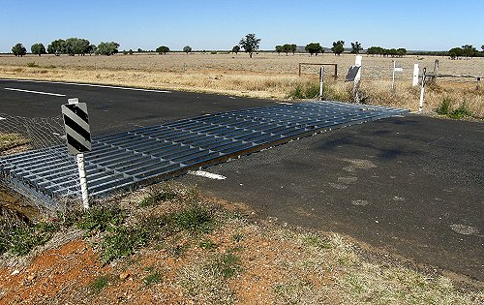

CODE | GG
DESCRIPTION | Grating
MODEL | SERVICES ASSET
TINNABLE | YES
DIRECTIONAL | NO
LOCATION INFORMATION | 4 point closed string
COMMENTS
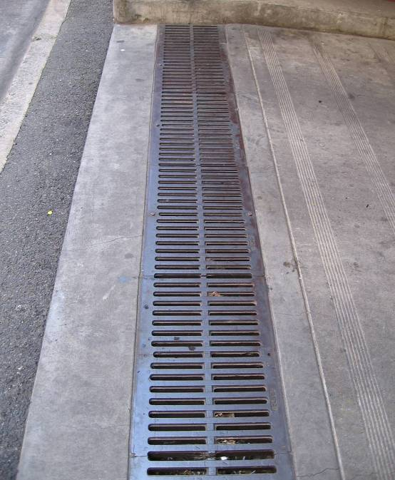

CODE | GR
DESCRIPTION | Guard Rail Face ***
MODEL | SURVEY MODEL
TINNABLE | YES
DIRECTIONAL | YES
LOCATION INFORMATION | Survey with feature on the right
COMMENTS
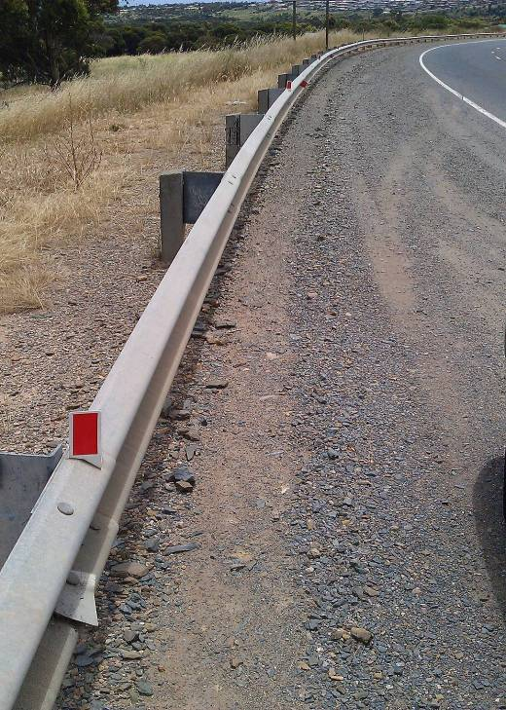
2

1

CODE | GU
DESCRIPTION | Gutter
MODEL | SURVEY MODEL
TINNABLE | YES
DIRECTIONAL | NO
LOCATION INFORMATION | Survey along lowest point
COMMENTS
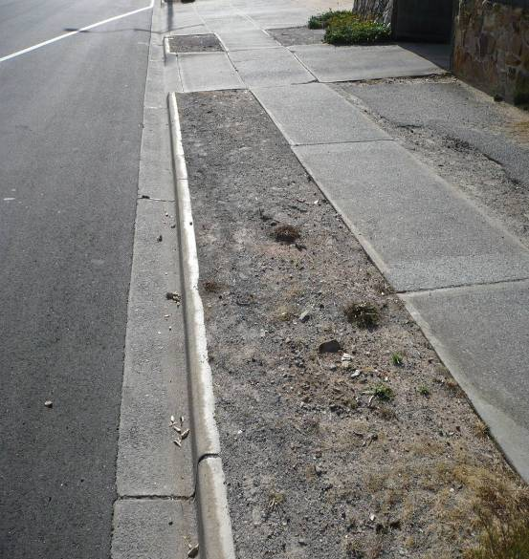

CODE | H
DESCRIPTION | Hedge ***
MODEL | SURVEY MODEL
TINNABLE | YES
DIRECTIONAL | YES
LOCATION INFORMATION
COMMENTS | locate with hedge on right
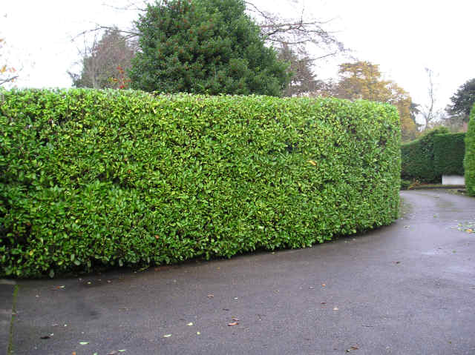
1

2

CODE | HW
DESCRIPTION | Headwall (Top)
MODEL | SURVEY MODEL
TINNABLE | YES
DIRECTIONAL | NO
LOCATION INFORMATION | Locate at centre of Headwall
COMMENTS | Show Natural string at base to TIN
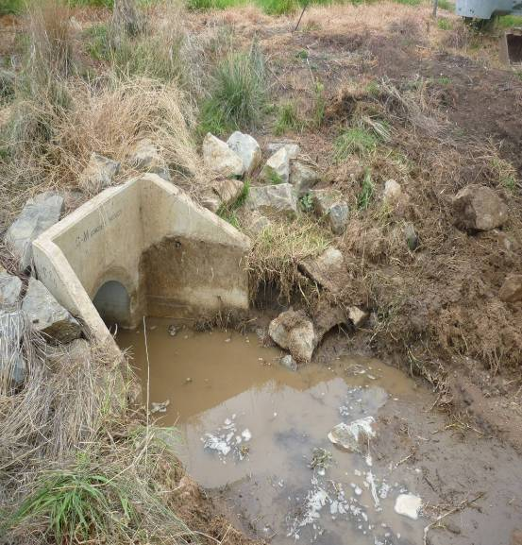

CODE | K
DESCRIPTION | Kerb
MODEL | SURVEY MODEL
TINNABLE | YES
DIRECTIONAL | NO
LOCATION INFORMATION | Fig. 1 Top of Kerb centre  Fig. 2 Top of Kerb roadside edge
COMMENTS
Fig. 1.
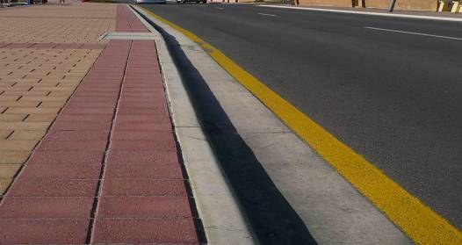
Fig. 2.
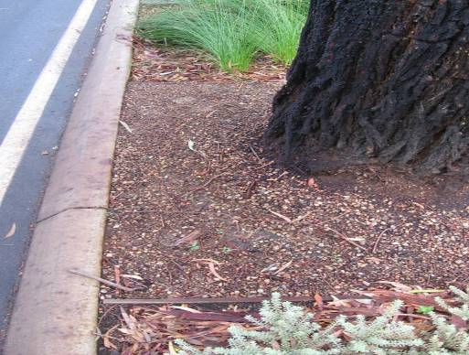

CODE | LA
DESCRIPTION | Ladder
MODEL | XSURVEY
TINNABLE | NO
DIRECTIONAL | NO
LOCATION INFORMATION | Locate in the centre of ladder
COMMENTS
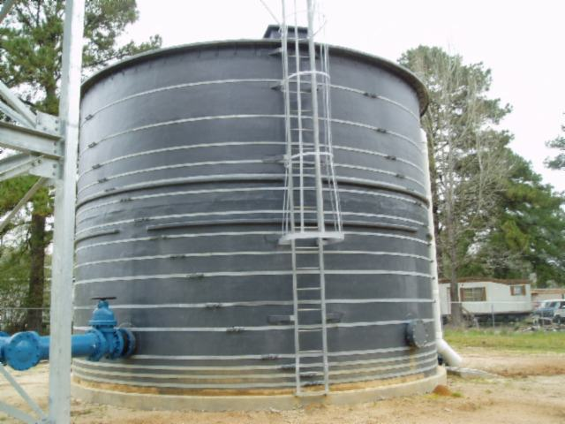

CODE | LB
DESCRIPTION | Trackside Location Box (Rail)
MODEL | SERVICES ASSET
TINNABLE | YES
DIRECTIONAL | NO
LOCATION INFORMATION | 4 point closed string
COMMENTS | Locate at base
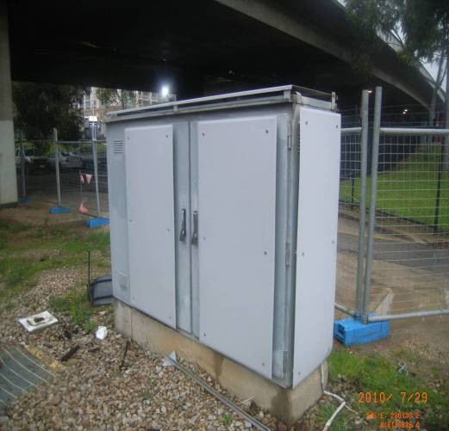

CODE | LVT
DESCRIPTION | Levee Bank (Top)
MODEL | SURVEY MODEL
TINNABLE | YES
DIRECTIONAL | NO
LOCATION INFORMATION
COMMENTS
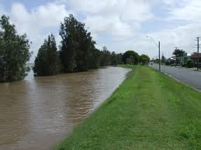

CODE | N
DESCRIPTION | Natural Surface
MODEL | SURVEY MODEL
TINNABLE | YES
DIRECTIONAL | NO
LOCATION INFORMATION
COMMENTS
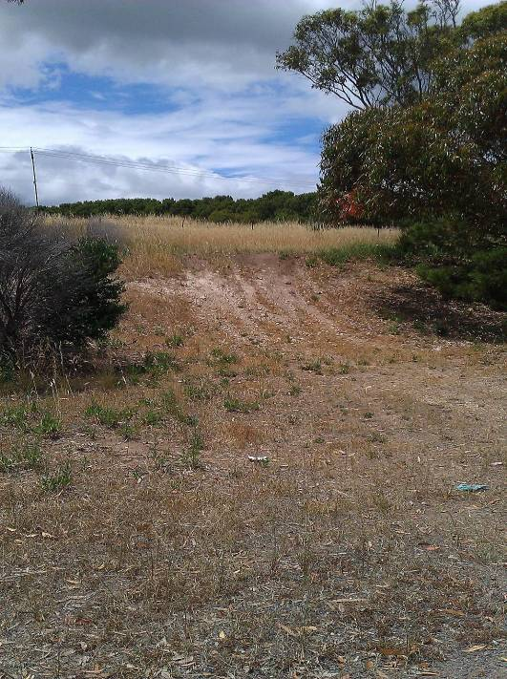

CODE | OH
DESCRIPTION | Overhead Wires
MODEL | SERVICES ASSET
TINNABLE | NO
DIRECTIONAL | NO
LOCATION INFORMATION | Locate as a 2d string pole to pole unless stated otherwise
COMMENTS
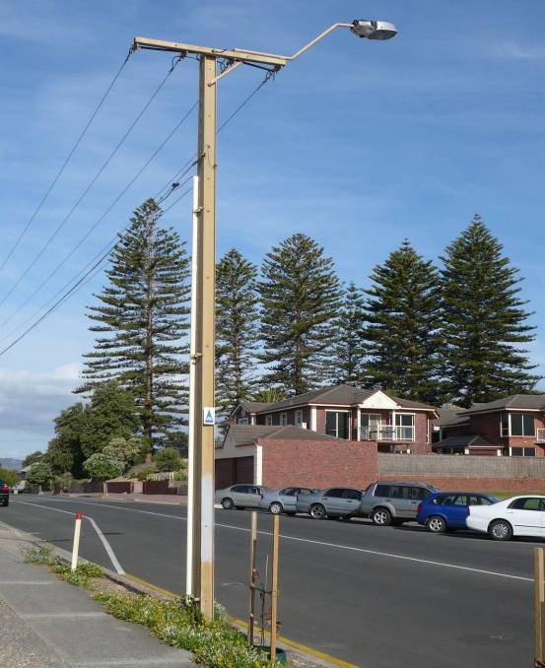

CODE | QQ
DESCRIPTION | Model Check String
MODEL | QQ MODEL
TINNABLE | NO
DIRECTIONAL | NO
LOCATION INFORMATION
COMMENTS | Independent Check string across model
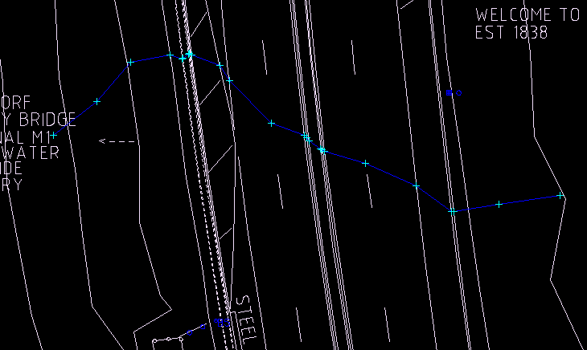

CODE | RG
DESCRIPTION | Rail Gauge
MODEL | XSURVEY
TINNABLE | NO
DIRECTIONAL | NO
LOCATION INFORMATION | Gauge is intersection of rail head and internal face. (Running Rail)
COMMENTS
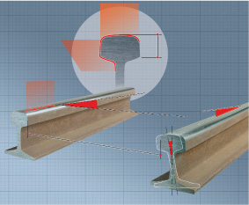

CODE | RK
DESCRIPTION | Rock Outcrop (Base)
MODEL | SURVEY MODEL
TINNABLE | YES
DIRECTIONAL | NO
LOCATION INFORMATION | Locate at base
COMMENTS
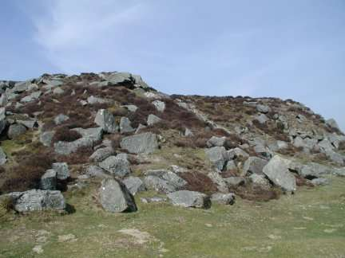

CODE | RS
DESCRIPTION | Road Sign or Hoarding ***
MODEL | XSURVEY
TINNABLE | NO
DIRECTIONAL | YES
LOCATION INFORMATION
COMMENTS | locate with face of sign on right
1

2

CODE | RT
DESCRIPTION | Rail Track
MODEL | XSURVEY
TINNABLE | NO
DIRECTIONAL | NO
LOCATION INFORMATION | Top of rail centre
COMMENTS

CODE | RW
DESCRIPTION | Retaining Wall ***
MODEL | SURVEY MODEL
TINNABLE | YES
DIRECTIONAL | YES
LOCATION INFORMATION | Locate at base
COMMENTS | Locate with feature to the right
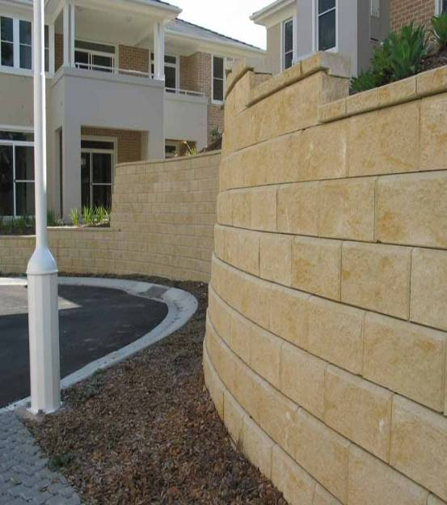
1

2

CODE | SD
DESCRIPTION | Sand Dune (Base)
MODEL | SURVEY MODEL
TINNABLE | YES
DIRECTIONAL | NO
LOCATION INFORMATION | Locate at base
COMMENTS
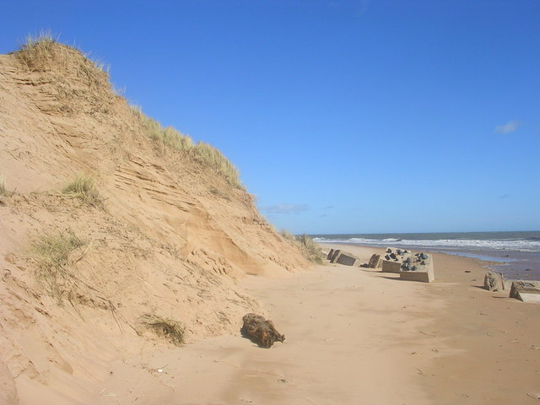

CODE | SPD
DESCRIPTION | Spoon Drain *****
MODEL | SURVEY MODEL
TINNABLE | YES
DIRECTIONAL | YES
LOCATION INFORMATION
COMMENTS | locate from highest to lowest point
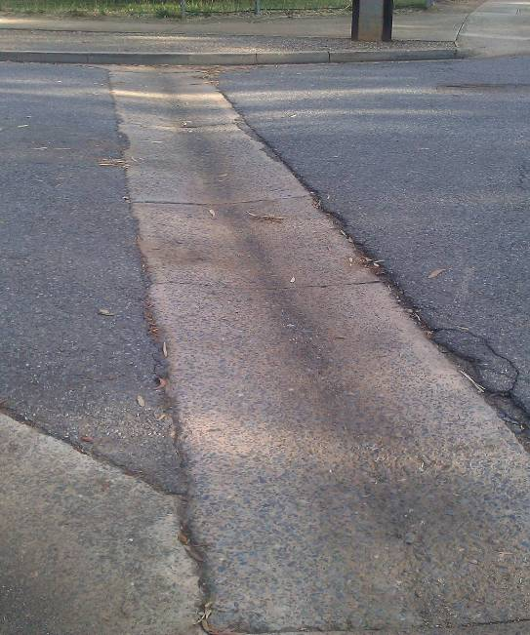
1

2

CODE | SU
DESCRIPTION | Sump
MODEL | SERVICES ASSET
TINNABLE | YES
DIRECTIONAL | NO
LOCATION INFORMATION
COMMENTS | Closed String
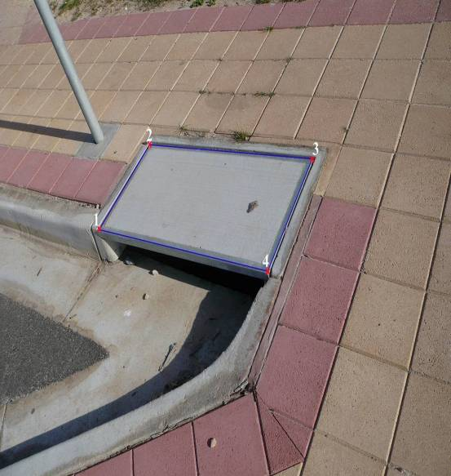

CODE | SW
DESCRIPTION | Swamp
MODEL | SURVEY MODEL
TINNABLE | YES
DIRECTIONAL | NO
LOCATION INFORMATION | Locate edge of swamp
COMMENTS
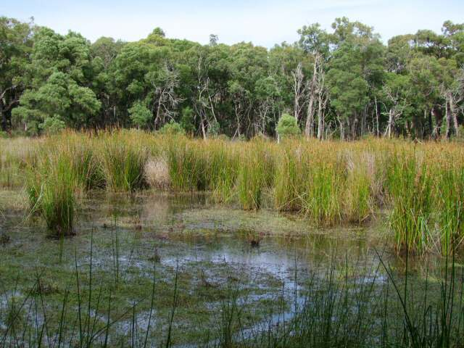

CODE | U
DESCRIPTION | Unknown String
MODEL | SURVEY MODEL
TINNABLE | YES
DIRECTIONAL | NO
LOCATION INFORMATION
COMMENTS


CODE | UG
DESCRIPTION | Underside Bridge Girder
MODEL | BRIDGE UNDERSIDE MODEL
TINNABLE | NO
DIRECTIONAL | NO
LOCATION INFORMATION | Locate at each side and the lowest clearance
COMMENTS
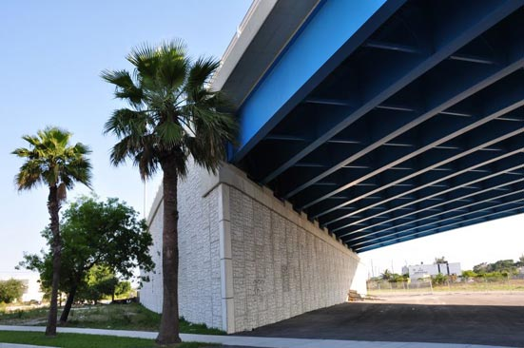

CODE | UX
DESCRIPTION | Unknown String
MODEL | XSURVEY
TINNABLE | NO
DIRECTIONAL | NO
LOCATION INFORMATION
COMMENTS

CODE | V
DESCRIPTION | Verandah
MODEL | XSURVEY
TINNABLE | NO
DIRECTIONAL | NO
LOCATION INFORMATION | Locate at outer extremity (nearest the kerb). If this is a vertical face, locate the lowest point
COMMENTS
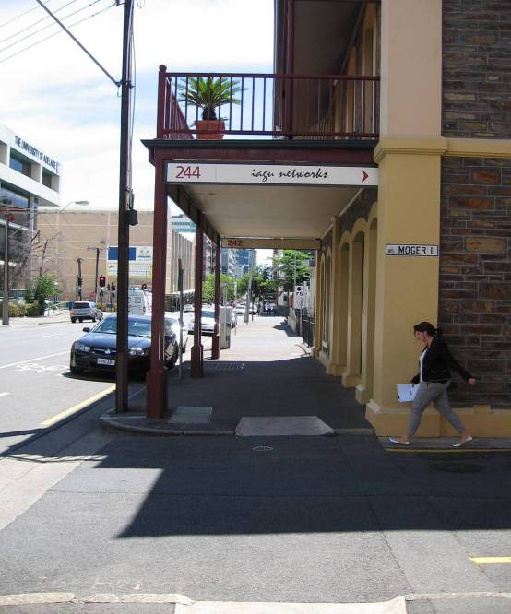

CODE | W
DESCRIPTION | Wall ***
MODEL | SURVEY MODEL
TINNABLE | YES
DIRECTIONAL | YES
LOCATION INFORMATION
COMMENTS | locate feature with wall to right
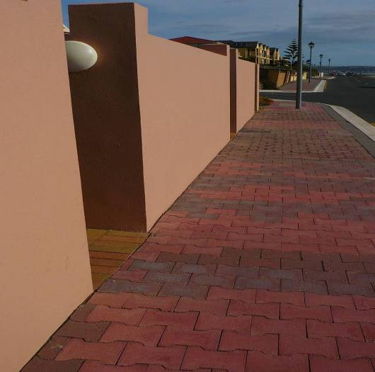
2

1

CODE | WB
DESCRIPTION | Weighbridge
MODEL | SURVEY MODEL
TINNABLE | YES
DIRECTIONAL | NO
LOCATION INFORMATION | Locate on weigh plate
COMMENTS | 4 point closed string
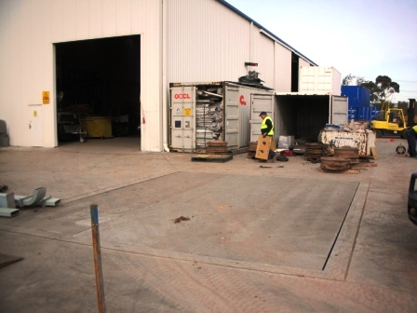

CODE | WC
DESCRIPTION | Tank
MODEL | SURVEY MODEL
TINNABLE | YES
DIRECTIONAL | NO
LOCATION INFORMATION | Locate at base to create circle within arc to chord tolerance
COMMENTS
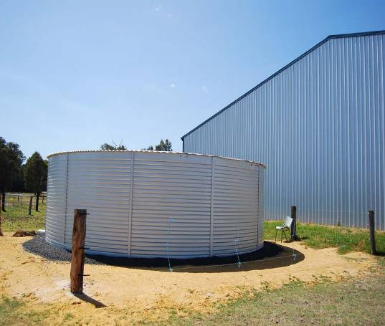

CODE | WE
DESCRIPTION | Well
MODEL | SURVEY MODEL
TINNABLE | YES
DIRECTIONAL | NO
LOCATION INFORMATION | Locate at base
COMMENTS | Closed string
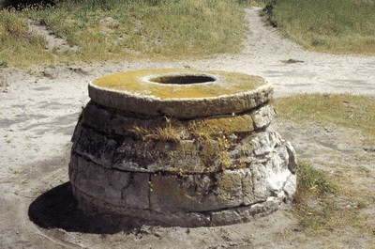

CODE | WP
DESCRIPTION | Water Pipe (Above Ground)
MODEL | SERVICES ASSET
TINNABLE | NO
DIRECTIONAL | NO
LOCATION INFORMATION | Locate on top of pipe
COMMENTS
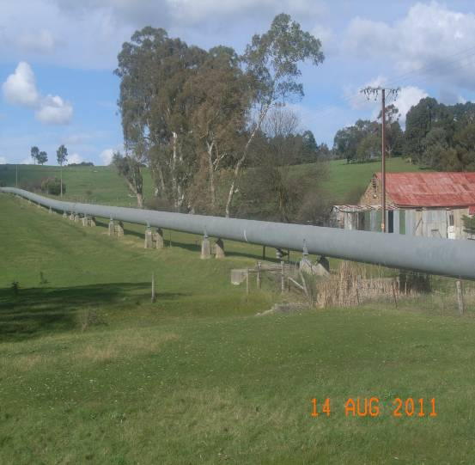

CODE | WT
DESCRIPTION | Water Trough
MODEL | SURVEY MODEL
TINNABLE | YES
DIRECTIONAL | NO
LOCATION INFORMATION
COMMENTS | 4 point closed string
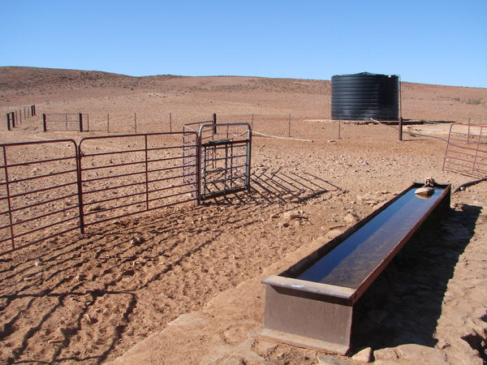

CODE | WW
DESCRIPTION | Wing Walls (Bridge)
MODEL | SURVEY MODEL
TINNABLE | YES
DIRECTIONAL | NO
LOCATION INFORMATION
COMMENTS


